DESIGN, ACCESS & HERITAGE STATEMENT FOR 87 THE STREET, ROTHERWICK, HAMPSHIRE RG27 9BG
REPLACEMENT LIKE FOR LIKE FRONT AND REAR WINDOWS AND FRONT DOOR

Purpose
This design statement has been prepared to support the planning application for replacement windows and front door to 87 The Street, Rotherwick. It is intended to provide information relating to the impact of the proposals on the Grade II listed structure, and to the conservation area in general.
Background
87 The Street is an attractive two storey, brick and tile dwelling, being one of a terrace of four cottages, believed to have been built circa 1850, situated on the south side of The Street in the village of Rotherwick, which is a Conservation Area. Immediately to the west of the row of cottages is the Grade II listed The Coach and Horses public house, which has a car park at the rear adjoining the side boundary of Row of cottages. To the rear and eastern boundaries of the terrace is open agricultural farmland.

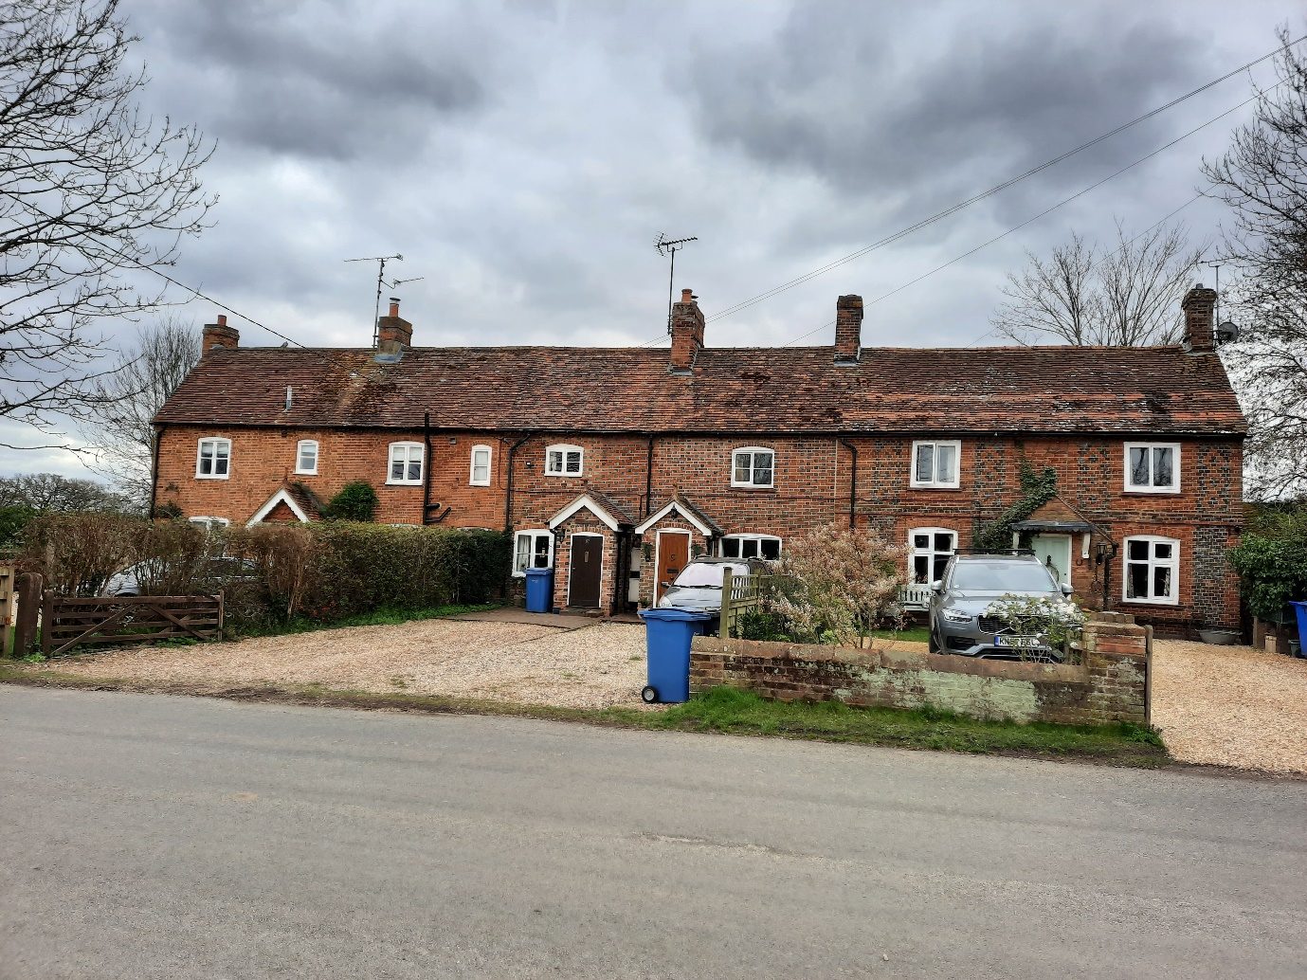

The row of 4 cottages 86 to 89 (Honeysuckle Cottage), The Street, Rotherwick were listed Grade II in 1987 with the following list description:
“C18, Cl9. 2-storeyed terrace of 4, the oldest larger westernmost unit of 3 windows (centre blank), the others of 1 window each. Red tile continuous roof, brick dentil, eaves to 86. Red brick walling in Flemish bond, with cambered ground-floor openings: 89 has bright red quoins and diaper patterns between 1st floor openings. Casements (modern to 87). Solid door frames; 89 has a canopy on carved brackets, 87 a modern porch.”
The front elevation of the cottage retains its original attractive appearance but the rear elevation, has a modern single storey extension which houses the kitchen area of the cottage. This extension was granted planning permission in 2012.) Ref. No: 12/01311/HOU | Validated: Tue 03 Jul 2012 | Status: Grant)
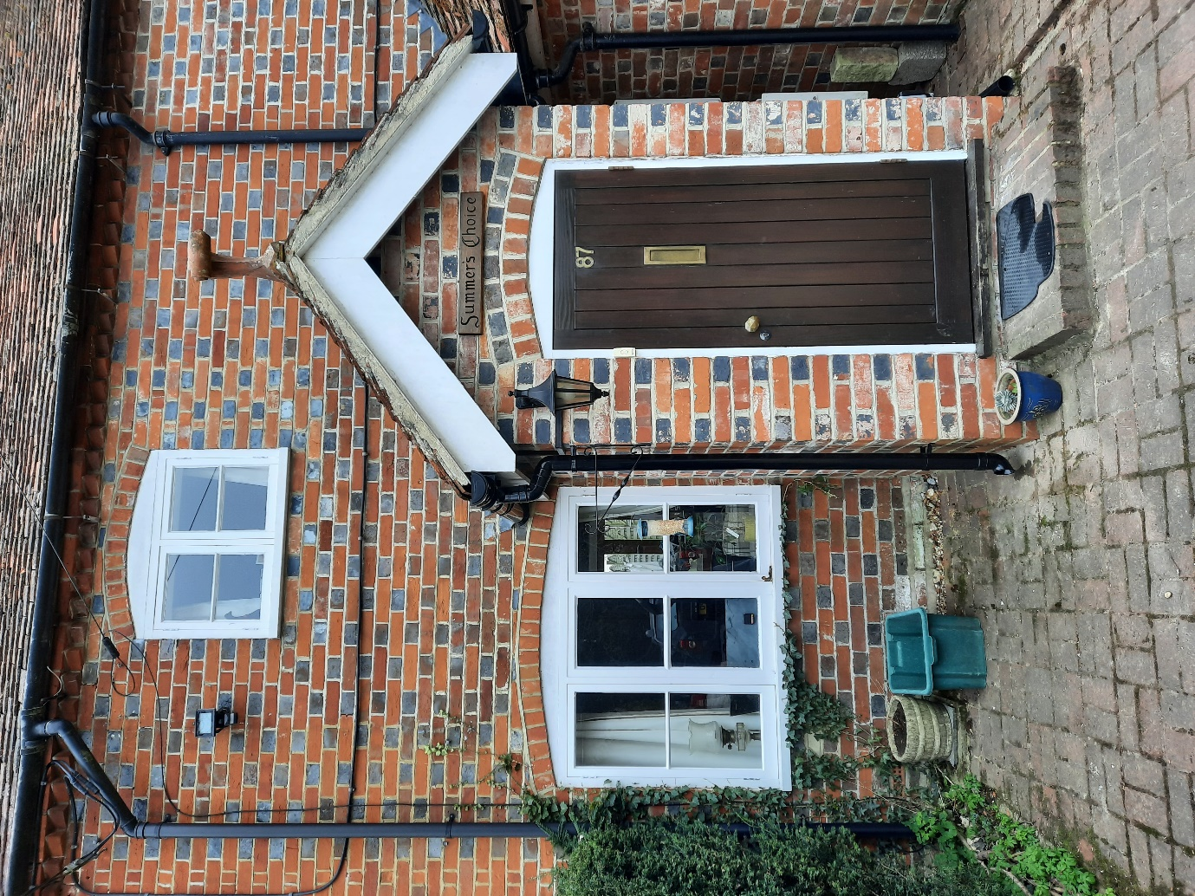

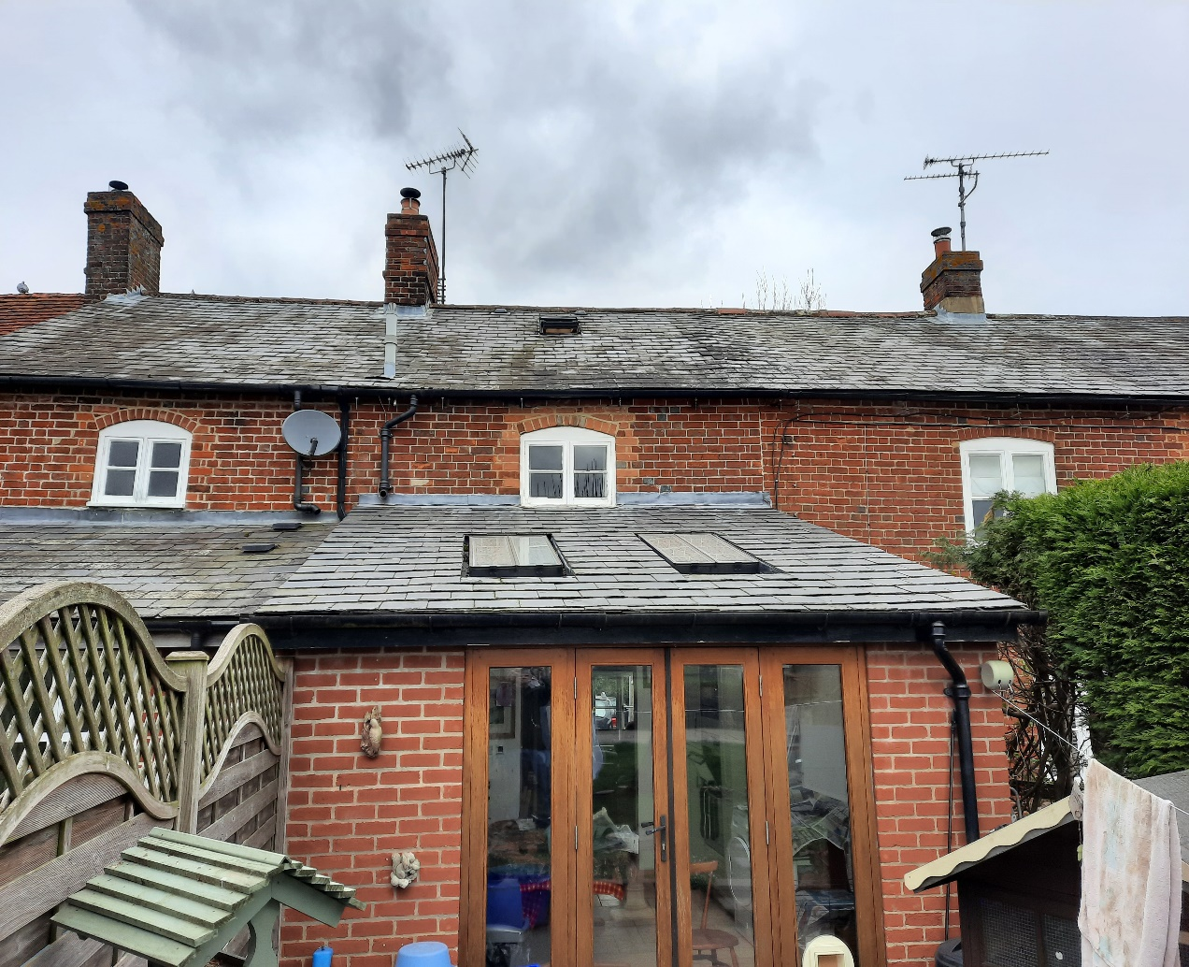

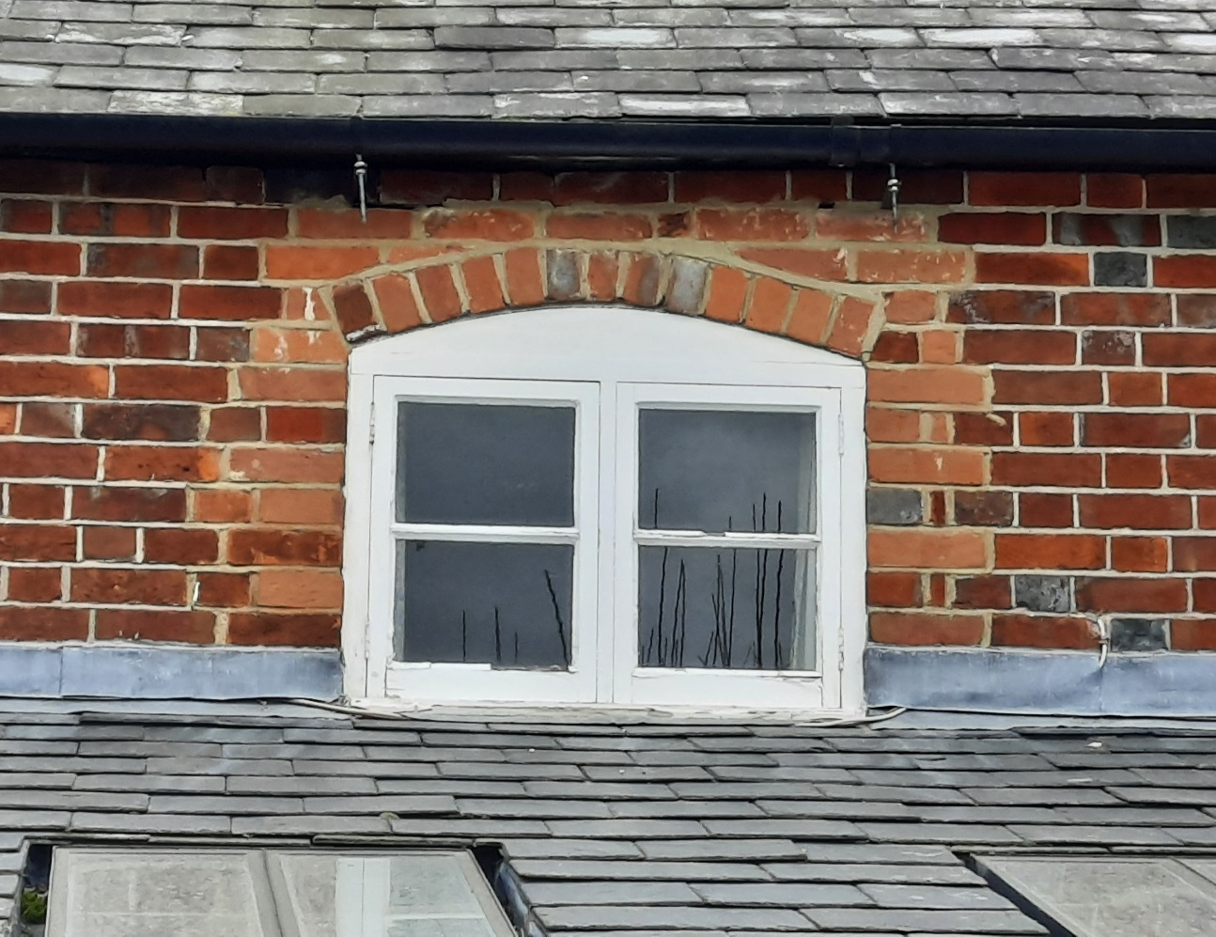

Proposed Works
The proposal is for like for like replacement of the 2 existing front and 1 rear modern casement windows with single glazed timber constructed casement windows, and a replacement timber constructed front door with the addition of a small single glazed window. The existing white timber framed window frames on the front downstairs and rear window are rotten, having been subject to previous repairs, and are now considered to be in a poor state to effect further repairs. The replacement windows would match the existing windows in style and size and also be in keeping with the neighbouring cottages in the terrace. The existing Front door is ill fitting and is not sufficient to prevent draughts entering the outer hallway.
(See attached proposed design schedule and specification for the replacement windows and door.)
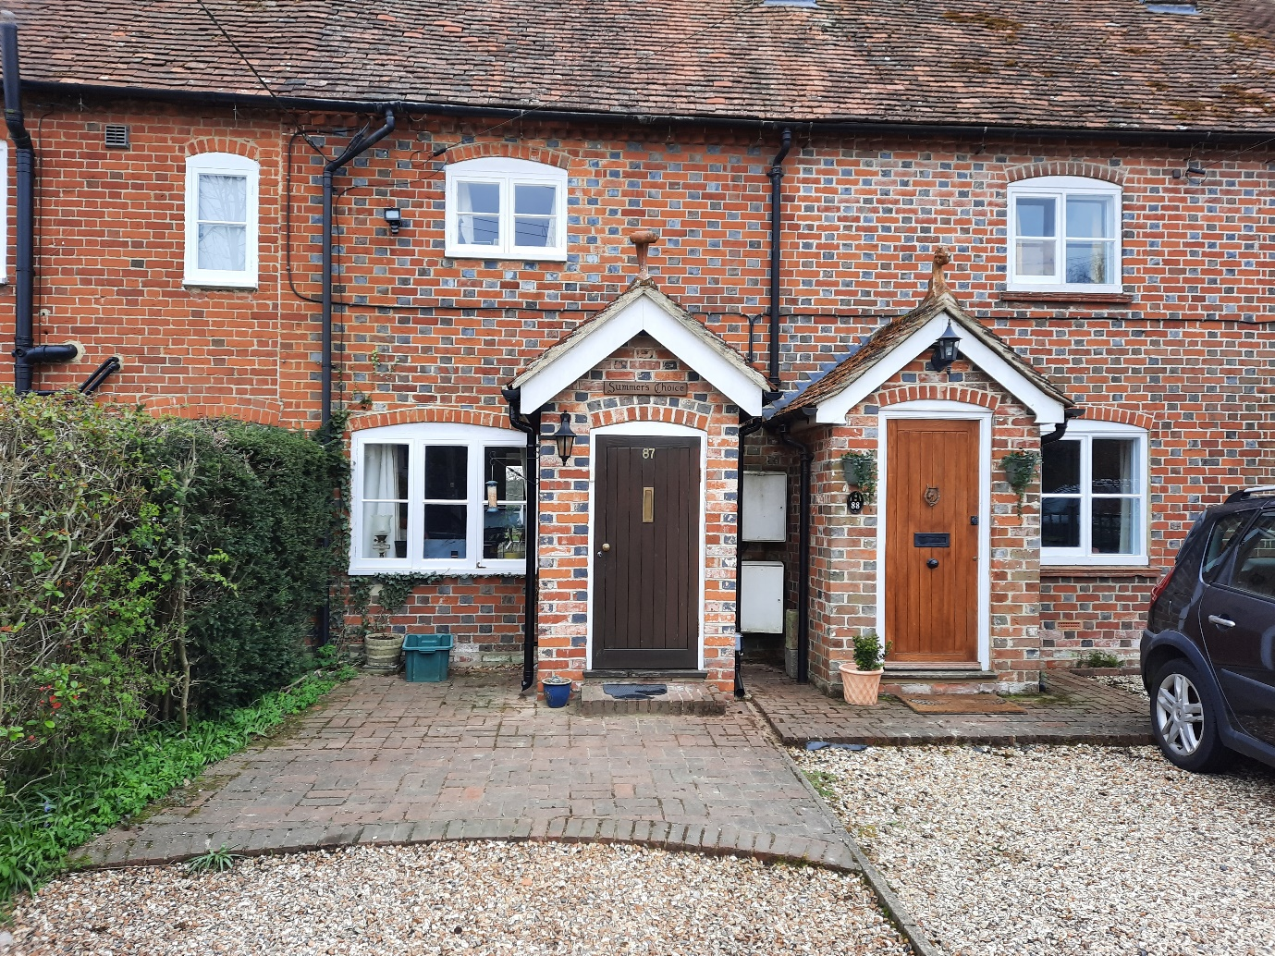

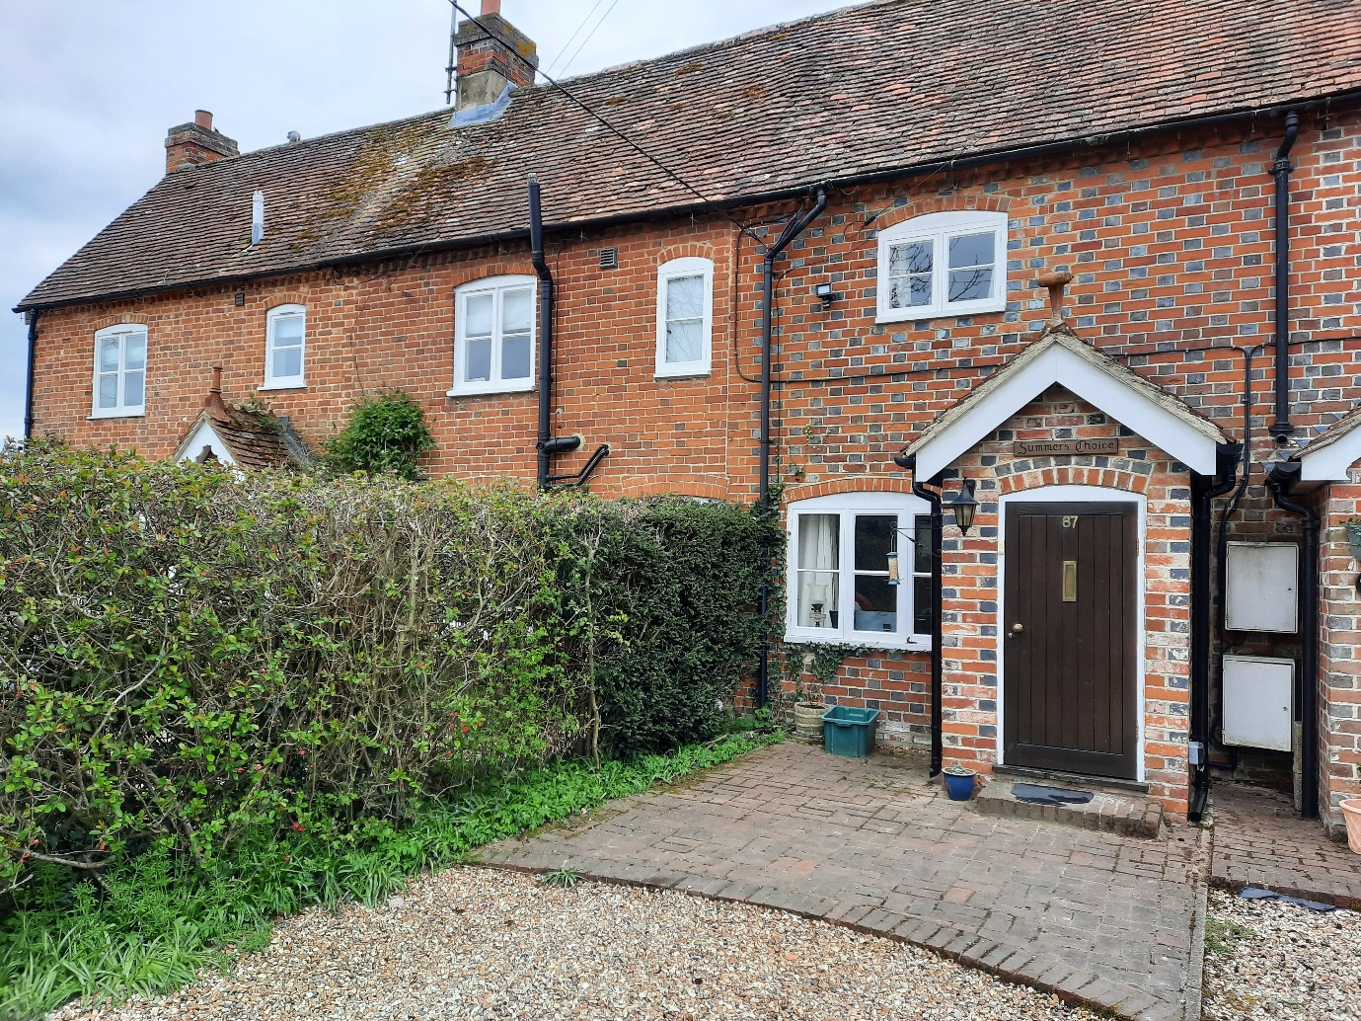

Policy Issues
The cottage is a Grade II listed building within the Rotherwick Conservation Area. These proposals therefore need to be considered against the relevant saved policies in the Hart District Local Plan (Replacement) 1996-2006 i.e. Policies GEN 1 General Policy for Development and CON17 Listed Buildings. Government advice in the National Planning Policy Framework is also relevant.
Saved GEN 1 General Policy for Development permits where the proposal is well designed, is in keeping with the local area and sympathetic to the existing building.
CON 17 Listed Buildings and Buildings of Local Interest – extension or alteration PROPOSALS FOR THE EXTENSION OR ALTERATION OF LISTED BUILDINGS OR BUILDINGS OF LOCAL INTEREST, WILL NOT BE PERMITTED UNLESS:
- The scale of the building is not materially changed;
- Design is appropriate to the character and setting of the building.

Published in 2011 the Rotherwick Conservation Area Character Appraisal and Management Proposals advise:
The dispersed layout of the buildings along both sides of The Street allows long views over the adjoining fields and woodland, and these, coupled with the large gardens, wide grass verges, and clipped front boundary hedges, give the Conservation Area its distinctly rural character.
Protect the special character of the Conservation Area by accepting only the highest quality development in the Rotherwick Conservation Area.
The Rotherwick Neighbourhood Plan 2016 to 2032 Vision Statement states
“Our vision is to maintain the rural character and identity of Rotherwick Parish, preserving its heritage assets, listed buildings and conservation area so that it will remain a visually attractive, independent settlement, set in unspoilt, tranquil and accessible countryside, providing an excellent quality of life for residents, visitors and those who work in the Parish”.
In terms of the Built Environment it seeks to “ensure that any new development is of an appropriate type, size, density and quality that contributes towards meeting the needs of the community.”
Policy BE 01 – Design, requires that the “design, scale, bulk, access, separation and density of development throughout the Neighbourhood Area, including conversions, alterations and additions, should:
a) secure high quality design;
b) maintain a good standard of amenity for all existing and future occupants of land and buildings;
c) reflect and enhance its immediate setting and the local character;
d) maintain a consistent street scene in relation to neighbouring buildings and the Neighbourhood Area, having regard to scale, density, mass, height, landscape, layout, materials, off-road parking and access to the development;
e) comply with the design principles set out in the Village Design Statement at Annex D Section 4;
f) reflect the existing scale and character of buildings in the surrounding area”
Within the Conservation Area Policy BE 02 states that development should:
a) respect the historic fabric of the area;
b) conserve or enhance the character of the Conservation Area, the buildings within it and its setting;
c) be in accordance with the design principles set out in the Village Design Statement at Annex D Section 4;
d) ensure that the size and scale of new and extended buildings relate sympathetically to the surrounding area;
e) use traditional and vernacular building materials which respect the context of the development concerned.

Neighbouring Properties
Directly opposite the terrace on the North side of The Street, the neighbouring properties have a mix of UPVC and modern timber framed windows.

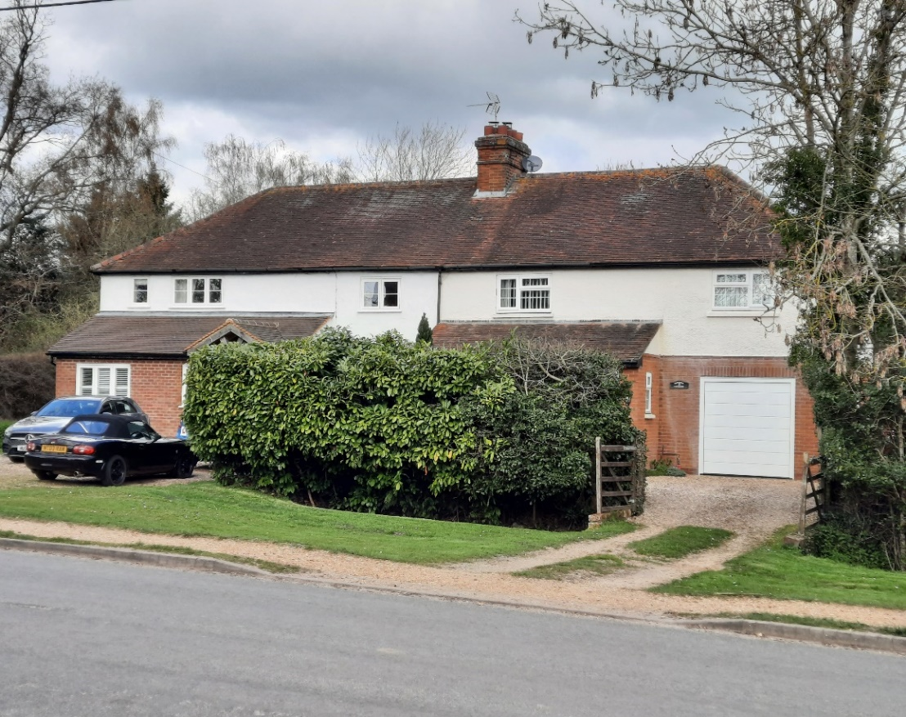

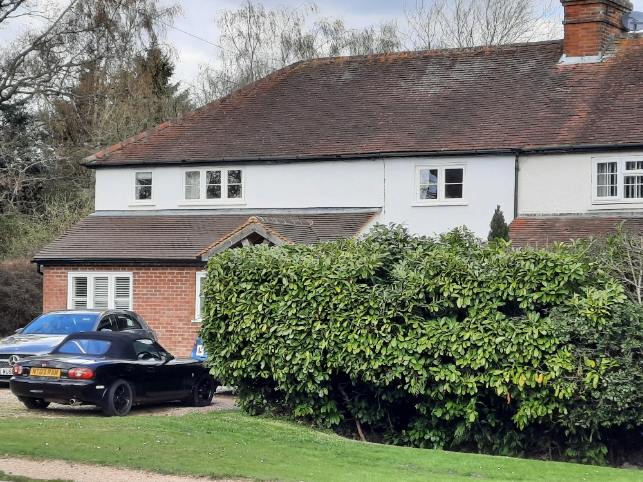
Modern Timber framed casement windows.
86 The Street has a modern timber framed casement window in the rear extension, granted planning permission in 2013.
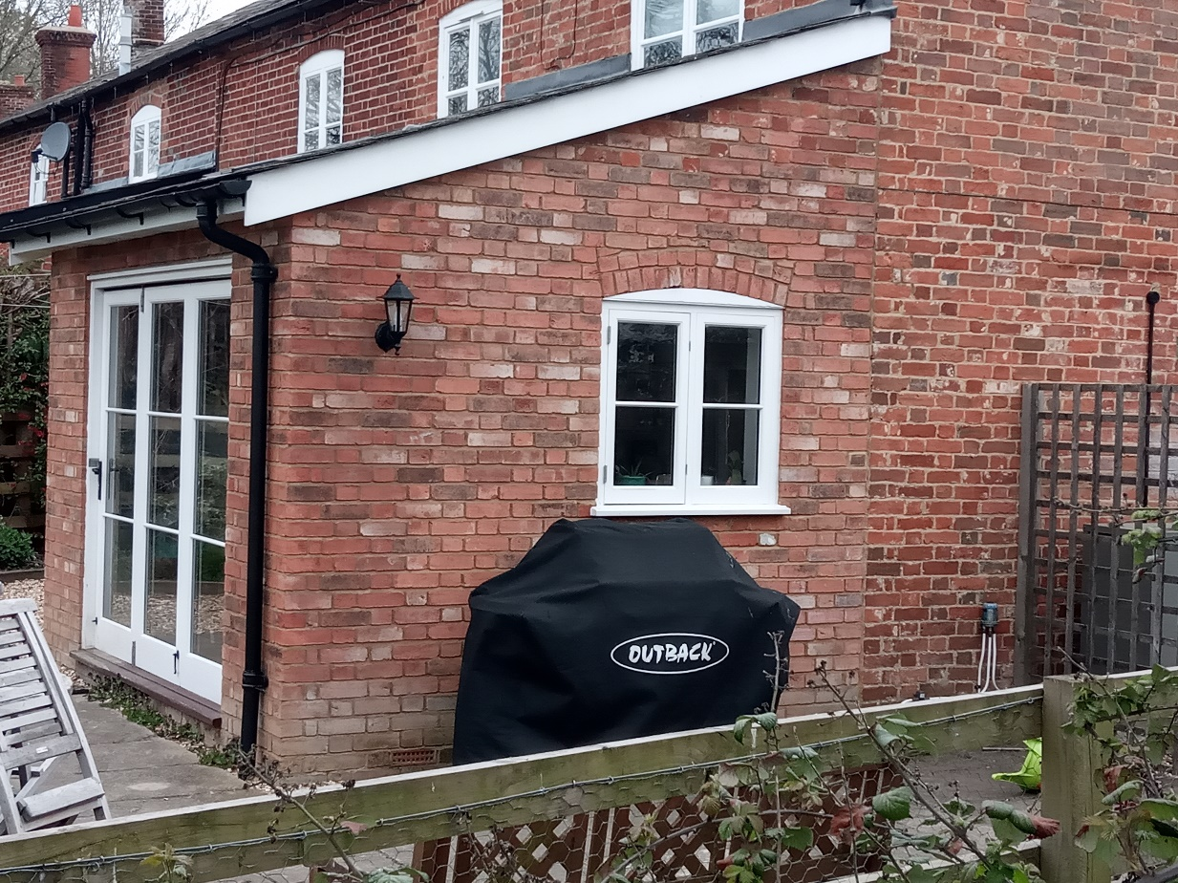

Conclusion
Overall these proposals have been carefully considered and designed to preserve the important aspects of the listed building, whilst bringing the standard of the windows and door up to date. They will have no material effect on the historic fabric of the dwelling or on its setting within the Conservation Area and be in full compliance with the relevant Local Plan Policies; and the advice given in the Conservation Area Appraisal, the Neighbourhood Plan and in the National Planning Policy Framework.
Given that the proposed windows and front door will match the look and dimensions of the existing windows and door, it is considered that the proposal is sympathetic to and meets the above criteria. It is therefore proposed that the householder planning permission and listed building consent be granted for the proposed works.

