**DESIGN AND ACCESS STATEMENT -** PA21/03722

**Purpose**

This application seeks to increase the visibility of St Martin & St Meriadoc church, Camborne, by making the church’s presence more noticeable, and inviting the people its serves to come and join with us. This report concentrates on using external lights to gently light up the church and make it a beacon for the town.

**Heritage Assessment Statement**

St Martin & Meriadoc, Camborne Parish Church is a grade 1 listed building on the approach to the centre of Camborne Town. The major part of the original church, was built in the late 15th C and early 16th C, incorporating some fabric of a smaller pre-15th century church in the north wall of the chancel.  In 1861-1862 it was restored and a west gallery that crossed the whole width of the church was removed.  New roofs were installed on the chancel, nave and north aisle.  The square high pews were also replaced with low open seat.  This was also when the stain glass window was added to the west tower.

A second restoration took place between 1878-1879, to enlarge the church and to accommodate a growing congregation, with the seating accommodation then increased to 705. A south aisle was added (80ft L x 65ft W x 30ft H), and the previous south aisle became the central aisle and was also fitted with a new roof.  A sub floor, heated air system was added.  The church re-opened in August 1879.

The woodwork and ironwork of the existing north door dates from 1862 while the granite door surround with an arch, set in a square-framed head, dates from the early sixteenth century construction of the north aisle, completed in the period 1535-1538 with a new lady chapel on the site of the present pipe organ at its eastern end.

There are also scheduled monuments within the curtilage, a wayside cross, positioned 10 metres west of the church and another near the south lobby. In addition, there is a chest tomb on the tower’s southern side.

The intention to light the church recognises the importance of the building as a gateway to the town and the status of the grade 1 listing. That is why the lighting scheme does not touch the envelope of the building and all of the fittings are intentionally placed within the grounds away from the church and any memorials. The lighting itself is intended to celebrate and enhance the architectural features of the church without inflicting any physical change on the building or monuments.

The small trench (650mm deep by 400mm wide) required to run the armoured cable is to follow the line of the boundary wall, where existing cables already run. There is a small section that protrudes into the churchyard opposite the tower door, we have consulted our archives and do not believe that graves are positioned in this area or that the depth of the trench or small concrete pad would disturb anything. However if our records are incorrect and to mitigate such a possibility an archaeological watch brief could be obtained.

**Listed Building entries**

**Name:** CHURCH OF ST MARTIN AND ST MERIADOCUS  
**Designation Type:** Listing  
**Grade:** I  
**List UID:** 1142659

**Name:** CORNISH CROSS APPROX. 8 METRES WEST OF TOWER OF CHURCH OF ST MARTIN AND ST MERIADOCUS  
**Designation Type:** Listing  
**Grade:** II  
**List UID:** 1328138

**Name:** COFFIN REST APPROX. 3 METRES WEST OF TOWER OF CHURCH OF ST MARTIN AND ST MERIADOCUS  
**Designation Type:** Listing  
**Grade:** II  
**List UID:** 1159528

**Name:** TREDENNICK MONUMENT BESIDE SOUTH SIDE OF TOWER OF CHURCH OF ST MARTIN AND ST MERIADOCUS  
**Designation Type:** Listing  
**Grade:** II  
**List UID:** 1142660

**Name:** VIVIAN MONUMENT APPROX. 4 METRES WEST OF SOUTH AISLE OF CHURCH OF ST MARTIN AND ST MERIADOCUS  
**Designation Type:** Listing  
**Grade:** II  
**List UID:** 1159563

**Name:** CORNISH CROSS APPROX. 6 METRES SOUTH-WEST OF SOUTH PORCH OF CHURCH OF ST MARTIN AND ST MERIADOCUS  
**Designation Type:** Listing  
**Grade:** II  
**List UID:** 1310972

**Plan of existing church**

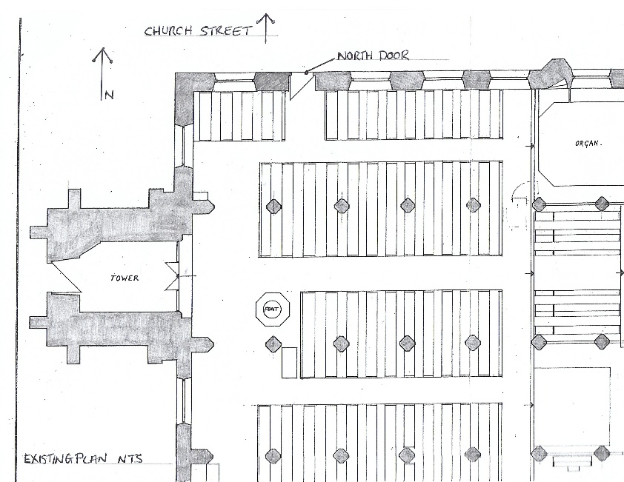

***Map*** *to demonstrate the orientation of the church, doors and relationship to Church Street.*

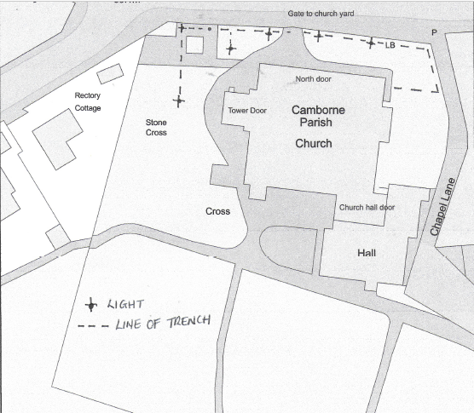

**Photos of existing doors.**

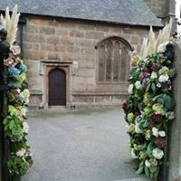 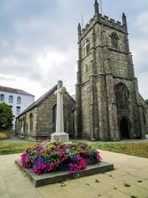

North Door Tower door

**The entrance & Accessibility**

For access we presently use the west door which is tucked around the corner near the church hall. It is not visible from the main thoroughfare and does not reflect the importance and architectural significance of this Grade 1 listed building.

**The Tower Door**

The Tower door is visible form Church Street and is presently used for weddings. When entering through the tower door you access the church via the central aisle, celebrating the grandeur and beauty of the church. The present opening is wide enough to allow wheel chair access. For all of these reasons the church will be returning to using the tower door as the main entrance.

**To light the way.**

To light the church so it becomes a beacon for the people of Camborne. Not only would we light the church to, encourage the community to come back into the church, but the colours of the lights can be changed to acknowledge important secular and non-secular events;

* Purple for Lent or Advent
* Green for ordinary times
* Pink for breast cancer
* Trevithick day or other town celebrations
* To compliment Christmas lights

We would like this beautiful Grade 1 church to become a beacon for the town. In the way that many places use prominent buildings to reflect the interest of the community it serves e.g. St Michael’s Mount or many churches or cathedrals. Below are some examples of beautifully lit churches.

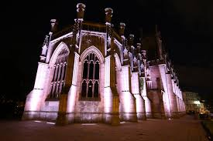 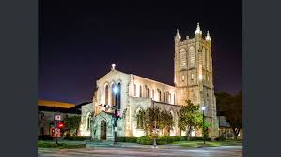

As shown on the plan the lighting will be positioned in the ground and aimed at the North elevation and the tower door. The Low level LED lighting will be faced away from neighbours so as not to cause a nuisance to the 3 houses on Rectory road, these houses are set lower than the church and are well shielded by the churchyard. The lights would be on a timer and would be turned off by 20.00 (or earlier if required).



**Lighting design**

Produced by Lavis Electrics, with Ansell lighting, schematic by Lighting designer, lighting the North elevation, tower door & war memorial.Lavis schematic showing the lights on the church and war memorial, the quote is now to have 2 lights on the war memorial.

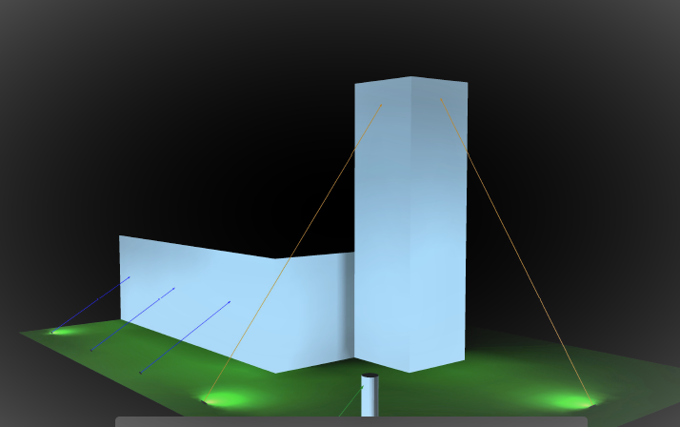

|  |  |
| --- | --- |
|  |  |

An example of the light fitting and anti - vandal cage, the anti - vandal cage is 400mm cubed.

**Ground works**

As per the heritage impact statement and above plan, a trench to run the cables in is required, this is 650mm deep and approx. 400mm wide and will carry an armoured cable, each light will be bolted to a cast concrete base (450 mm2).

**Public Consultation**

A public consultation was carried out, this involved information being sent out with the news sheets to the church community and boards being erected in the church explaining the scheme. No adverse comments or objections were received, many positive comments and encouragements were made.

**Summary**

To light up St Martin & Meriadoc Church, positioned on the entrance to Camborne Town so it may become a beacon for the town and community. Enhancing the buildings architectural features and Camborne Town, by installing a sympathetic lighting scheme.

All of the work required can be removed and the churchyard reinstated to its present condition if required, none of it has any permanent effect on the church or the monuments in its curtilage.

If planning is given the next step is to apply for a faculty.

**Links**

Church Faculty

<https://facultyonline.churchofengland.org/CHR/ChurchDetails.aspx?id=13489>

**Historic England**

Planning Guide - <https://historicengland.org.uk/advice/planning/planning-system/#Section1Text>

Camborne church (M&M) entry - <https://historicengland.org.uk/listing/the-list/list-entry/1142659>

|  |  |  |
| --- | --- | --- |
| Church website: www. <http://cambornecluster.org.uk/> |  |  |
| Part M building regulations. - <https://www.gov.uk/government/publications/access-to-and-use-of-buildings-approved-document-m>  Church of England lighting advice  <https://www.churchofengland.org/more/church-resources/churchcare/advice-and-guidance-church-buildings/lighting#main-nav> |  |  |