8th May 2021

9 St Andrews Close,
Haughton le Skerne
Darlington
DL1 2EB

Statement to support application

1. Beech – prune to remove major dead wood and crossing branches
3. Beech – fell to ground level
4. Beech – prune to remove 3 no. low branches encroaching on and touching neighbours house roof (see photo below)

The pruning of T1 and T4 is relatively minor in comparison to the overall size of the trees and well within the guidelines of British Standard 3998 – 2010.

The individual branches do not exceed one third of the stem from which they are being pruned and the total area of any wounds do not exceed one third the area of the stem when measured at 1.5 metre above ground level. The removal of the dead wood is a safety precauttion as the crowns of the trees overhang the adjacent footpath.

It is not known when any pruning was last carried out but little evidence remains of any major works and is estimated to be in excess of 5 years.
The intervening years will have allowed the trees to recover any reserves of starch that were depleted by the previous works.

The recommended pruning is not expected to have any long term ill effects on each tree and there are no further works planned.
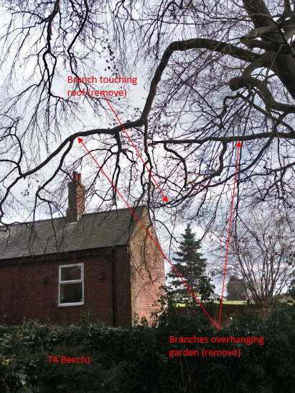

All tree work is to be undertaken in accordance with BS 3998 -2010
See diagram below:

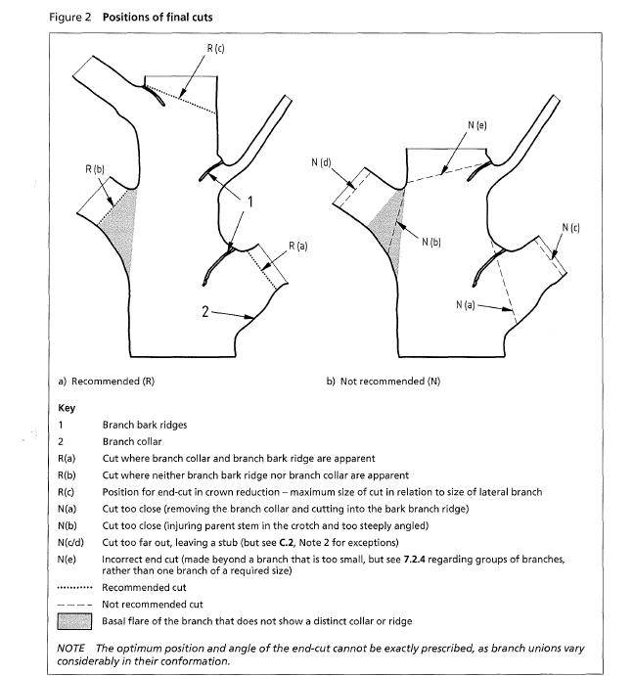

Tree 3 has evidence of infection by the Giant Polypore (Meripilus Giganteus) and due to the location of the adjacent property it is recommended that it is removed.
Meripilus signifies root damage and can be attributed to crown decline. In this case it brings into question the structural stability of the tree. (see photo below

