Dear Sir/Madam

Bromsgrove District Council
21/05/2021
Our Ref: NZP719CM
Title: The Electronic Communications Code (Conditions and restrictions) (Amendment) Regulations 2017 – BT intends to install fixed line broadband electronic communications apparatus at
TALL TREES, BITTELL ROAD, ALVECHURCH, BIRMINGHAM, B48 7BN
Under Regulation 5 of the above Code, I hereby give you 28 days’ notice informing you of our intention to install 1 x 9m wooden pole (7.3m above ground) at the above location. I enclose a copy of the plan indicating the approximate position for the proposed apparatus.
Grid ref: 402147273881-- ON SITE TALL TREES COMPOUND, BITTELL RD

Should you require further information with regard to the above works, please do not hesitate to contact me. Via e-mail coppersurveyprenoticing@openreach.co.uk
If no response is received within 28days we will assume deemed consent and proceed as planned
Kind Regards
Rita Lodhia

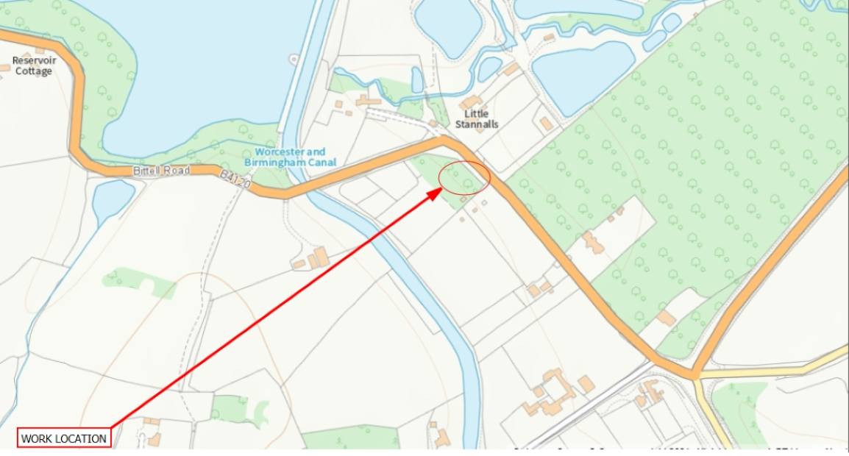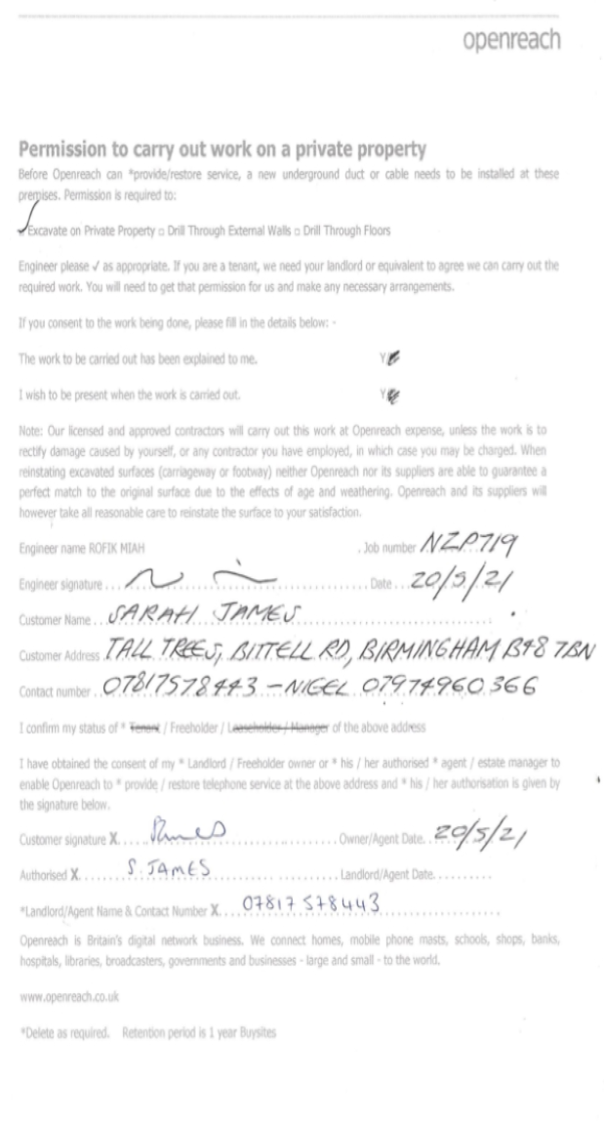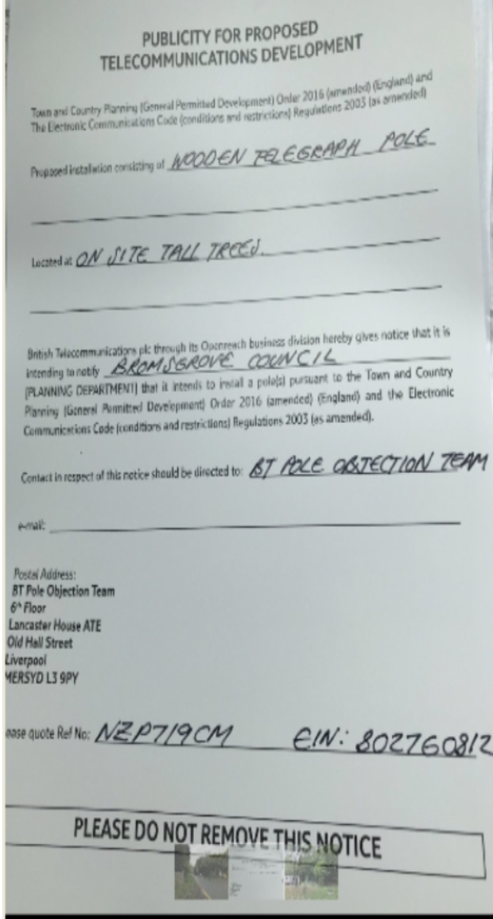

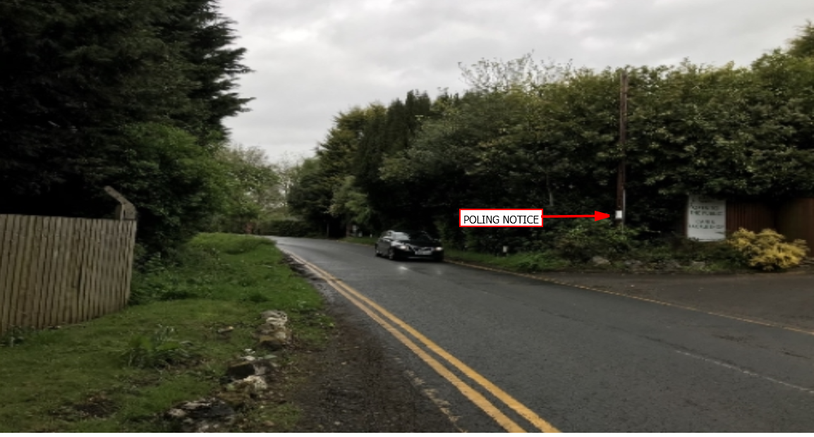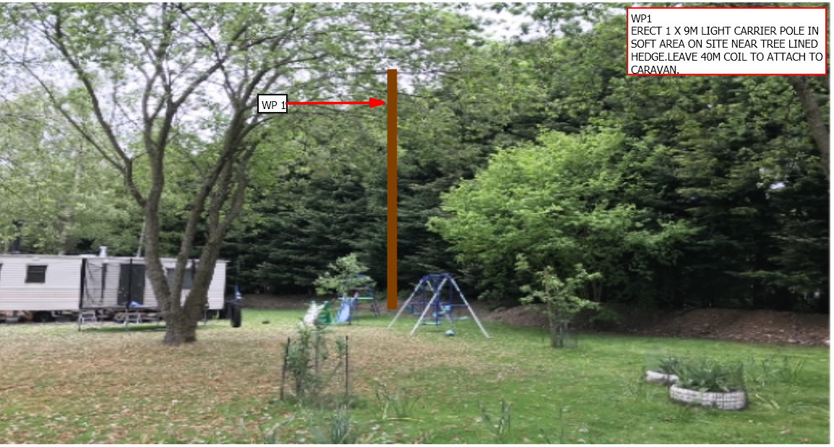
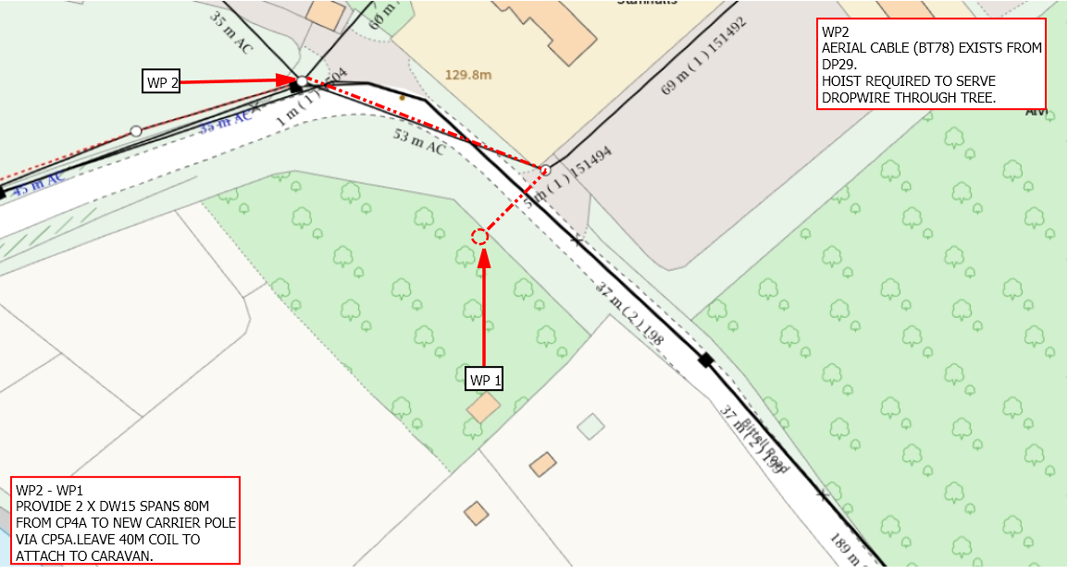

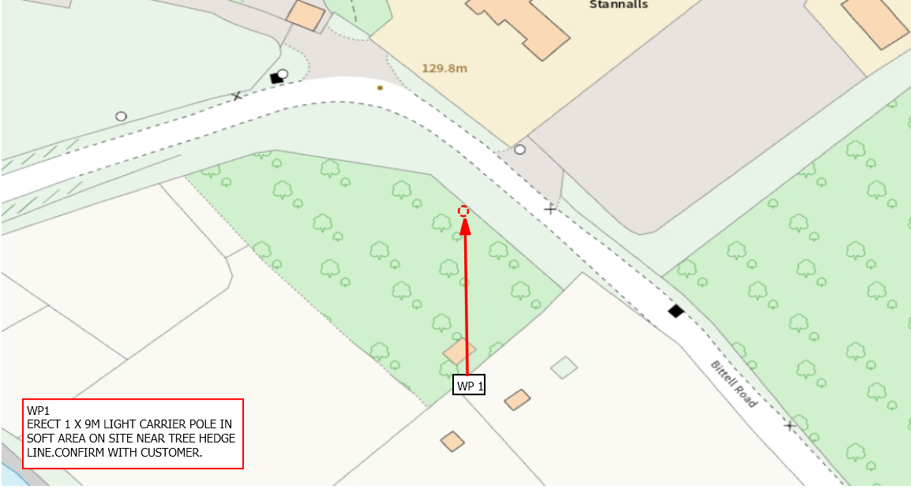

v

