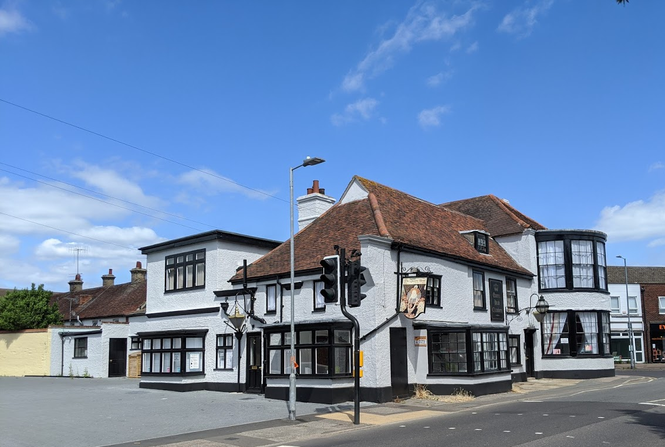
Spring 2021
Design & Access statement for
The Queens Head Chambers, 16 St Johns Road, Clacton.

Introduction.
The Queens Head Chambers was purchased by Earlwood following planning permission 18/00323/FUL
Change of use of ground floor to flexible use class A1 (non-food) retail or A2 financial and professional services or A3 restaurant or A5 hot food takeaway, first and second floors to one 2 bedroomed flat and one 3 bedroomed flat, erection of two detached houses and reconfiguration of car parking area.
As part of the permission a detail in the approved plans regarding adding a secondary insulated stud wall was taken as a concept and repeated in various areas of the building. The conversion works began with advice from a Building regulations company being followed, unfortunately said company were not versed in the protections afforded a Listed building. Unauthorised works were carried yet thankfully not at the expense of meaningful historic fabric.
This application seeks permission for the works carried out to be retained as it is argued they do not cause detrimental harm to the character or historic fabric of the building, being that the fabric of the building is not as old as once thought. This is explained in the accompanying Heritage report.
An oversite in the permission 18/00323/FUL left the ground floor with no toilet facilities as the existing toilet block was proposed to be altered to provide a bin and cycle store while a part of the building that was the old boiler house was not included in the application. Therefore, this application seeks to retain the existing toilet block whilst utilizing the ex-boiler room to provide cycle and bin storage amenity.
Use.
As within the approval, the Ground floor is for commercial use, the 1st floor consisting of two apartments and finally the 2nd floor provides storage for one of the apartments.
Size.
There is not change to the existing approved building just the inclusion of the ex-boiler that has a floor area of 12.183 m².
Layout.
The has not changed.
Landscaping.
The landscaping has not changed.
Appearance and Design.
The only changes to the appearance of the building relate to aspects of the fenestration that are dealt with in the Heritage report.
Access.
There are no changes to the previously approved access.

