Photo 1 showing 2 beech stems to be removed in group T7

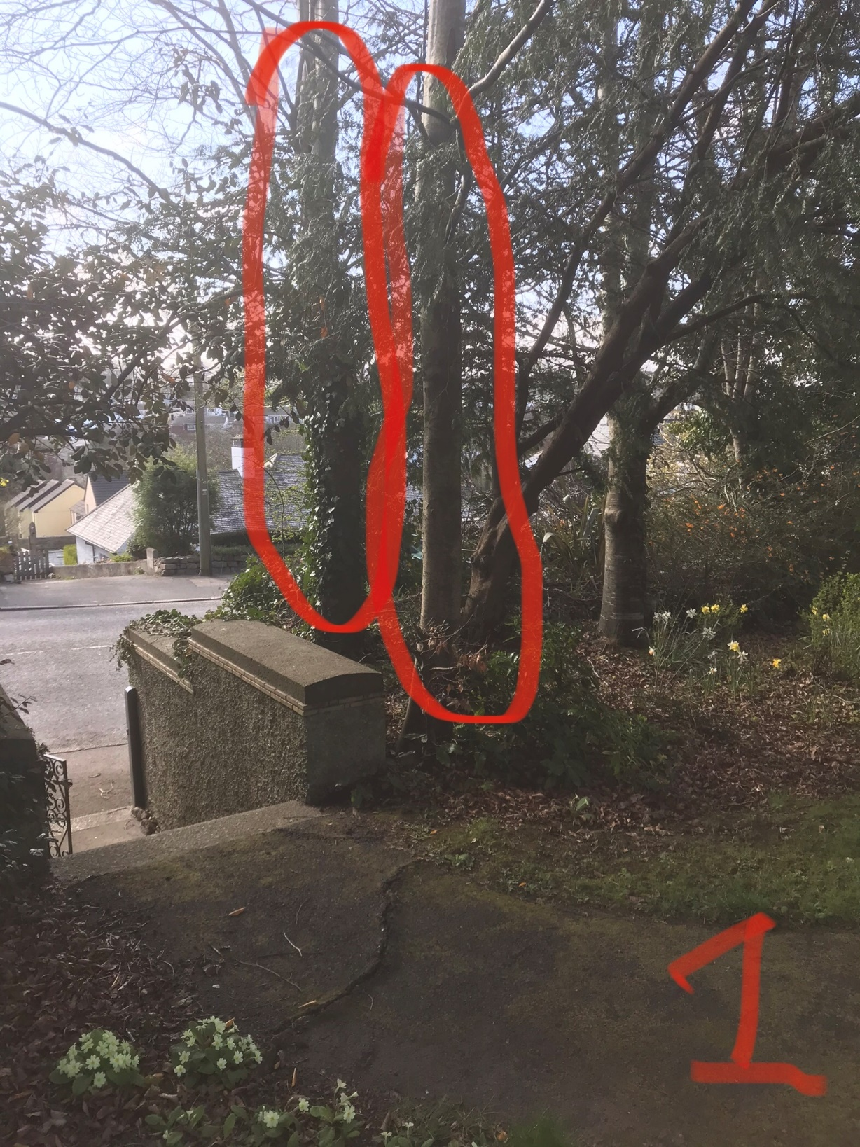

Photo 2 showing T6 sycamore stems to be removed leaving the stem in the middle not marked in red

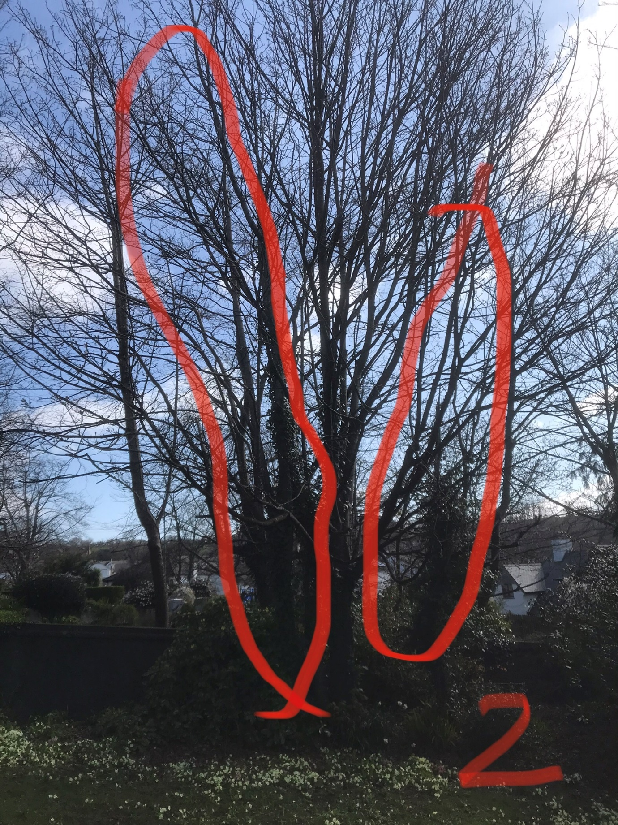

Photo 3 showing T4 and T5 the two beech trees to be removed because of their proximity to the property

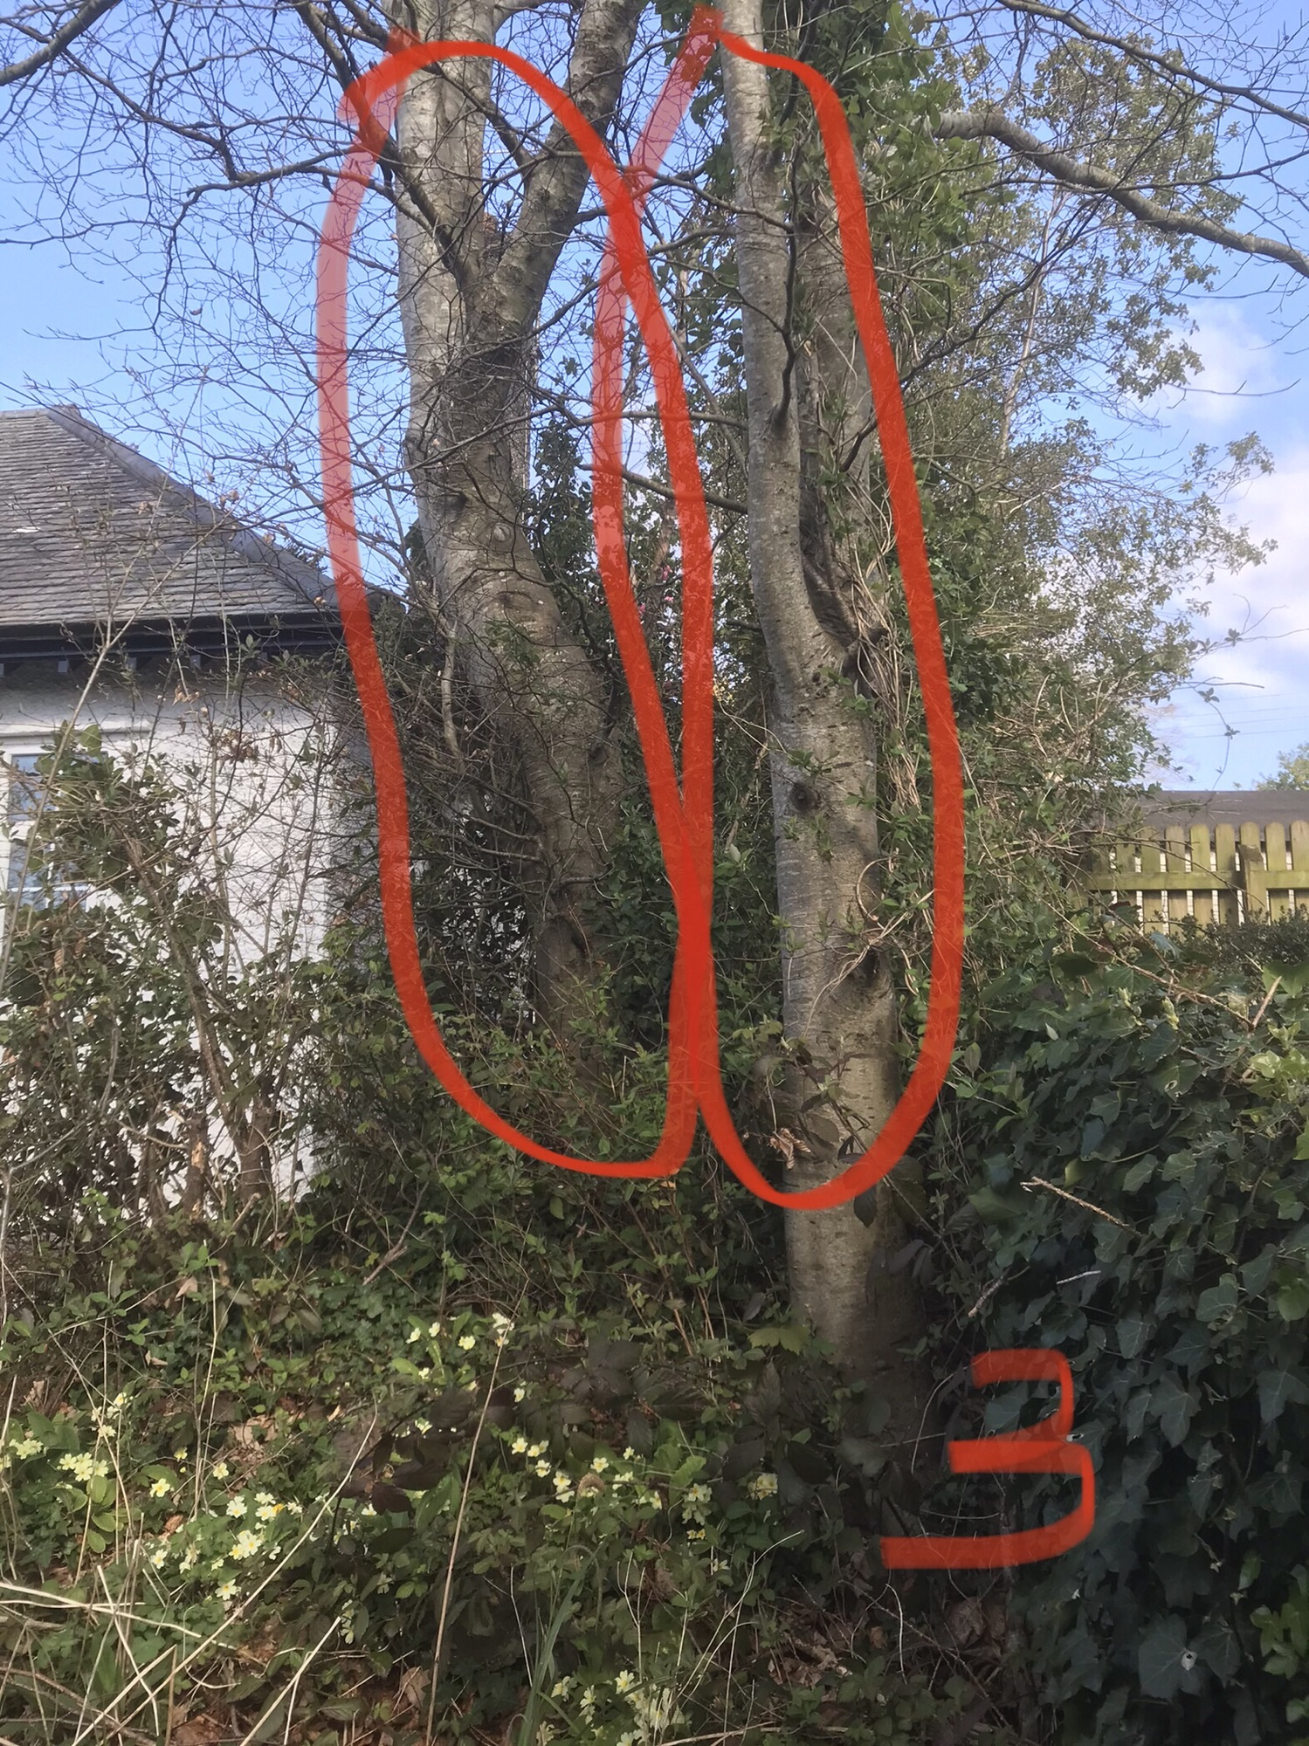

Photo 4 showing T2 dead rowan to be removed

