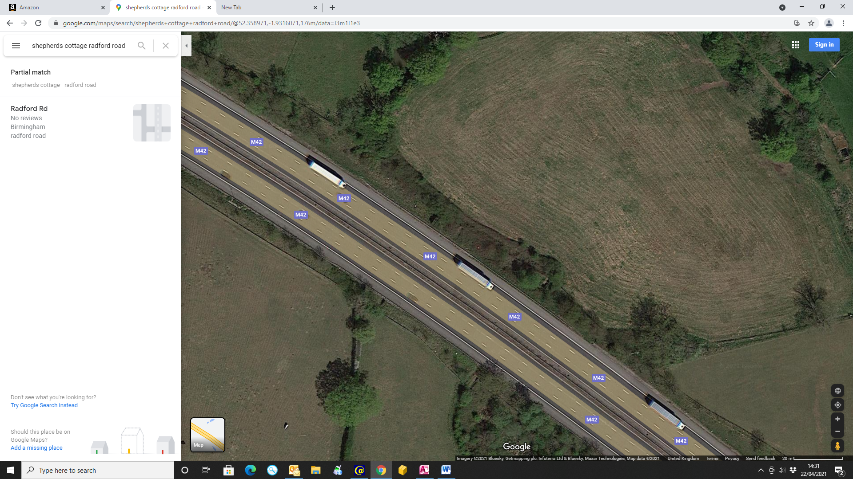

One bush

Here to here is just fence line and field

This tree will stay

This tree will stay

Here to here is just fence line and field