Planning Condition Discharge

Project : The Shaad - Swanley

The following seeks to discharge the conditions in connection with planning reference 20/1917/FUL

Below / Attached is the proposal in connection with Condition Nr 06 – Biodiversity

Bird & Bat Boxs

We propose the use of the following in connection with the above discharge of condition

Bird Box - 5.3.1 - Schwegler House Sparrow Brick Box Type 24

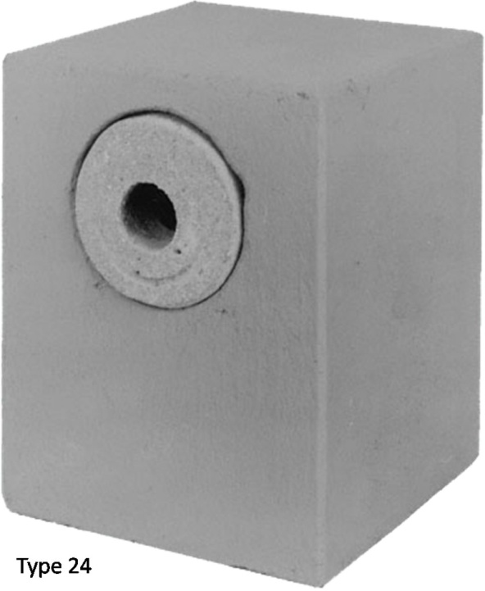

Bat Box - 5.3.2 - Schwegler 1FR Bat Tube

