Design and Access statement
Design
This application is for Listed Building Consent for the installation of 27 double glazed windows and 3 double glazed/wooden doors.
The Priory is a Grade II Listed building which was listed in 2001. The property is a detached brick building and stands in its own grounds of about 5 acres surrounded by mature gardens and woodland. The boundary to the public road has a stone wall with metal and wire fencing above.
The existing mainly single glazed wood windows will be replaced with wooden double glazed windows incorporating slimline double glazing units.
The 3 existing partially glazed wooden doors will also be replaced and will match the excess units with a mix of wooden panels and double glazing panels.
The wooden frames for the windows and doors will be made from grade A Accoya wooden frames which will provide rotten resistant, reduced maintenance, high performance windows.
Window Design
The proposed windows will be manufacture in Accoya software wood with slimline double glazed units. The new frames will be manufactured with the same profile, window pattern and layout as the existing windows.
Accoya is a high-performance, engineered wood which has been chosen for its exceptional quality for rot resistance, stability and very low thermal conductivity. The Accoya frames should last well in excess of 50 years.
The Accoya wood provides protection against shrinkage, swelling, jamming, insects and fungi damage means future repairs are kept to a minimum. Accoya also has superior thermal insulation compared to softwood thus reducing heat lost through the timber frames.
The glazing units will be high performance double glazed units filled with Krypton gas.
The glazing units will be made up of
4mm glass, 8mm Kryton gas, 4mm glass
The Kryton filled glazing units offer a slim unit preserving the aesthetics of the building while enhancing the insulation.
The new windows will have a u value of 1.1W/m²K
Note the existing, old single glazed windows will have a U valve in the order of 5.5 to 6. Added to this the poor fit, drafts, swelling and shrinking of the windows it will be a marked improvement to upgrade the windows
The new windows will be painted with a water based white paint which will match the existing look of the building.
The existing windows are a mix of single and double glazed units which are nearing the end of their useful life. Many of the windows were only installed in the early 2000’s when the property was updated. The soft wood frames are rotten with wood filler used to repair some of them.
The window openers are a poor fit which are difficult to open/close and are draughty.
The existing windows swell in the wet whether making them difficult to open and close.

Benefits of completing the work:

The new windows will have the following benefits for the property and for the environment.

- Improved Energy Efficiency
The new windows have greatly improved U values and reduced draughts.

- Improved environment
The new Accoya windows and doors will provide a stable window frame removing shrink/swell as thus will be easy to open and close.

Reduces Maintenance
New windows have water-based paints and durable Accoya frames which will reduce the environmental impact of the windows, reduced chemicals, waste etc.

The reduced maintenance will also remove Healthy and Safety risks associated with maintenance.

Reduced condensation
The improved thermally efficient windows will reduce the condensation problems which will improve the living environment within the house and benefit the structure if the house.

- Maintaining the Character of the house
Wooden Frames with slim glazing units will keep the look and charter of the house into the future.

Front View of Property Large ground floor window
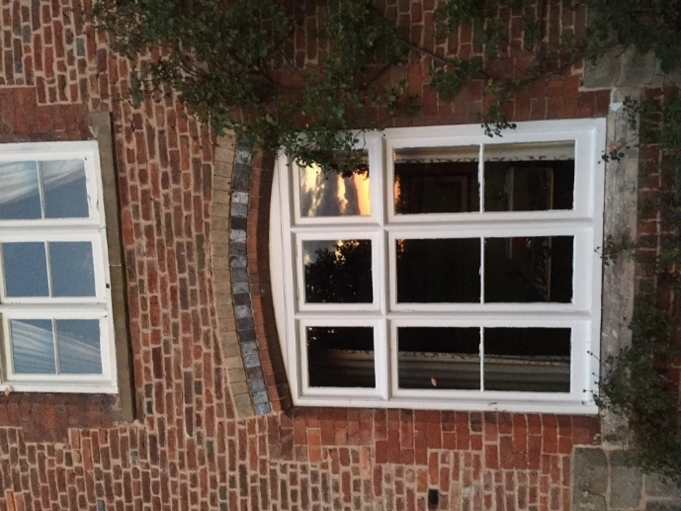
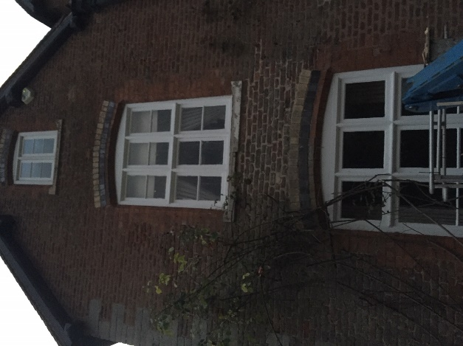

View of the Back of the house Arched Window in the Pool Room
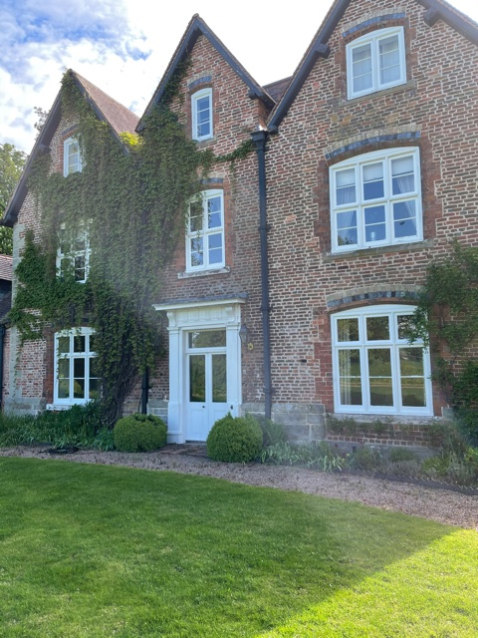
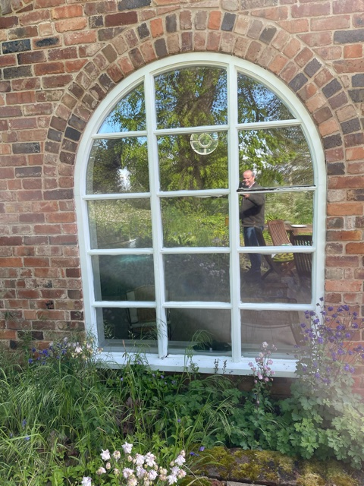

Window – External detail – the windows have a very simple external profile
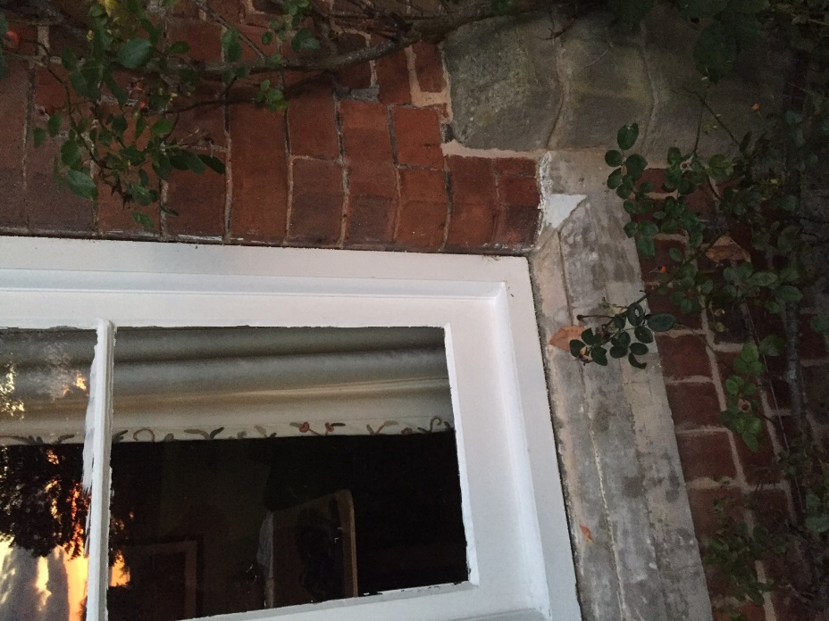

Window Internal detail – the internal profile will be matched in the new frames

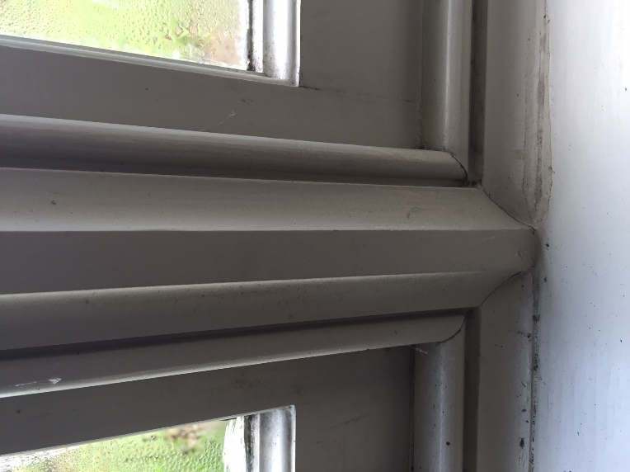

Existing Doors
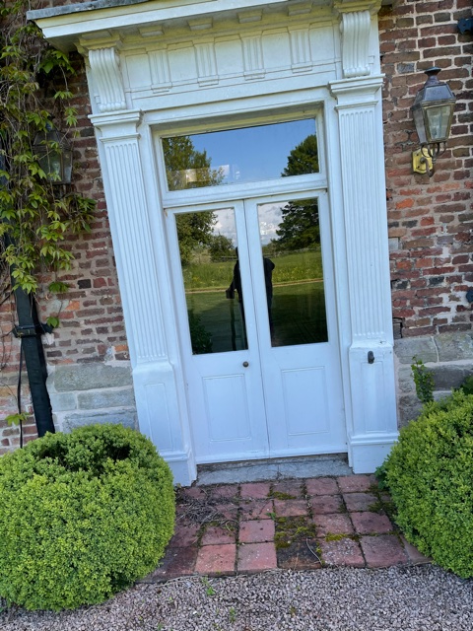
Back Door to the Old House

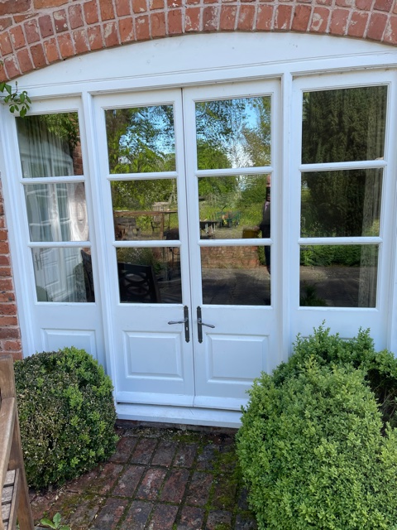
French Doors to Snug French Doors to the Pool Room

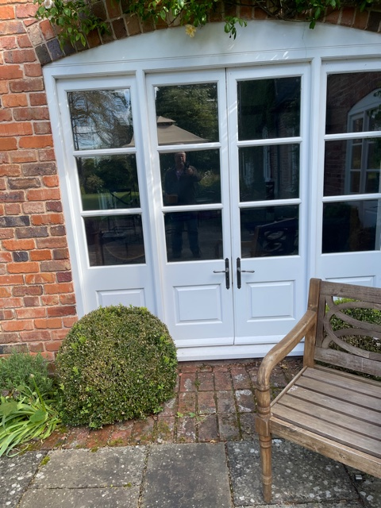

Typical New Window Design
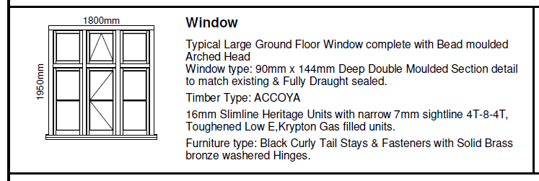

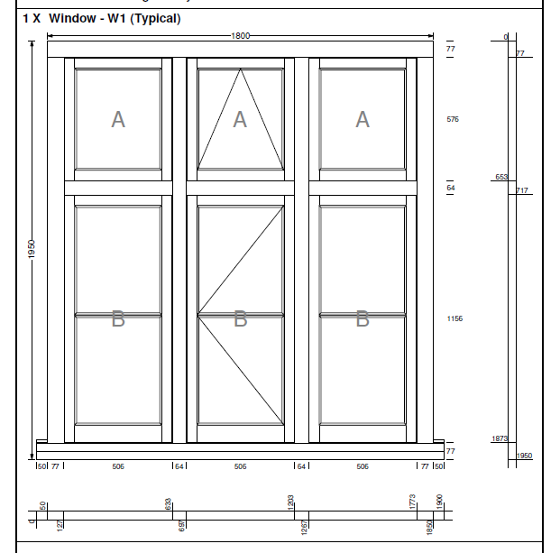

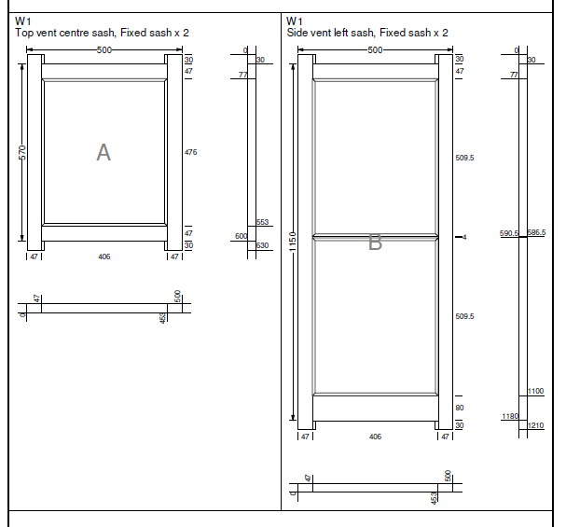

Detailed cross section of window frame

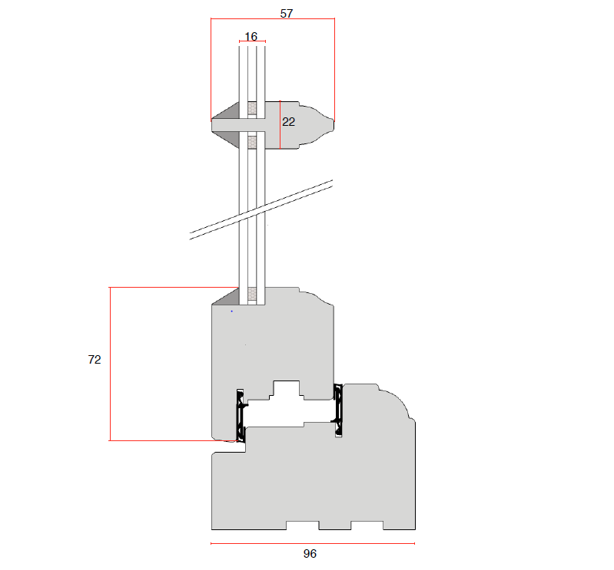
Access
The proposal modifications are for the installation of new windows and doors to the property and the existing access and lay down hard standing will be utilised. The works involves to delivery of the manufactured windows and doors which will be achieved by a van. The property has good vehicle access and the works will have no detrimental impact on the property, neighbours or general public.

