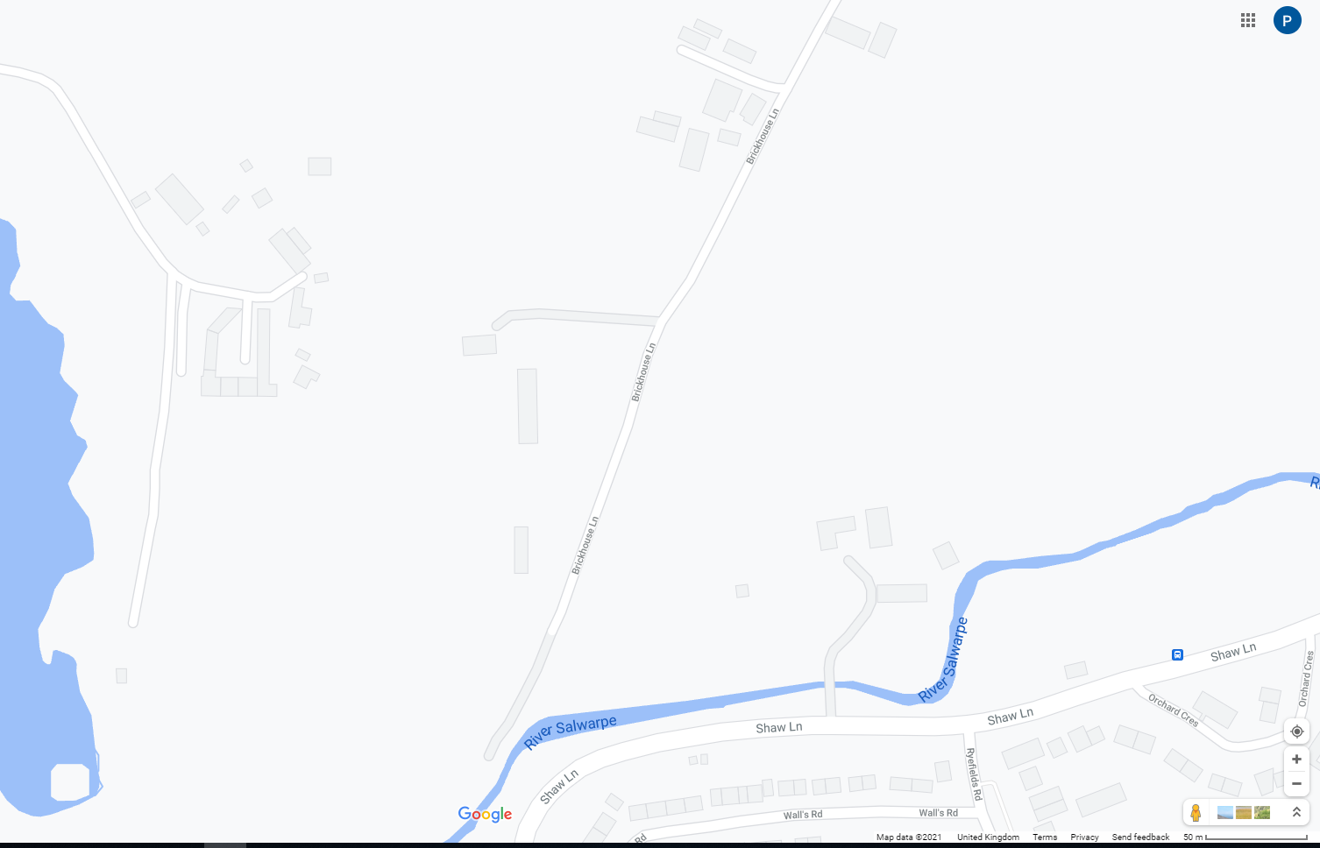

The Wagon House

50m |__________|

Moors Farm

Brickhouse Farm

North

Long Acre

(Recent barn conversion)

The Priory

Old Mill House

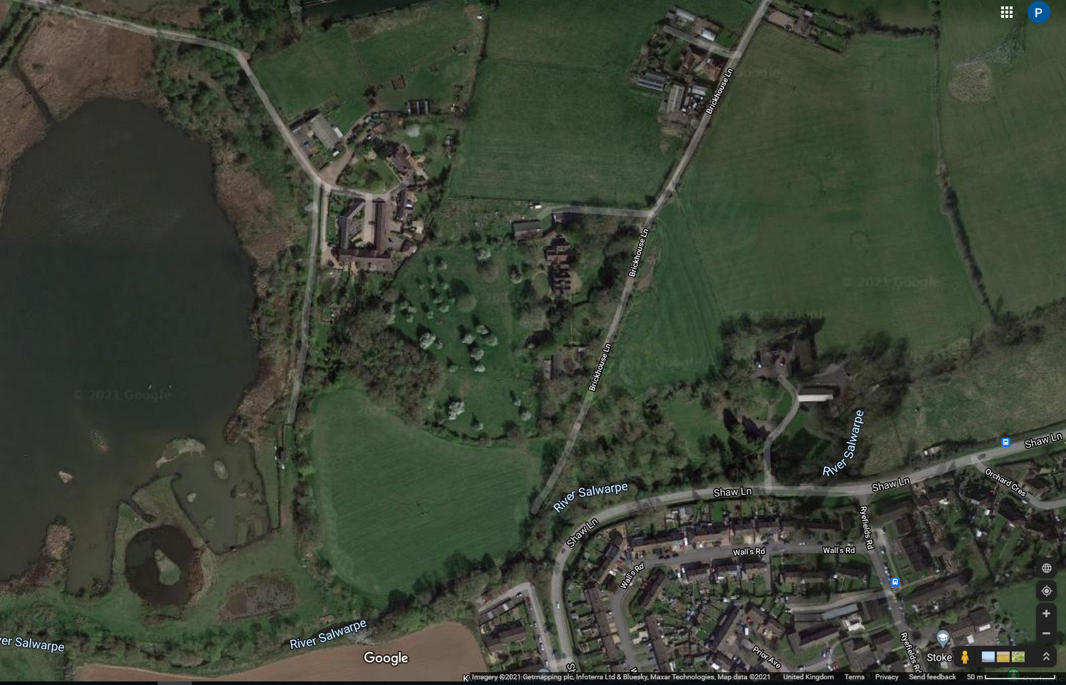

North

50m |________|

The Wagon House

Brickhouse Farm

Old Mill House

Long Acre

(Recent barn conversion)

The Priory

Moors Farm

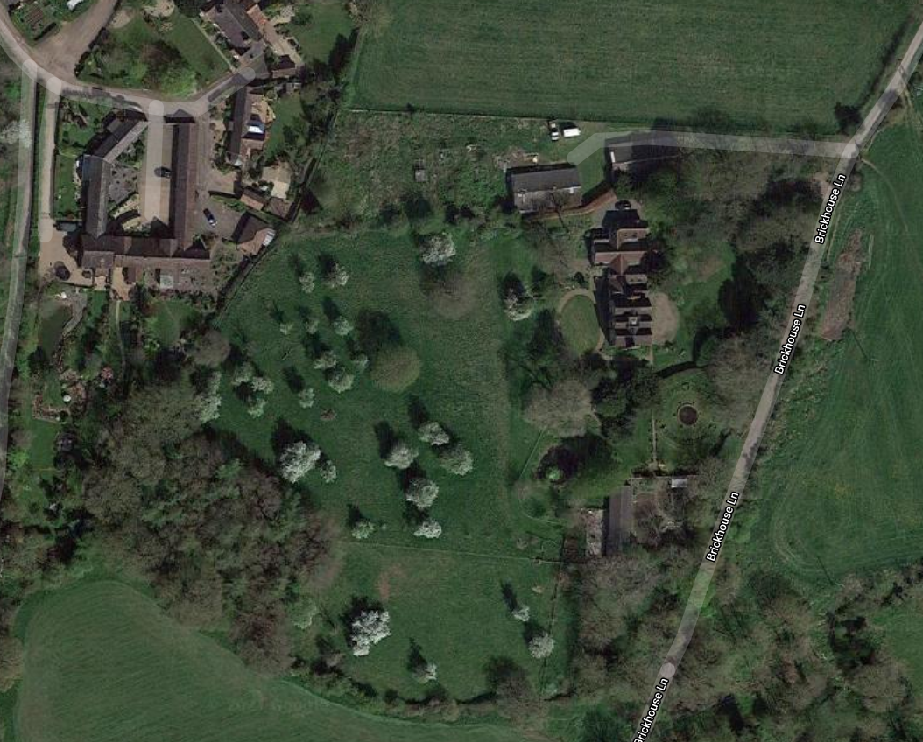

Orange outline details the garden boundary.

Formal Vegetable Garden

(Added circa 2005)

Workshop, 2 stables and small barn

Red outline details the property owned by me.

North

The Priory

Main House

Old Barn recently converted into new house (by others)