House Plan
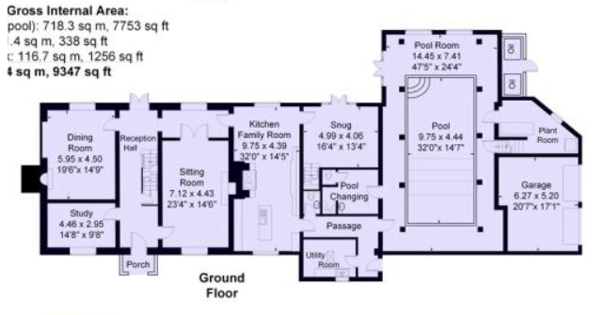
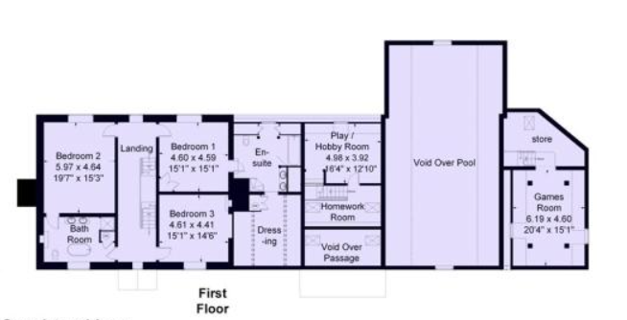

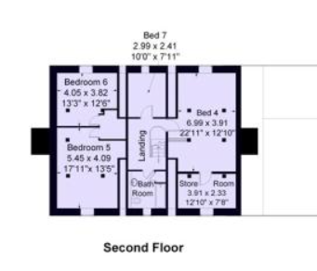

Property Listing Information

Coordinates
Latitude: 52.3057 / 52°18'20"N
Longitude: -2.0877 / 2°5'15"W
OS Eastings: 394118
OS Northings: 267509
OS Grid: SO941675
Mapcode National: GBR 2G9.F06
Mapcode Global: VH929.R9PT

Entry Name: The Priory Including Outbuildings Adjoining North
Listing Date: 26 June 2001
Grade: II
Source: Historic England
Source ID: 1389251
English Heritage Legacy ID: 487886
Location: Stoke Prior, Bromsgrove, Worcestershire, B60 4LY
County: Worcestershire
District: Bromsgrove
Civil Parish: Stoke
Traditional County: Worcestershire
Lieutenancy Area (Ceremonial County): Worcestershire
Church of England Parish: Stoke Prior, Wychbold and Upton Warren
Church of England Diocese: Worcester

Grade II Listing Text
1655/0/10033 BRICKHOUSE LANE
26-JUN-01 The Priory including outbuildings adjoining north
HOUSE. Circa mid-late C17; remodelled circa early and late C19. English bond red brick with sandstone plinth and quoins. Clay plain tile gabled roof. Large brick stacks at sides with sandstone quoins and original brick triple shafts.
PLAN: Central narrow stair hall with entrance at front and rear, study and dining room [parlour] on left [South] and drawing room [hall/kitchen] on right. Remodelled late C19 when single storey kitchen range was added on right [North] side with outbuildings, stables and coach house built around a small yard.
EXTERIOR: 2 storeys and attic. Symmetrical 3-bay gabled east front, the centre gable smaller; late C19 wooden 3-light mullion-transom windows in chamfered brick openings with polychrome brick cambered arches; attic windows are smaller 2-light casements, the centre of 1-light; central doorway with studded door, overlight with Gothic intersecting glazing bars and elaborate Victorian openwork timber porch. Rear [East] elevation is similar, but has pilastered central doorcase and glazed double doors. C19 single storey brick service and outbuilding ranges on north built around small courtyard.
INTERIOR: C17 moulded and chamfered ceiling beams and C17 roof structure. C18 and C19 joinery, including panelled doors, window shutters, chimneypieces and early C19 open-well staircase with stick balusters and mahogany handrail wreathed over curtail with column newel. Old plank doors and boarded partitions in attics.
Listing NGR: SO9411867509

