Design and Access Statement

For
Stables and Riding Arena at

Bridleway Barn
Branthill Farm
Belbroughton
DY99TT

June 2021

Location

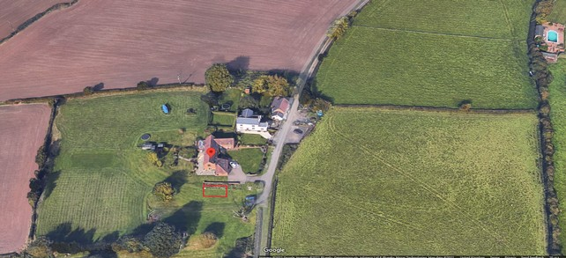
Fig 1. Site area annotated with a red box.

Site Overview.

The site is located at the end of a public bridleway South of Dark Lane, it has previously been used extensively as a racing stud and livery. In the 1980’s and 90’s Branthill Farm was used for the keeping of horses and livery. Prior to this horses were an integral part of the farm for many years. The previous owner, Mr Luther Bridge, was a successful race horse trainer and himself rode in the Grand National in 1956 & 1957. It is understood that the site hasn’t been used for a normal agricultural use since that time.
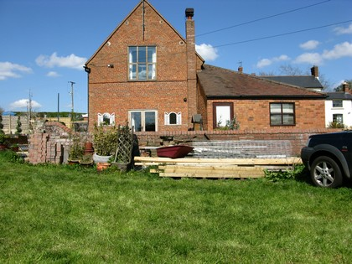
The site comprises approximately 6.9 acres in total and is in the Greenbelt.
Fig 2 site area looking north.
Proposal

To erect a small, single storey, wooden stable for equestrian use. The facilities will be for the personal use of the applicants family who reside at Bridleway Barn. The lawful use is understood to be equestrian but a request for change of use will be made to regularise this.
The fundamental aim of Green Belt policy is to prevent urban sprawl by keeping land permanently open; the essential characteristics of Green Belts are their openness and their permanence. Openness has a visual and a spatial dimension.
This application seeks to retain the openness of the Green Belt by keeping the scale small yet functional. This is also achieved by positioning the building in such a way to give a farmstead appearance, and reducing the levels to make the building less obtrusive.

This proposal replaces a previous application for “Construction of a storage barn for agricultural use and proposed stables' (reference 20/00711/FUL).

Use

The stable building will be used exclusively by the applicant for personal use to keep horses, store feed, bedding and utensils. At no time shall it be used for any commercial purpose whatsoever, including for livery, or in connection with equestrian tuition or leisure rides.

Movement

The applicant would not have occasion to visit the field using a vehicle, the only traffic would be occasional feed and bedding deliveries and visits by a vet or farrier.

Environmental Sustainability

JWS the suppliers of the timber building is a member of TRADA, all timber supplied is only from sustainable resources. Suppliers of their timber are members of the Timber Trade Federation and are signed up to The Environmental Code of Practice. The proposal is very small in scale and is an area with no vegetation except mown grass. There is no loss or impact to trees or hedges. Loss of habitat will be minimal, given the scale of the proposal and potential impact a Preliminary Ecological Appraisal has not been undertaken.

Landscaping

The proposed stables will occupy an area adjacent to the garden boundary, Fig 2, the area will have the levels reduced by up to one metre which will have the effect of making the building less obtrusive. It is the most ideal location on the whole site. No further landscaping is proposed except to make any newly formed slopes appear natural.
Character

We have kept the appearance as traditional as possible. The walls will be timber shiplap
boarding with a Tanalith finish which is very natural in colour and blends well generally.
The roof is proposed to be black corrugated Onduline sheeting which will look in keeping for this type of building in a farmstead style setting.

Access

Access will be made to the site very occasionally, the only traffic would be feed and bedding deliveries and visits by a vet or farrier. The current access is safe and does not lead directly from the highway. No highway issues are anticipated.

Policy

The application site is located within the Green Belt. Paragraph 145 of the National Planning Policy Framework and Policy BDP4 of the Bromsgrove District Plan set out that the construction of new buildings is inappropriate development in the Green Belt, subject to a number of exceptions. One of these exceptions is 'the provision of appropriate facilities (in connection with the existing use of land or a change of use) for outdoor sport, outdoor recreation...;as long as the facilities preserve the openness of the Green Belt and do not conflict with the purposes of including land within it.' This is supported by Policy BDP15.

Assessment

This application seeks to meet the test for being an appropriate development and to preserve the openness of the Green Belt. We feel this meets the exception the provision of appropriate facilities for outdoor sport or outdoor recreation. The scale has been kept very small, considerably smaller than the original plans submitted with a pre-app.

Drainage

The soils in the vicinity of the site are classed as Soilscape 6 which are recognised freely draining slightly acid loamy soils. An effective attenuation cell will be installed to allow infiltration of the small amount of surface water produced.

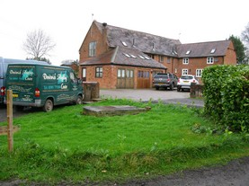
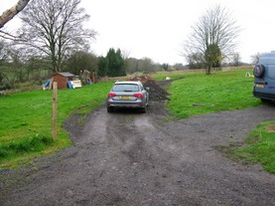

Bridleway Barn. Access track from the bridleway.

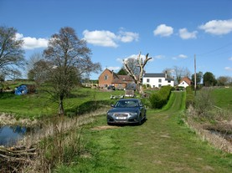
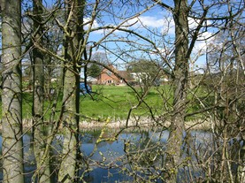

Site viewed from from bridleway. Viewed from across the lake.

Preservation of existing trees.

Justification of root protection area.
Tree | Single Stem Equivalent Diameter in mm | Protection Area in mm
T1 | 586 | 7037

All existing trees and hedges will be preserved, tree T1 will have the root protection area fenced during construction work to stop equipment and materials entering the protection area to prevent root damage.

