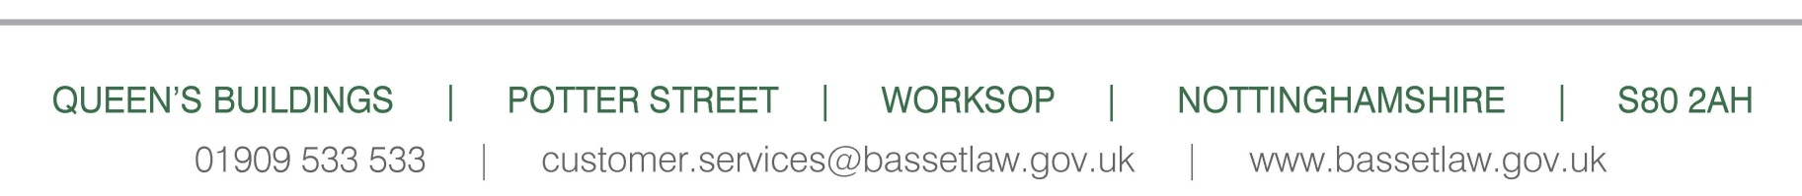

|  |  |
| --- | --- |
| Megan Wilson  Avant Homes (Central)  Unit C3 & C4  Holmewood Business Park  Chesterfield  S42 5US | Our Ref:21/00877/NMA  Officer: Jamie Elliott  Email: [planning@bassetlaw.gov.uk](mailto:planning@bassetlaw.gov.uk)  10 June 2021 |

Dear Sirs,

|  |  |
| --- | --- |
| **Location** | Land To The North East Of North Road Retford Nottinghamshire |
| **Proposal** | Non Material Amendment of P.A. 20/01477/RES to Replace Approved Brick Selection |

I refer to the above application for which was granted conditionally on 15 March 2021 and to your application for a non-material amendment received on 3 June 2020.

On the basis of the information submitted, I can confirm that the proposed substitution of facing bricks to be used in the above development, would not materially alter the scheme permitted under planning application reference number 20/01477/RES. As such, the submission of a further full planning application will not be required in this instance.

Please be aware that the Council has now adopted its Community Infrastructure Levy (CIL) charging schedule, which applies to all applications **determined** after 1 September 2013 **regardless of when they were submitted**. The CIL is a charge that local authorities in England and Wales can require of most types of new development in their area (based on £X per sqm of floor space), in order to pay for the infrastructure needed to support development. CIL charges are based on the size, type and location of the development proposed. Where applicable (please note that there are exceptions) all net increases in floor space for residential, some commercial and retail developments will have to pay a CIL charge. For more details, please visit:

[www.bassetlaw.gov.uk/planning-and-building/planning-services/community-infrastructure-levy/](http://www.bassetlaw.gov.uk/planning-and-building/planning-services/community-infrastructure-levy/)

Please note that planning applications which are refused prior to 1st September 2013 but which are subsequently approved on appeal after this date may be liable for CIL.

Yours faithfully



Development Team Manager