PROPOSED HOUSE TO NORTH OF LARG GHRU, CORRIEGILLS, ISLE OF ARRAN
DESIGN STATEMENT
This design statement accompanies an application for planning permission for the erection of a detached house to the North of Larig Ghru in Corriegills, Isle of Arran.
Planning permission was granted for the erection of two semi-detached houses in 2013 (reference 13/00652/PP) on this site, as well as conversion of an existing piggery to the South-West. The piggery building has since been demolished and the proposed house sits in the same location as the two approved semi-detached houses.
The site is a gap site, sitting between two existing houses at the end of a number of houses, which form a nucleated group of 4 existing dwellings. As well as its previous planning history, therefore, the proposal is consistent with paragraph i) in the Countryside Objective in Strategic Policy 1 of the Adopted Local development Plan for North Ayrshire.
The properties on either side are bungalows whereas the applicants wish to erect a single storey house, with accommodation in the roof space, in a very traditional style, more in keeping with the local vernacular, finished with white wetdash render and traditionally style white windows with architectural dressings.
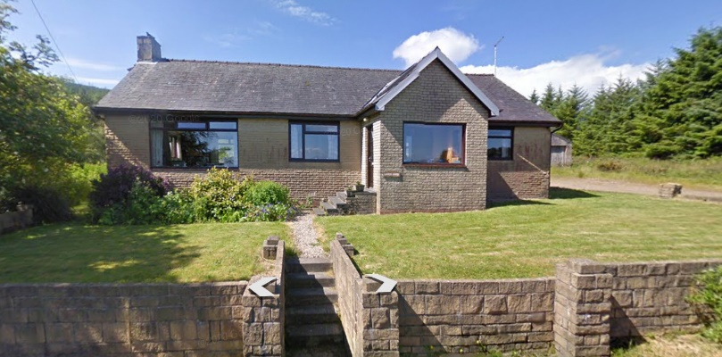 Larig Ghru to South of application site
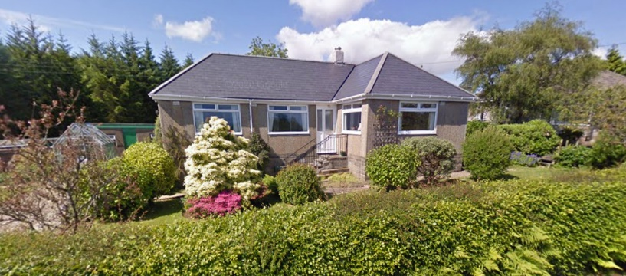 Alt Na Feuran to North of application site
The proposal therefore accord with Local Plan policy and is an appropriate architectural solution embodying traditional local architectural features and style.

John Lamb
June, 2021

