Substance Location Plan
Unit 1, Stadium Court
AREA 5 HA
SCALE 1:1250 on A4
CENTRE COORDINATES: 335541, 382636
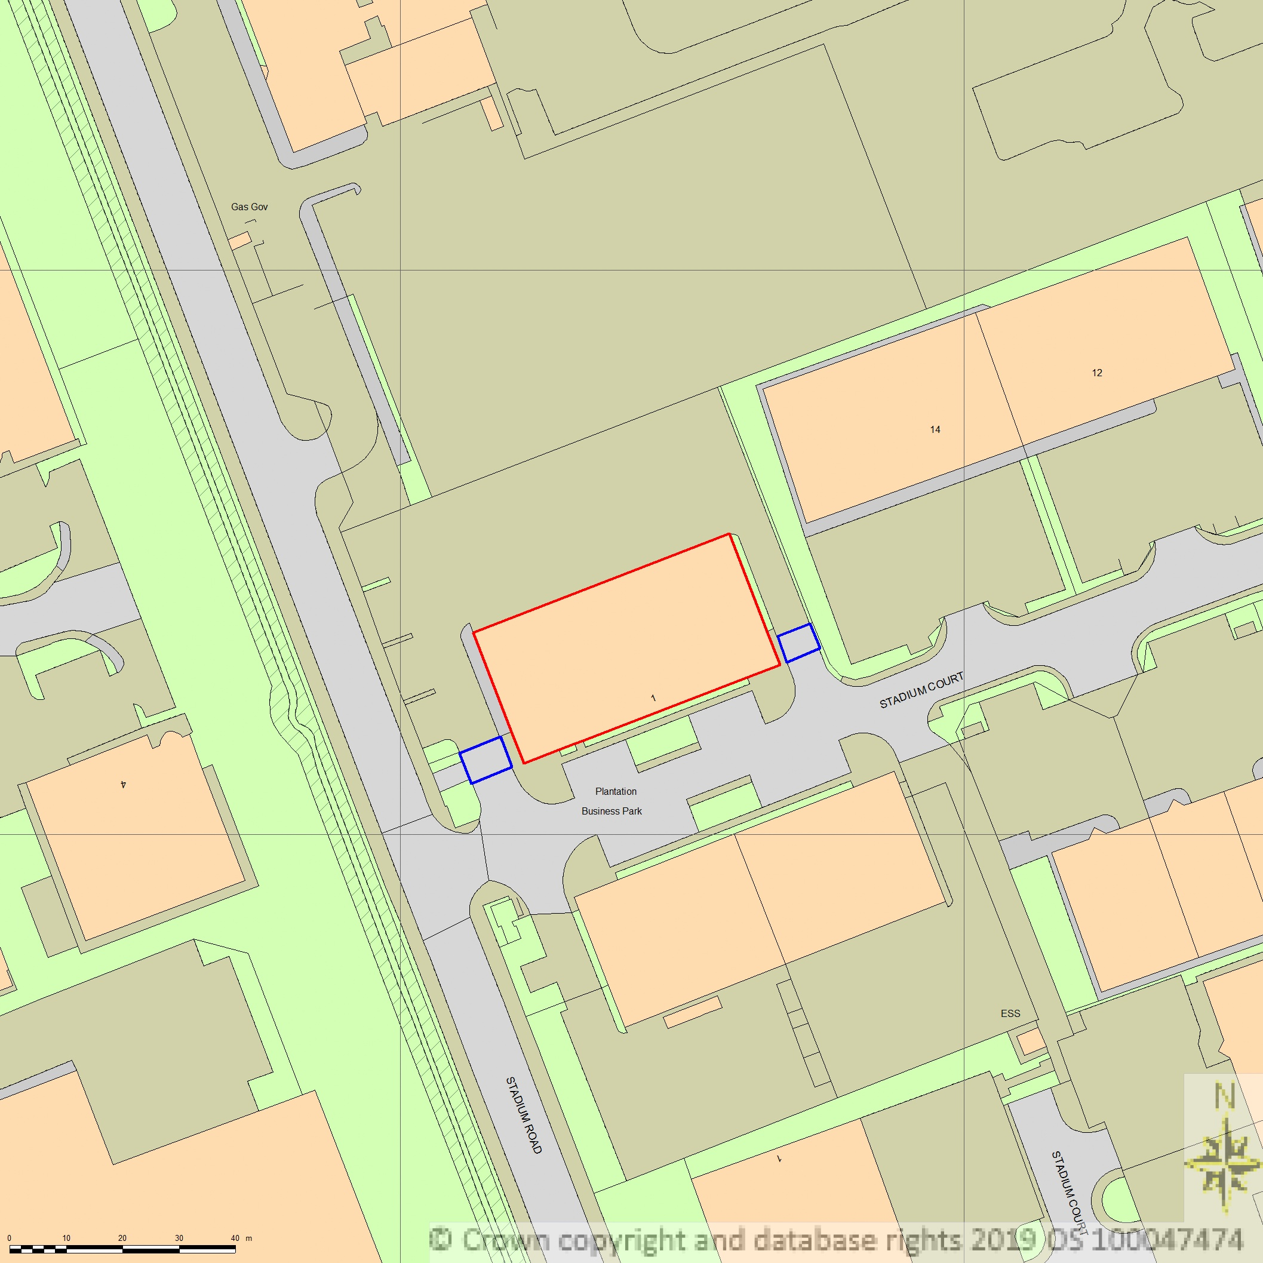

- Proposed Location of essential oils storage

- Access points to and from the land



Supplied by Streetwise Maps Ltd
www.streetwise.net
Licence No: 100047474

