Site Map Showing location of Ungerer Ltd Warehouse

CENTRE COORDINATES: 335541, 382636

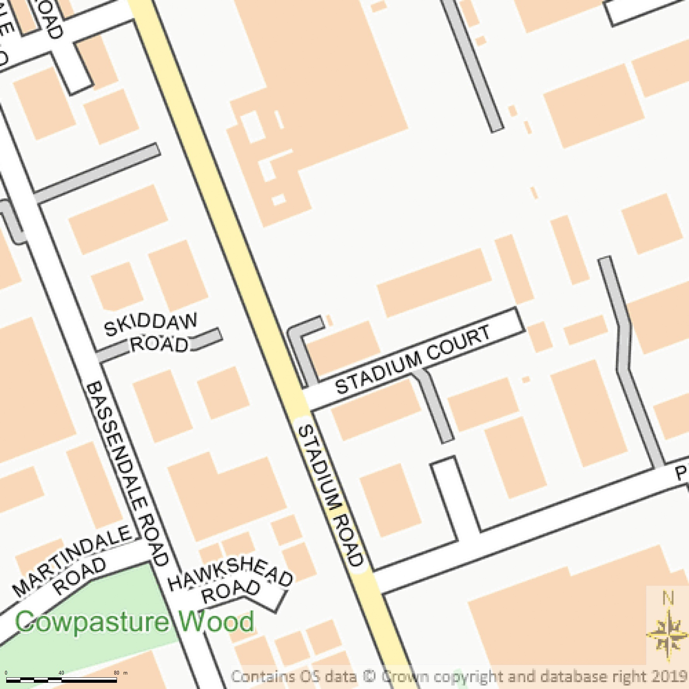



Supplied by Streetwise Maps Ltd
www.streetwise.net
Licence No: 100047474

