Removal of existing uPVC Door and Side Screen.

Remove existing door and side screen and replace with uPVC sliding sash window to match those to be fitted on the front (eastern) elevation of cottage

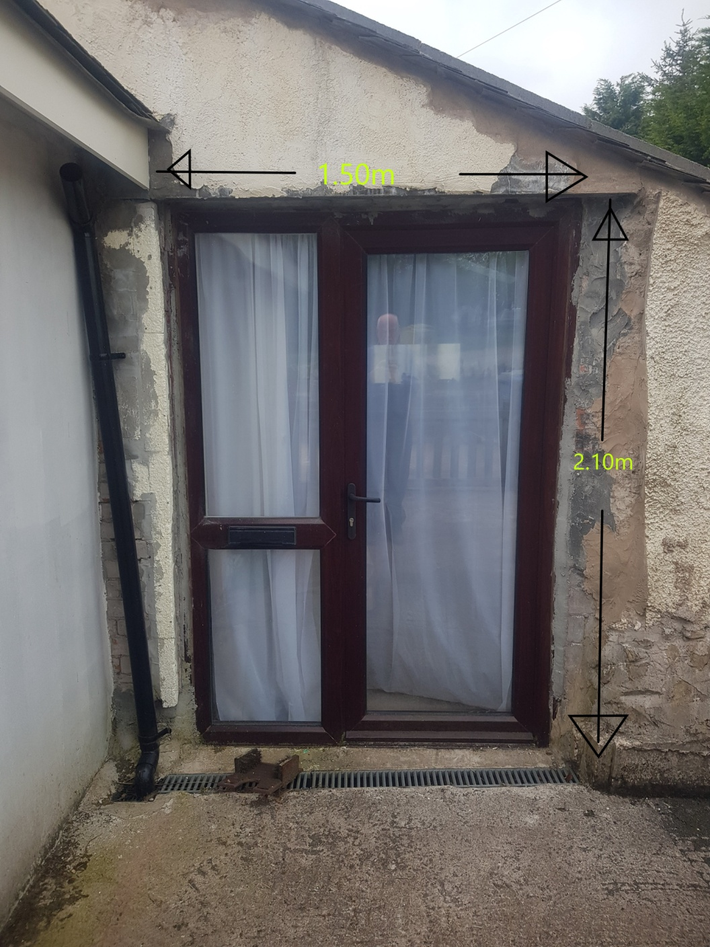

Existing opening to be reduced in size to approximately 800mm x 1100mm and a uPVC sliding sash window fitted to match style as shown in photo below with stone/ block infill and cement rendered to match existing.

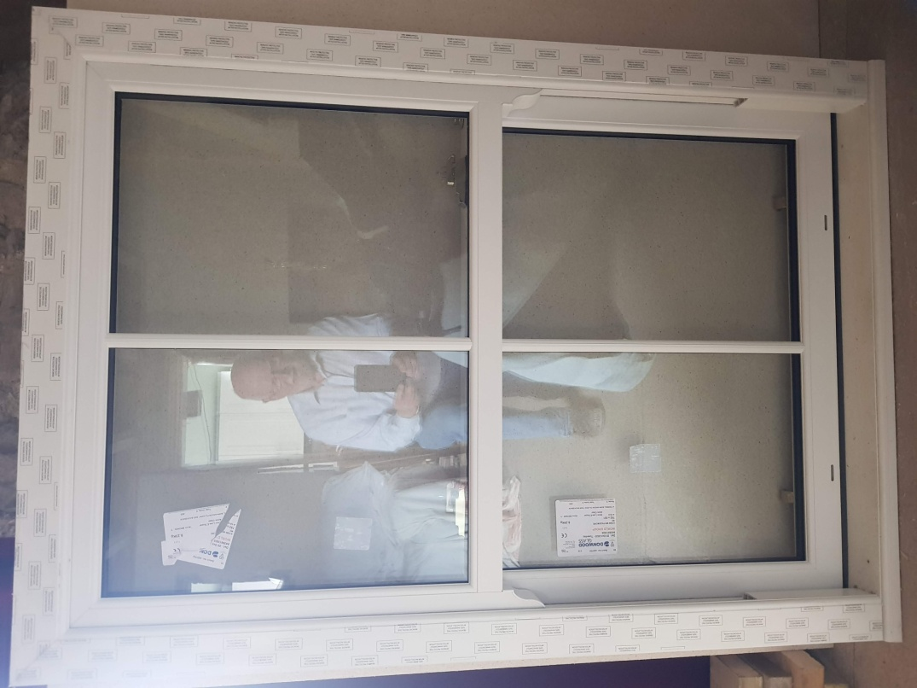

Please note there is an existing door to the utility area adjacent to the door being removed.

