1 Curfew Place Leadhills – Proposed Replacement Gates

The existing double gate (4.3m wide x 0.9m high) with adjoining pedestrian gate (0.9m wide x 0.9m high) are of lightweight construction and unfit for purpose.

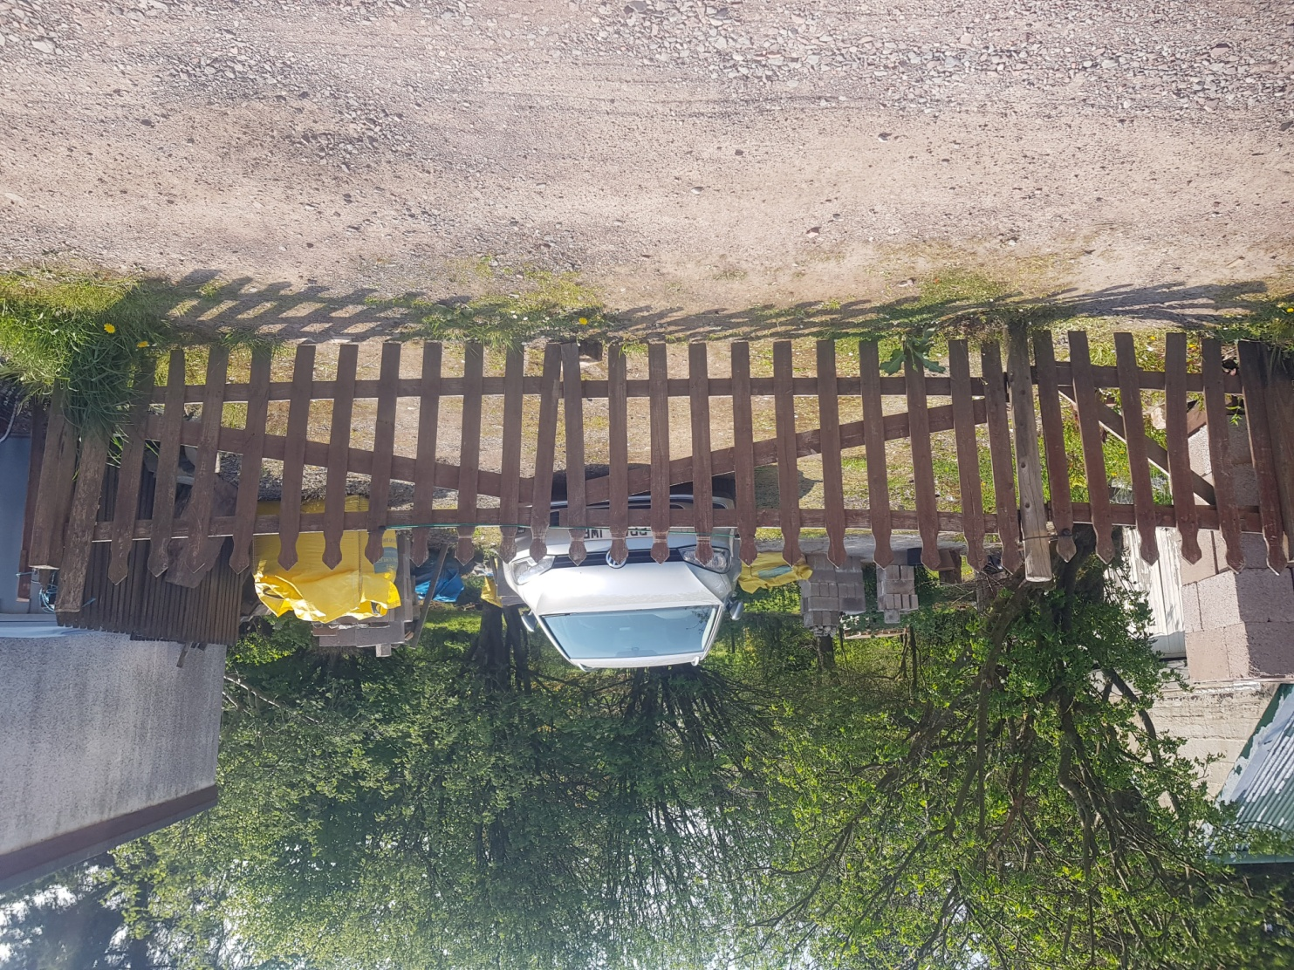

Proposal is to replace with timber field gates in style similar to photos below. Double gate will be 4.2 m wide x 1.2 m high with pedestrian gate 0.9m wide x 1.2 m high. Gates will be mounted to suitable heavy duty timber gate posts concreted into ground.

