- Retrospective permission to replace flat roof
A small section of flat felted roof to the northwest corner of cottage has been replaced with a pitched slated to match existing roof pitches. This work was carried out in August/September last year to prevent potential water ingress due to the poor condition of the felted roof. Planning permission was not sought at that time due to Covid 19 and the obvious delay in gaining planning approval as a result. See photos

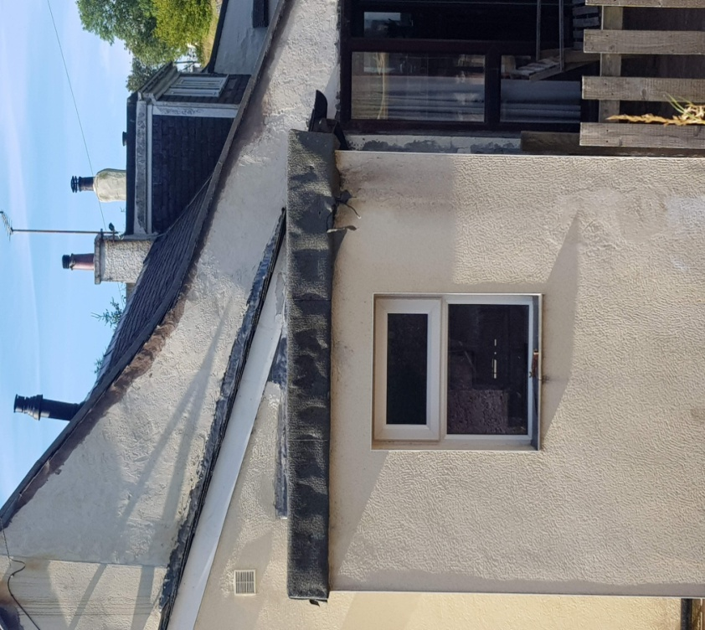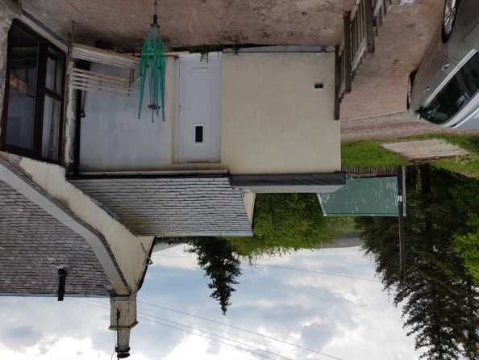

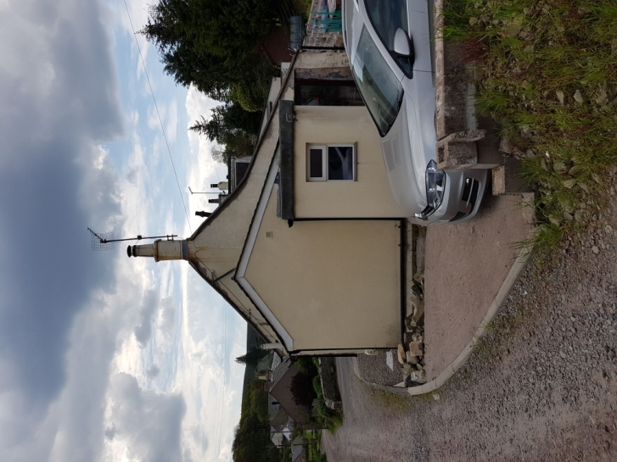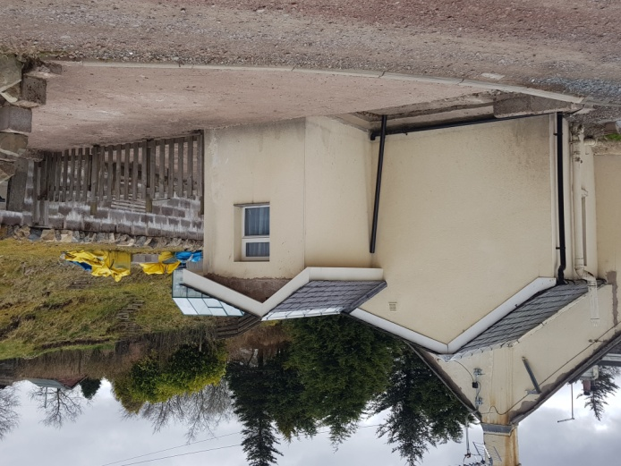

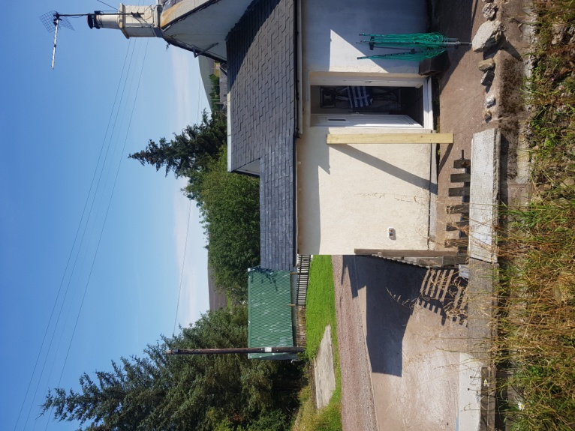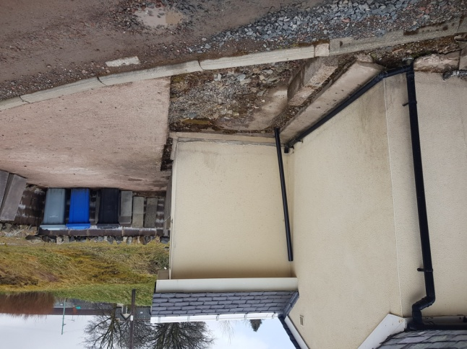

11.Erection of fence
Erection of agricultural fence approximately 1.1m high to land boundary to the north of workshop/store. See Plan FW1 showing position. This will comprise timber straining and line posts with galvanised Rylock and line wires similar to photo attached. This fence will be supplanted by the planting of natural hedging with hardy varieties such as Beech, Laurel, Fuchsia, and Hawthorn to give appearance of field hedging.

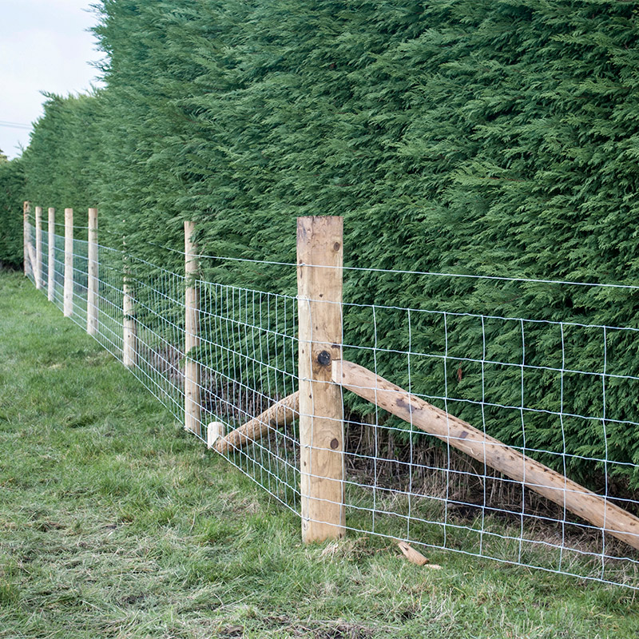

12.Bin Store
Erection of screen fence and gate to “hide” the 3 refuse/recycling bins approximately 0.9mx 2.0m x1.1m high. This will be constructed in the north east corner of the cottage as shown on plan and comprise timber posts, rails and vertical slats to screen bins from passersby and additionally protect wall of cottage from muddy splashes from water filled potholes. See Plan B1 shown red.

13.Replacement of gates
Replace existing double and single gates with timber field gates in a similar style as shown in photos.

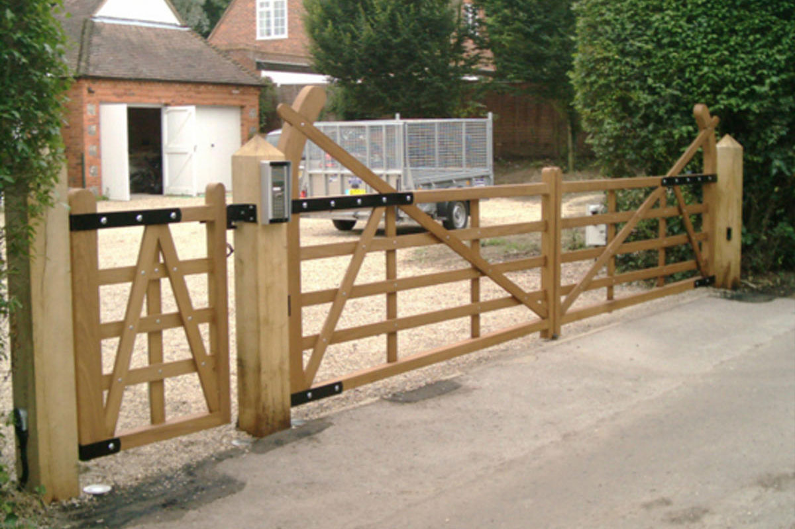

14.LPG gas tank shielding wall.
The existing gas tank which has been in its current location for over 30 years ( a replacement tank was supplied by my gas provider in April 2020 on a new level base in the original position. (See photos) I was advised at that time that to comply with current LPG regulations a solid concrete wall would be required on the northern boundary to a height of the valve on top of the tank (1.2m) This wall will be constructed of 215mm concrete blocks bag rubbed with mortar and painted in a pastel colour and capped with local stone coping to match that to the north and west of the cottage see Plan FW1. The wall will return on the road side toward the gate at a reduce height to replace the disintegrating stone wall approximately 300mm high. This wall will be topped with a timber pale fence to a height to match to block wall.
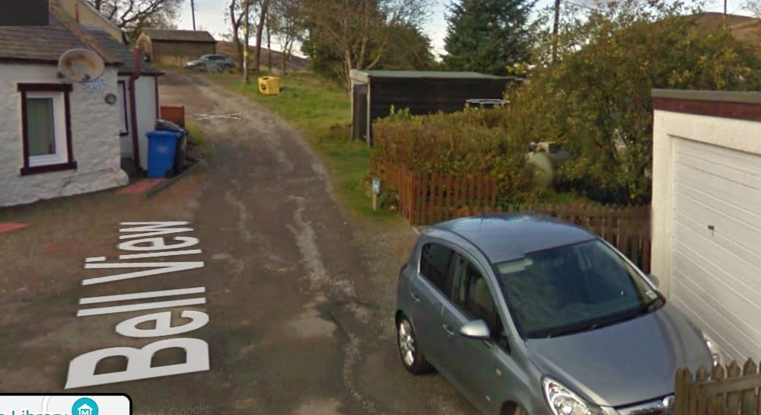

Google Earth photo 2010

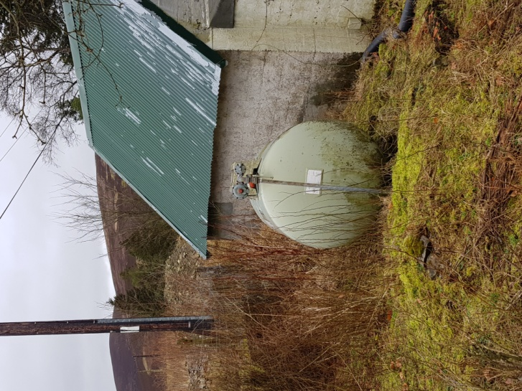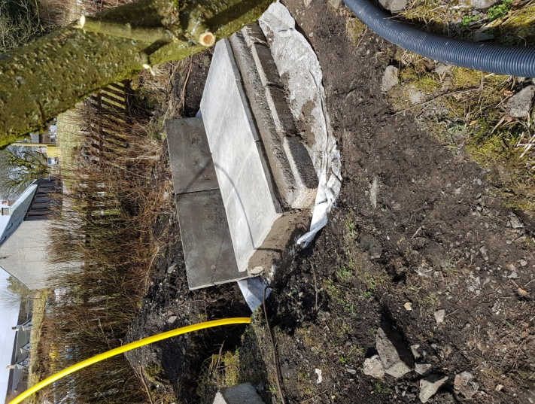

Original tank on failed base New base in same location

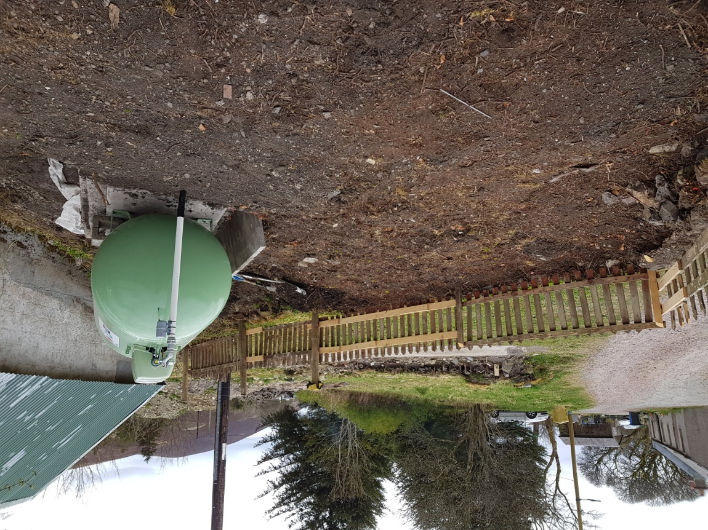

Replacement tank on new base connected to existing pipe.

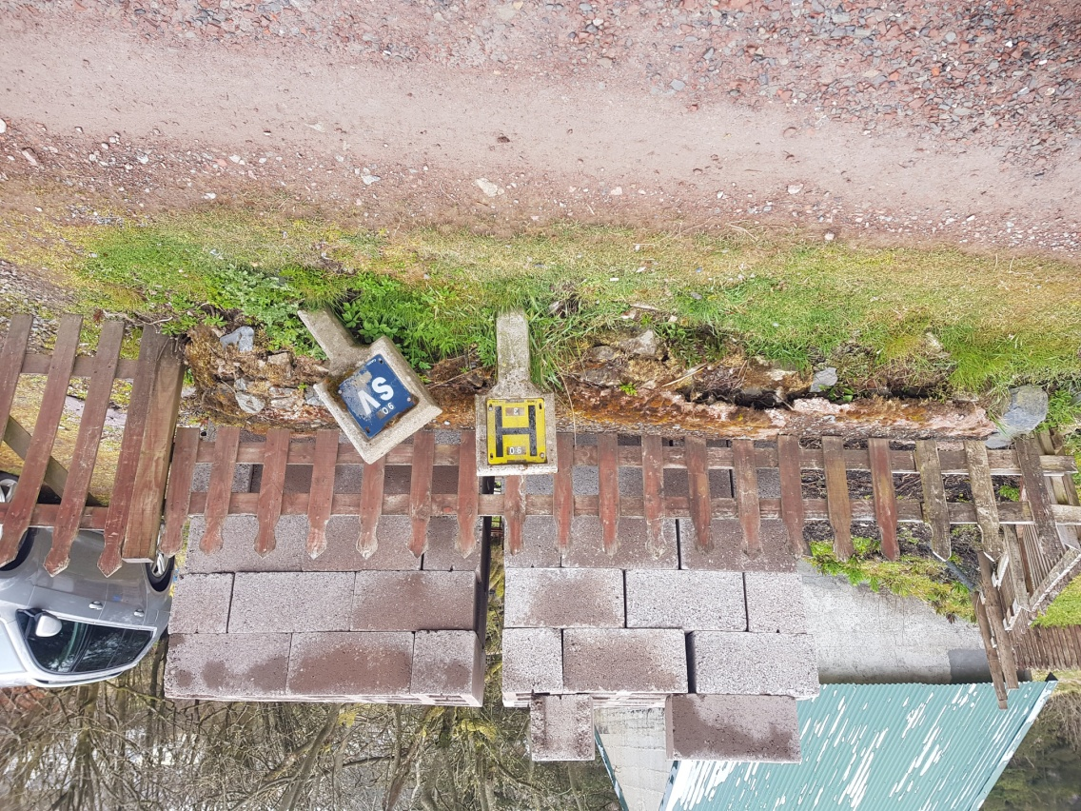

300mm high wall to be replaced with block wall and fence

15.Removal of Laburnum tree.
Existing Laburnum tree to be removed to comply with LPG regulations relating to proximity of combustible material and to facilitate Workshop extension. Additionally it is very close to existing foul drain running to septic tank. Position marked on tree site plan. See photo below

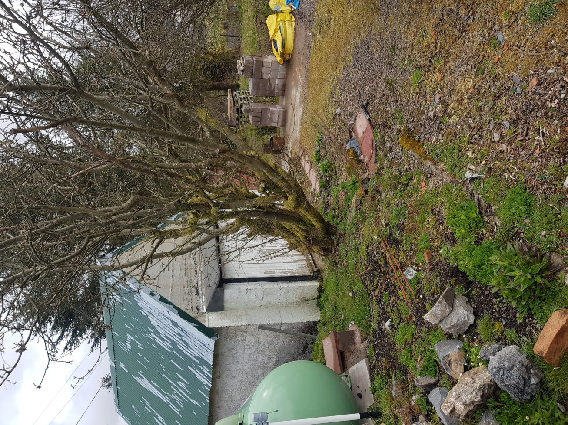

16.Removal of existing vinyl emulsion paint to front elevation
Existing paint finish to be removed to expose stonework. Pointing to be replaced with lime mortar and subject to condition/appearance of stonework left natural. If resultant appearance is poor then a limewash or equal to be applied in a pastel shade.

17.Erection of Summerhouse.
Erection of timber summer house in northeast corner of site as shown on plan. Dimensions 4mx 3m with pent roof maximum height 3m; clad in larch to match other structures with insulated profile sheet steel roof to match garage/store. Windows to northeast and southwest elevation with door to south east elevation. See plan B for location. Photos below show style and cladding finish.

