Proposed Replacement Roof Windows to Front (Eastern Elevation)

The existing Roof windows are Velux GGL9 centre pivot which are the first version that Velux produced.

The GGL9 is 500mm x 700mm.

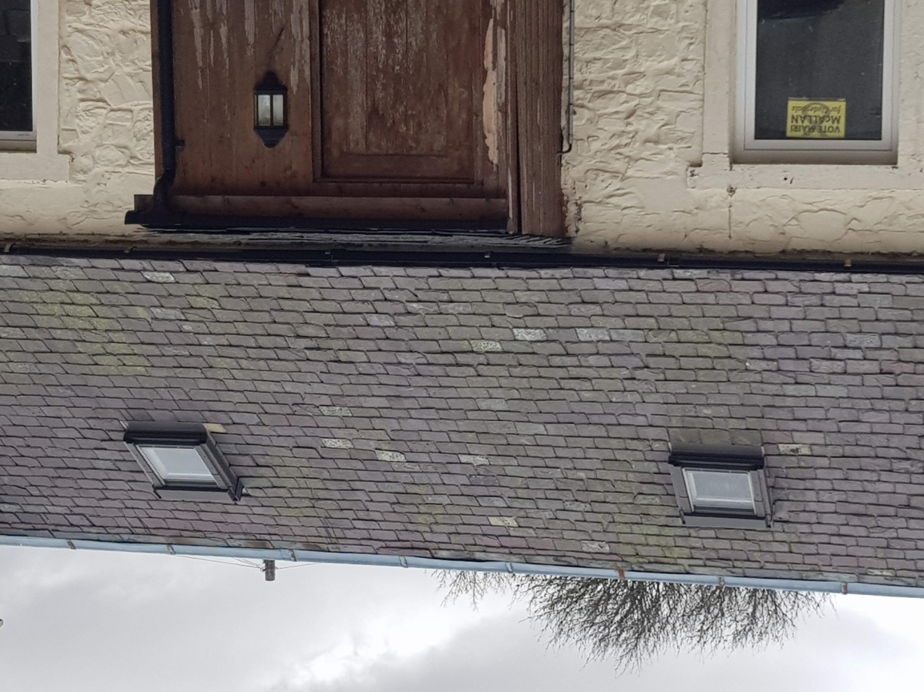

The modern equivalent is a CK01 which has identical dimensions as the GGL9 that are currently installed. The CK01 are finished in grey colour unlike the existing GGL9 which are finished in a brown colour. I propose to use a recessed flashing which allows the rooflight to sit closer to the roofline.

