LPG Gas Tank Shielding Wall.

The existing gas tank has been in its current location for over 30 years.
Google Earth photo of 2010 shows tank in established position.

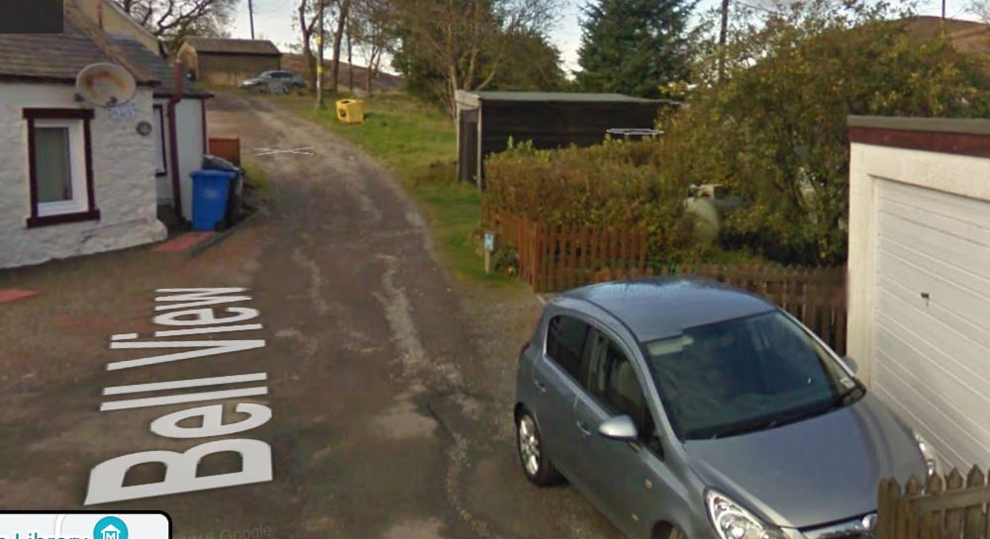

A replacement tank was supplied by my gas provider in April 2020 on a new level base in the original position. (See photos below to confirm).
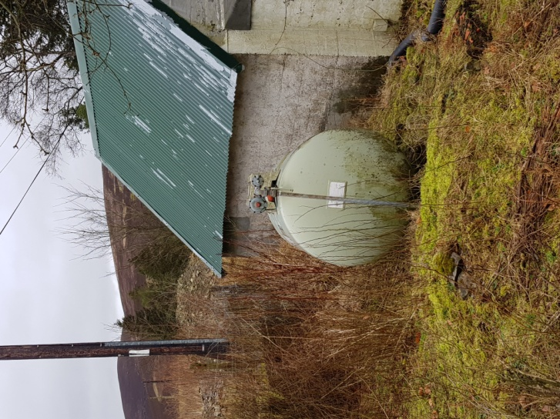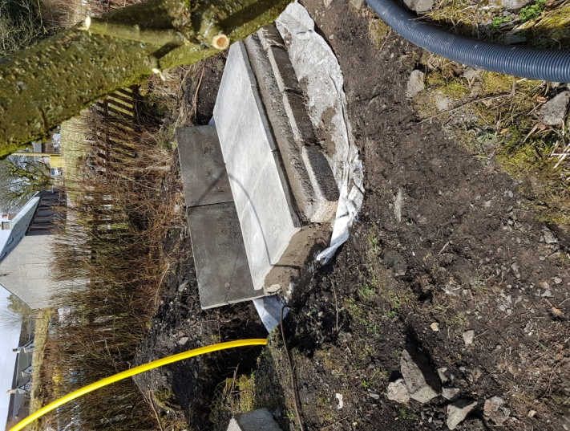

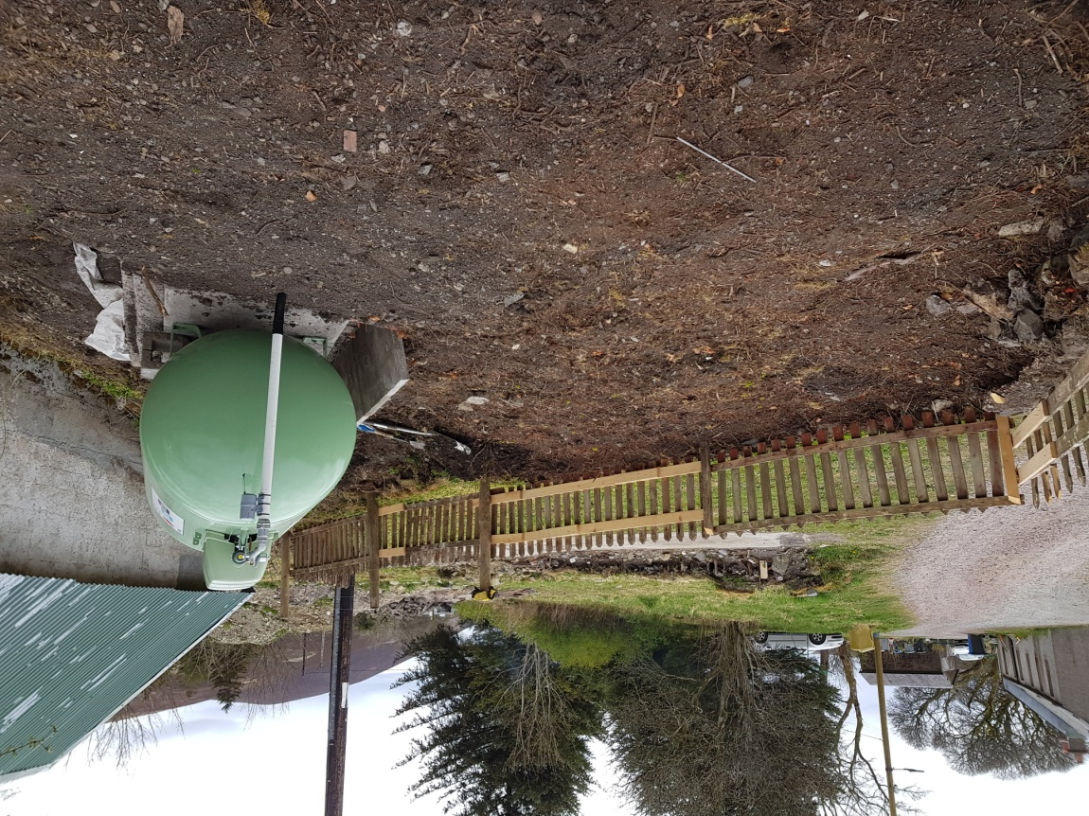

I was advised at that time that to comply with current LPG regulations a solid concrete wall would be required on the northern boundary ( to a height of the valve on top of the tank (1.2m)

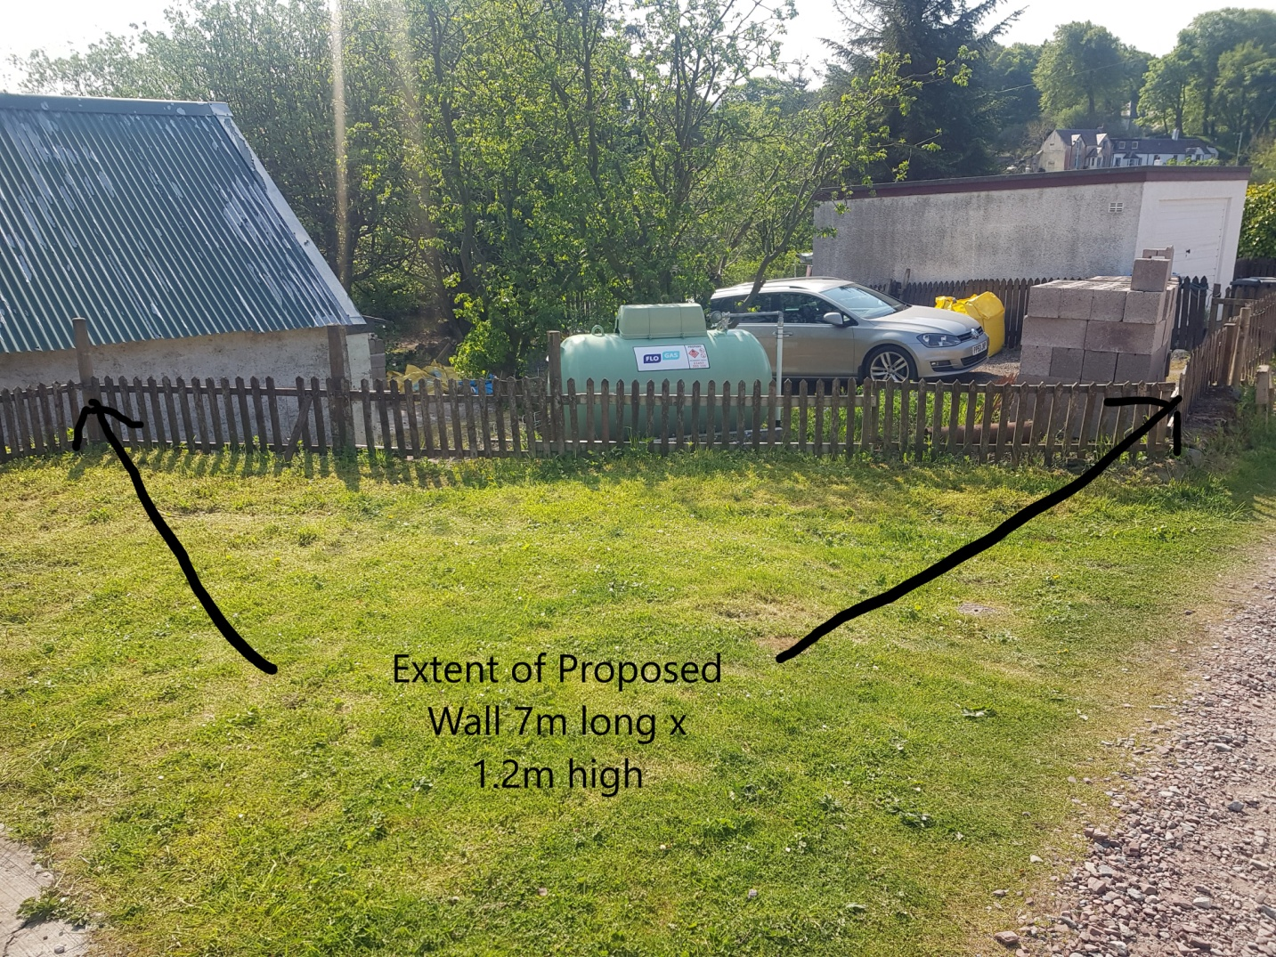

This wall will be constructed of 215mm concrete blocks bag rubbed with mortar and painted in a pastel colour and capped with local stone coping to match that proposed to the north and west of the cottage (see photo below)

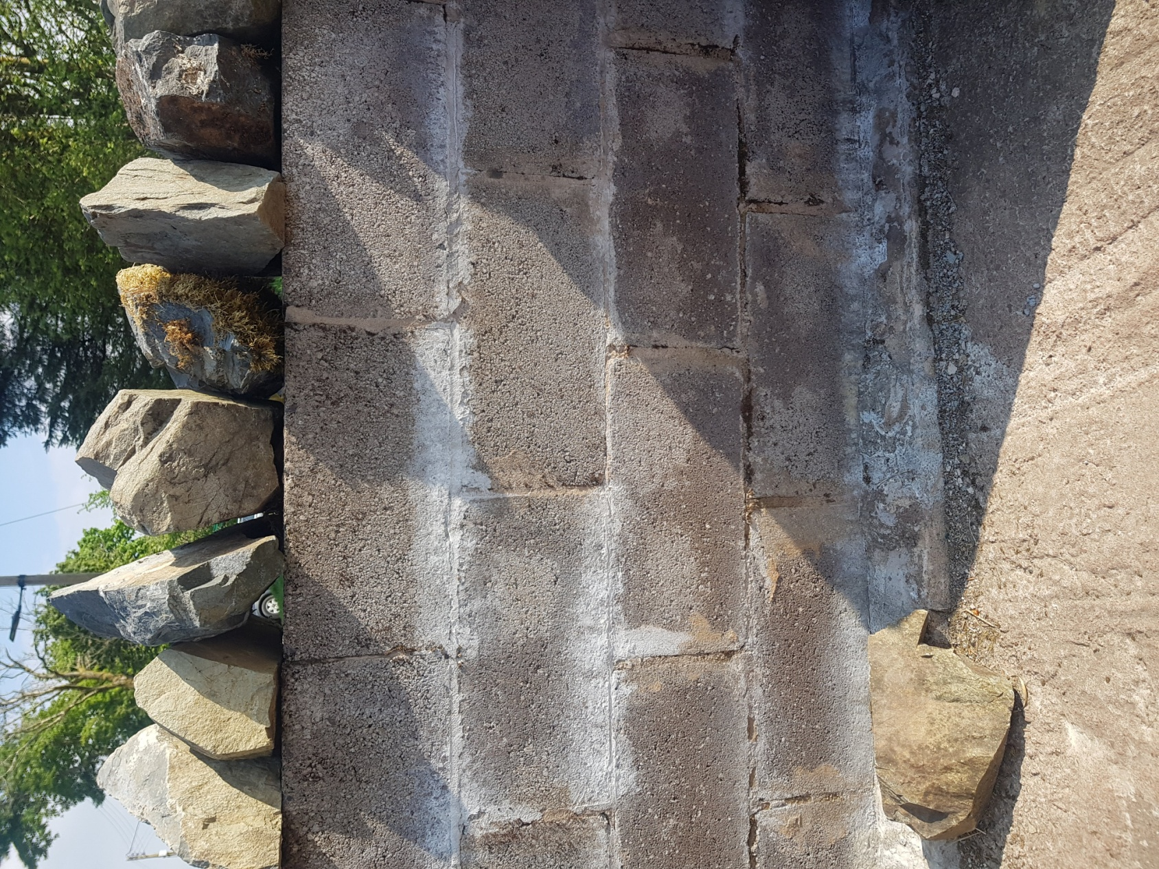

The wall will return on the road side 3.2m toward the gate at a reduce height to replace the disintegrating stone wall approximately 300mm high. The blockwork will be bag rubbed with cement mortar and painted in a pastel colour.

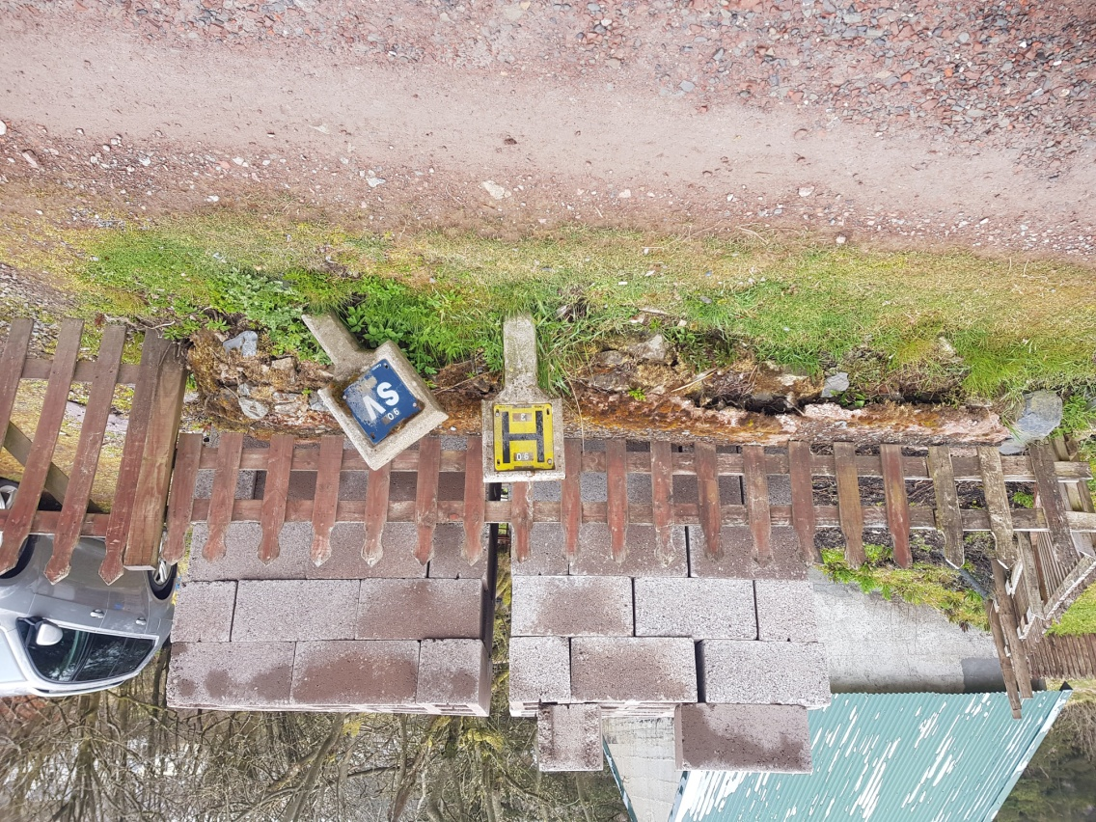

This wall will be topped with a timber pale fence to match my neighbours fence adjacent to the road.
