Form New Window opening in Kitchen.

Slap opening in existing stone wall to west elevation to facilitate a 600x800mm top hung uPVC window. Please note this window is already manufactured and in my possession ready to be installed.
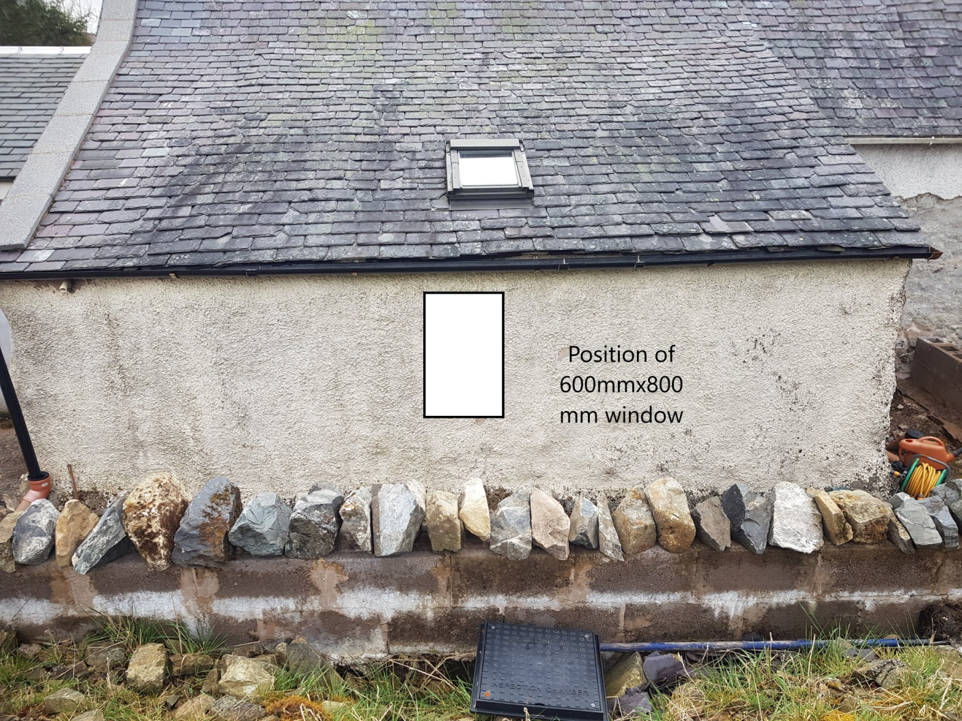
This window will be centrally positioned on elevation as shown above.
The window will be top hung opening out as shown below.
