Documentation and photographs in support of Planning Application Proposal Ref- 100367718 Part 1

- Extension to existing workshop/store
The existing poured concrete workshop which was originally built as a garage and the timber lean-to store to be extended as per drawings G 1-5
The existing workshop will be extended approximately 2.4m using 150mm concrete blocks bag rubbed with cement mortar to blend with existing poured concrete and the complete structure painted in a pastel colour. The roof of the existing together with the extension will be covered with double skinned insulated profile steel sheeting finished in a slate gray colour. The double doors will be built to match existing and the existing uPVC store door will be re-used and painted to blend with larch wall finish. A window to the North elevation is proposed to allow influx of some natural light.
The lean to store is to be extended in length to match workshop and extended in width 1m. The existing frame and cladding will be replaced with a timber frame sat on a block wall to keep timbers clear of ground and clad vertically in home grown larch left to weather naturally. The roof will be clad in same material as workshop. There will be windows to east elevation overlooking garden.
This proposal maintains the appearance of the existing building and is far less obtrusive than my original idea to build a separate garage structure to the north of the existing workshop which would have had a greater impact on the surroundings.
See photos below to show existing elevations.

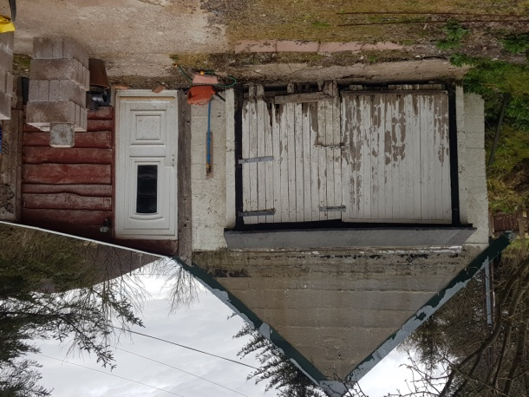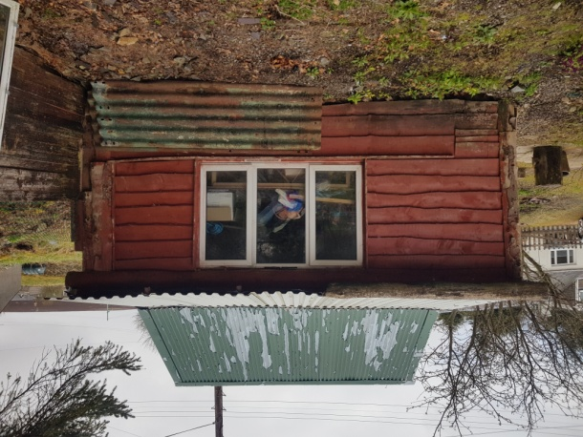

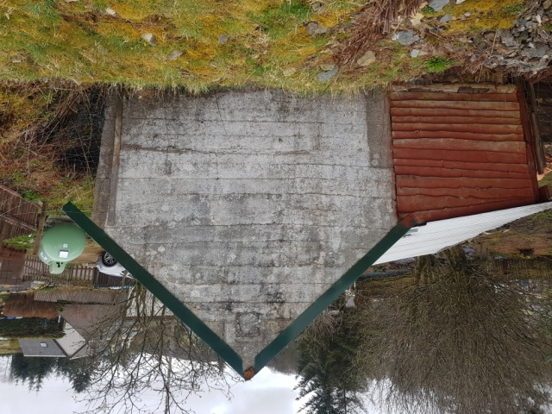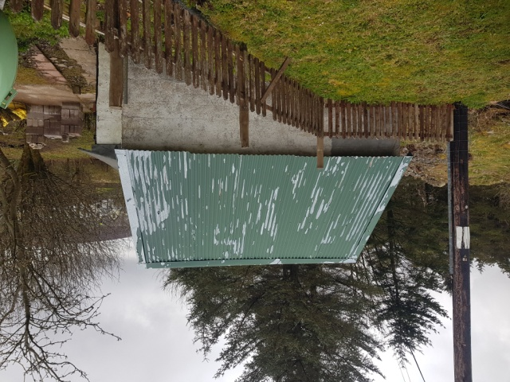

- Replacement of existing porch to front (East) elevation of cottage. Existing timber framed and clad porch (built 2016 by previous owner) to be replaced on exact footprint of existing with a timber framed and clad vertically in home grown larch similar to lean–to store. ( see plans P1-2) The door will be repositioned to south elevation as shown on drawings and will be a composite door in style as shown. The reconstruction of the porch will allow for the roof pitch to be increased to 20 degrees and the existing slates will be re-used. There will be a small fixed window to the east elevation. The existing “disabled access ramp” will be removed. See photos to show existing.
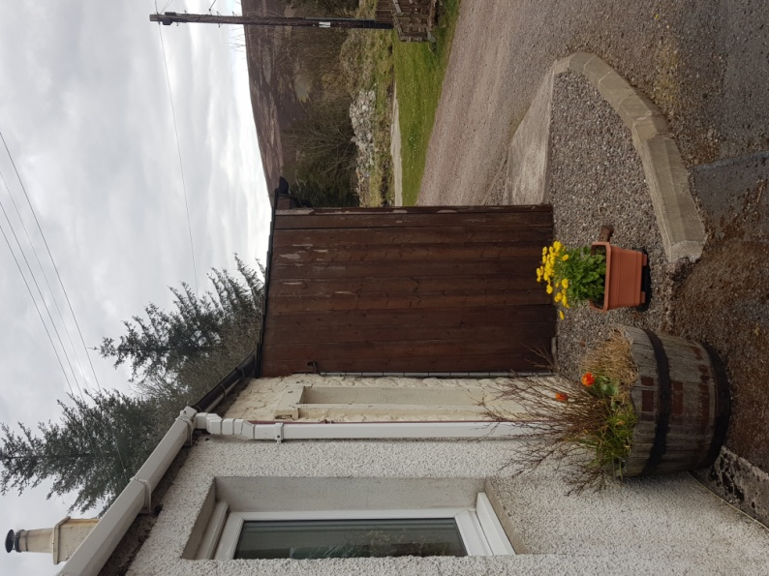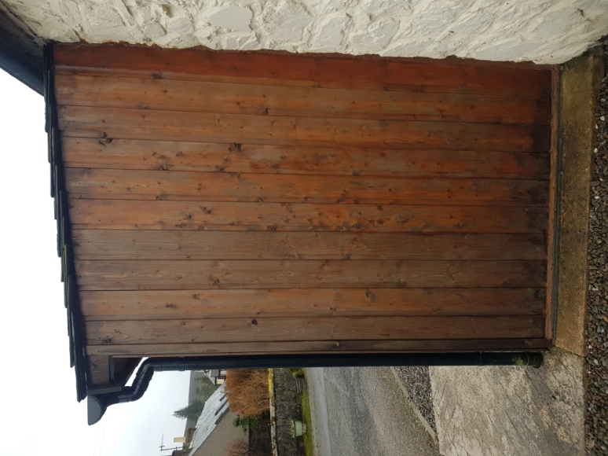

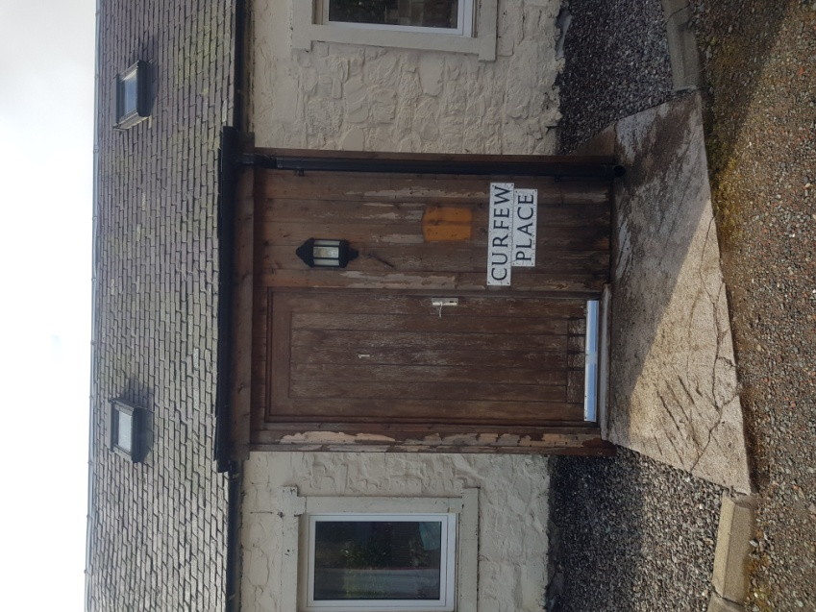

- Replacement of existing uPVC tilt & turn windows
The existing windows to be replaced with uPVC sliding sash windows to improve the appearance of the cottage frontage. Please note these windows are already manufactured and in my possession ready to be installed. See photos and drawing P1

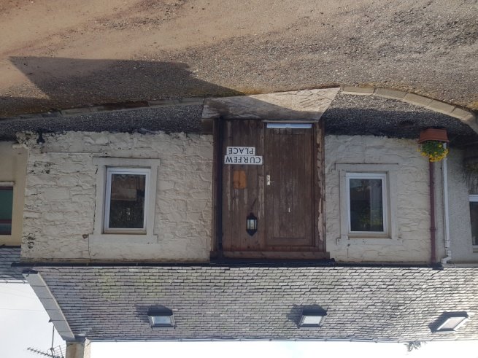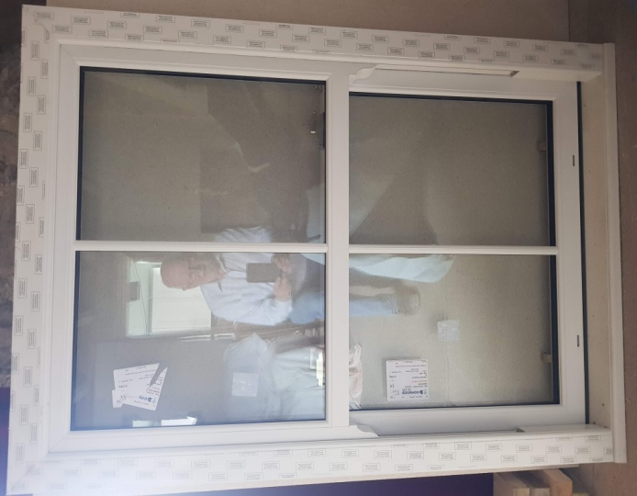

- Replacement of existing roof windows.
Replace existing Velux GGL9 centre pivot roof windows with Velux CK01 (or equal) the modern equivalent with recessed flashings to reduce visual impact.

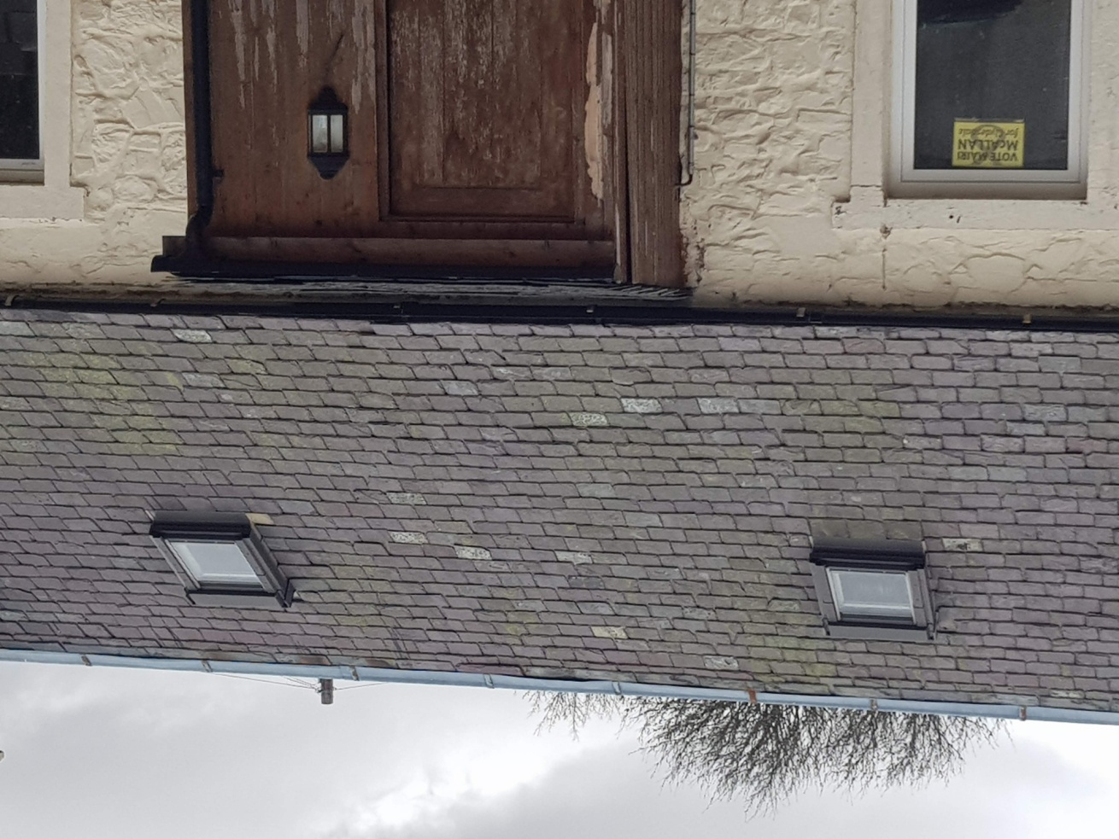
Existing rooflights

- Remove existing window from kitchen.
Existing tilt & turn window in south elevation to rear of cottage to be removed and opening filled in and finished externally to match existing finish. This window looks south directly into neighbours land and rear door. Replacement window to be fitted to west elevation see Item 6 below.

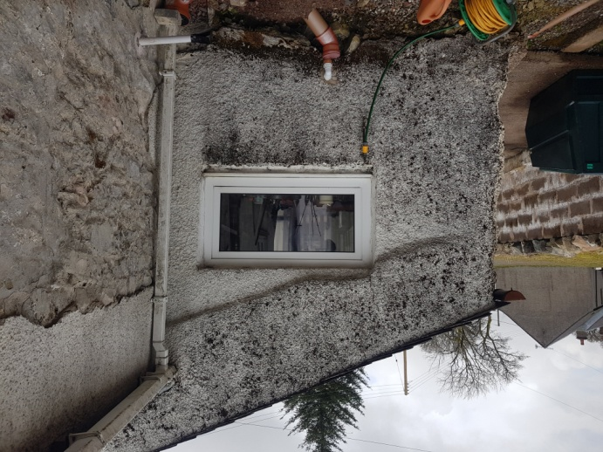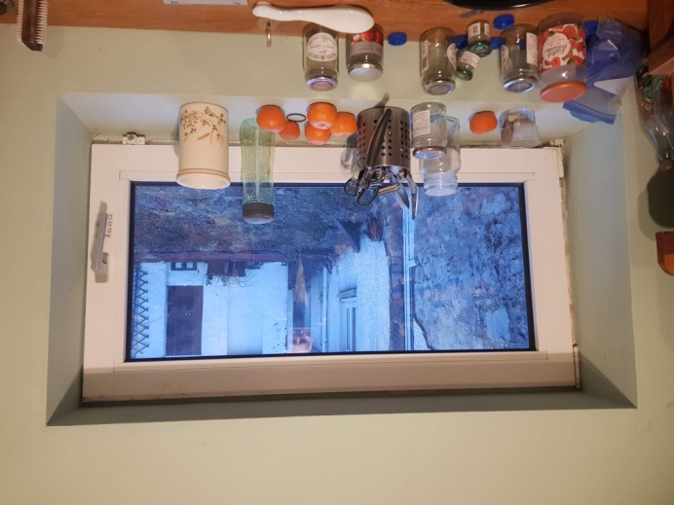

- Form new window opening in kitchen.
Slap opening in existing stone wall to west elevation to facilitate a 600x800mm top hung uPVC window. Please note this window is already manufactured and in my possession ready to be installed.
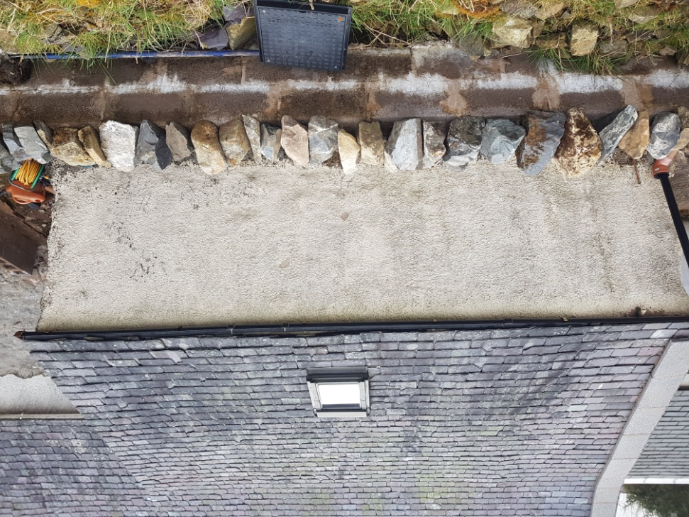
This window will be centrally positioned on elevation shown.

- Removal of existing uPVC door and side screen.
Remove existing door and side screen and replace with uPVC sliding sash window to match those to be fitted on the front (eastern) elevation of cottage. Existing opening to be reduced in size to a similar size as those to the front with stone and blocks and cement rendered to match existing.

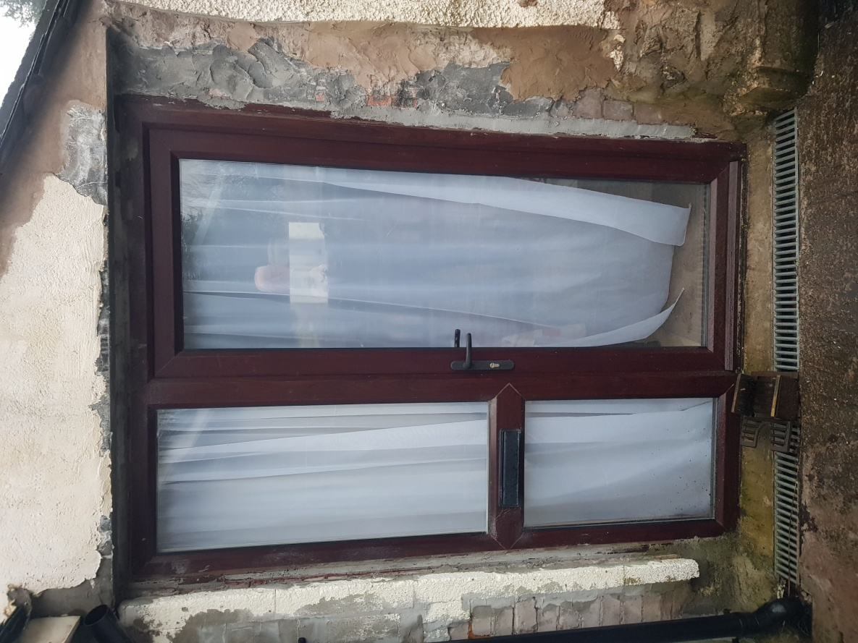

- Alterations to existing wall
Existing 215mm concrete block wall (built 2016 by previous owner) to be bag rubbed and painted in pastel colour to disguise its origin. The top to be capped with local natural stone to give a “dry stone wall” appearance. See photos

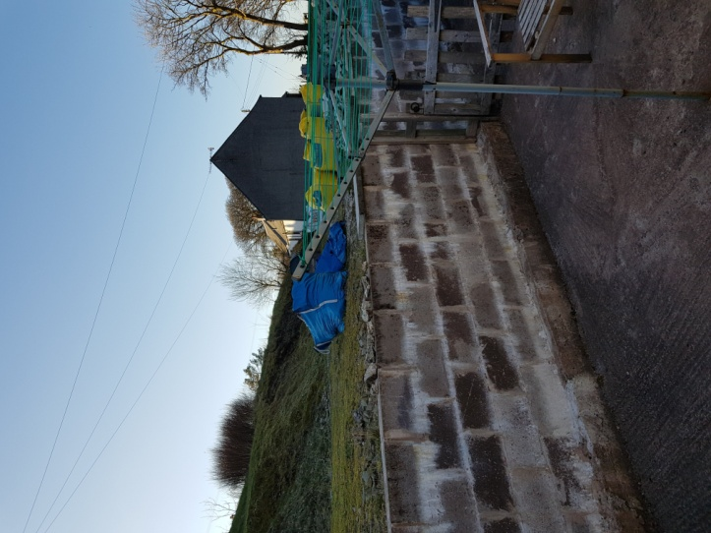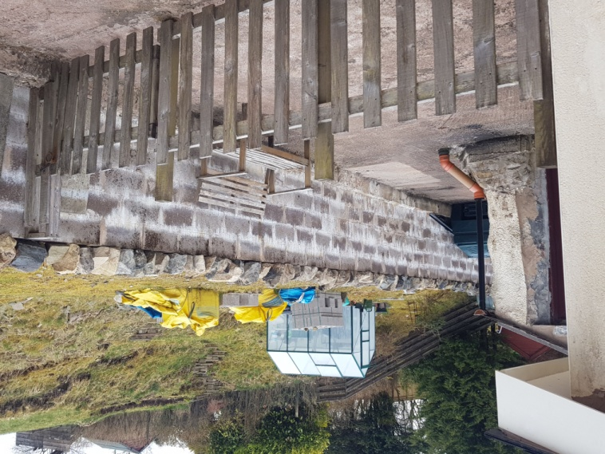

Existing Proposed

- Removal of concrete hard standing
Existing concrete hard standing (constructed in 2016 by previous owner) to north and west of cottage to be broken up and removed and replaced with gravel on hardcore base.
