Dear Sir/Madam,

Please find attached a Pre-application advice form and these documents:

Structural report,
Stable Plans,
Proposed Site and Waste Management ,
Proposed Site & Parking,
Bat & Nesting Survey,
Green Roof information sheets,
Description and Schedule,
Payment receipt,

We have taken on board all of the advice given to us by Fionna Catlin from our last Pre-application advice report.
Please note we did contact Mr Alan Whittle chairman of Launcells Parish Council (01288 381169), who kindly popped over to our stables, to give his opinion on our plans. He suggested we put our plans to the council, but due to lockdown and the councils Covid restrictions on their meetings, this will not be possible for some time. After hearing his opinion we decided to proceed with the pre-application advice form attached.

Since Fionna’s last visit, the only things that have changed at the stables is:
The stables are no longer in use.
The large mound behind the south facing stables has been flattened, as picture below:
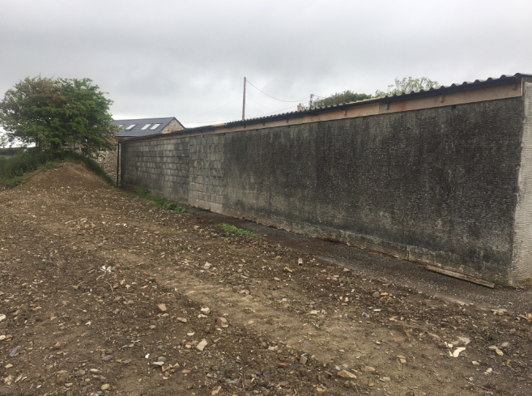

Kind regards,
William & Stephanie Huggins

