Design, Access and Heritage Statement

for

Removal of the existing modern glazed entrance lobby structure, extension of the existing kitchen area, and the replacement of 4 no. existing window units. Solar pv panels to detached garage/ storage out-building.

at

Willy’s Croft : Church Road : Wreningham : Norfolk : NR16 1BA

for

Mrs Jill Maidment
Willy’s Croft : Church Road : Wreningham : Norfolk : NR16 1BA

Job ref. JM/1763 7th. May 2021
REV A 23/06/2021

The Approach to the Design Element

Introduction

This supporting Design, Access and Heritage Statement has been prepared by Mr Andy Love of Andrew P R Love architecture.design.planning Ltd. on behalf of Mrs Jill Maidment.

This statement accompanies a detailed Householder/Listed Building application for the removal of the existing modern glazed entrance lobby structure, extension of the existing kitchen area, a new open entrance porch area, and the replacement of 4 no. existing window units. Solar pv panels are to be added to the detached garage/ storage out-building.

The site, as a whole is owned by Mrs Jill Maidment who lives at the application address.

Mrs Jill Maidment is the Applicant, and this application is submitted, as Agent, by Mr Andy Love of Andrew P R Love architecture.design.planning Ltd.

The Planning Portal application reference no. is PP-09808213.

The Site and Surrounding Area

Willy’s Croft is located on the west side of Church Road, in the centre of the village of Wreningham.
There is a neighbouring residential property to the north of the application which owns the site access, Willy’s Croft has a right of way over the access.
There are further residential properties to the south and on the opposite side of Church Road to the east.

The property is bordered by agricultural arable land to the west.

The application site road frontage is bordered by mature native species hedge and tree planting, the remainder of the boundaries are of various styles/types of fencing. There are many trees and shrubs on the site, none of which will be affected by the proposed works.

The curtilage of the application site extends to approximately 820 square metres.

All existing areas of tree, hedge and shrub planting are to be retained and will not be affected by the proposed scheme.

The area immediately surrounding the building group is of gravel paths and drive, paved patio areas, grassed areas and garden borders and will not be affected by the proposed scheme.

Other than the above there are no landscaping or external works proposed as part of this application.

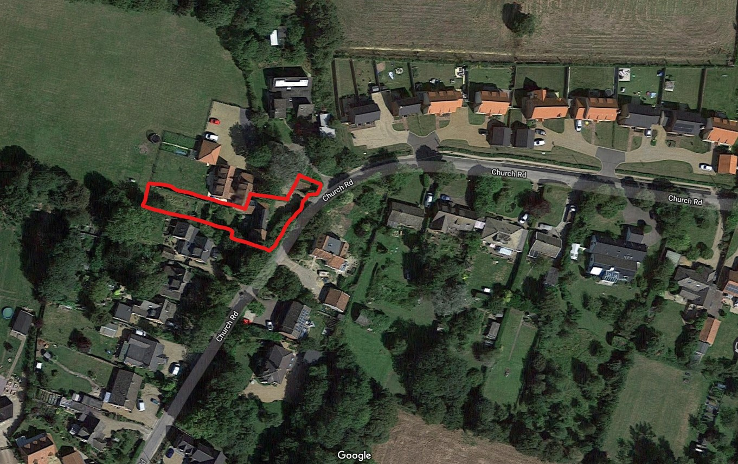

Figure 1: Google Maps extract showing the site location

The Design Brief and Concept

The project brief involves the removal of the existing modern, large, glazed entrance lobby, and increase the size of the existing small kitchen area utilising the footprint area of the glazed lobby. A small covered open porch area is to be included to provide cover from the weather and emphasise the new entrance door area.

The project also includes the removal and replacement of four of the existing timber windows, as shown on the scheme drawings. The existing window units are in an extremely poor state and are beyond sensible repair, therefore replacement with new units to precisely match the existing is proposed.

The proposed extension area has considered the attractive quality of the existing Listed Building and the careful and thoughtful design of the proposed scheme will enhance both itself and the contribution it brings to its landscape setting while not creating Party Wall issues with the adjoining dwelling.

The architectural treatment of the new and improved existing building takes into account the existing building features and materials.

All materials for the new building and improvements are to be chosen to match the existing and, where possible and if practicable, re-claimed materials will be incorporated.

The extent of the necessary works requires a formal Listed Building application to be submitted.

The works also require determination under the Approved Documents and a formal Building Regulations application will be prepared and submitted to CNC Building Control.

External Materials

The external materials for the proposed works – black painted brickwork plinth, colour-washed two-coat lime render, red clay pantiles and painted timber joinery all make reference to the existing dwelling materials and finishes.

The new replacement windows are to be timber with a painted finish to match the existing windows and doors.

The open entrance porch will comprise green oak posts/head beams with red clay pantile roof covering.

The south-west facing roof slope of the existing garage/storage out-building to the north-east of Willy’s Croft is to be fitted with solar photovoltaic panels.

Landscaping and External Works

The existing grassed areas, concrete drive and parking areas are to be retained and are unaltered by the proposed works.

The existing boundaries are to be retained and are unaffected by the proposed works.

Other than the above there are no landscaping or external works proposed as part of this application.

Environmental Impact

The proposed extension will be insulated to a high standard, above the level required within the Approved Documents, and all new windows and doors are to be double glazed.

All new windows and doors are to be fully sealed within the new and existing openings in accordance with the Building Regulations Approved Documents.

Low-energy light fittings and energy and water-efficient appliances will be installed where possible.

All foul-water from the proposed scheme will be connected to the existing mains foul-water drainage system via the existing on-site drainage runs.

All surface-water from the proposed scheme will discharge into existing or new on-site soakaways.

All space heating will be provided by the existing system.

Flood Risk

The application site is located within flood zone 1 and outside flood zones 2 & 3 as designated by the Environment Agency as shown in Figure1 below.

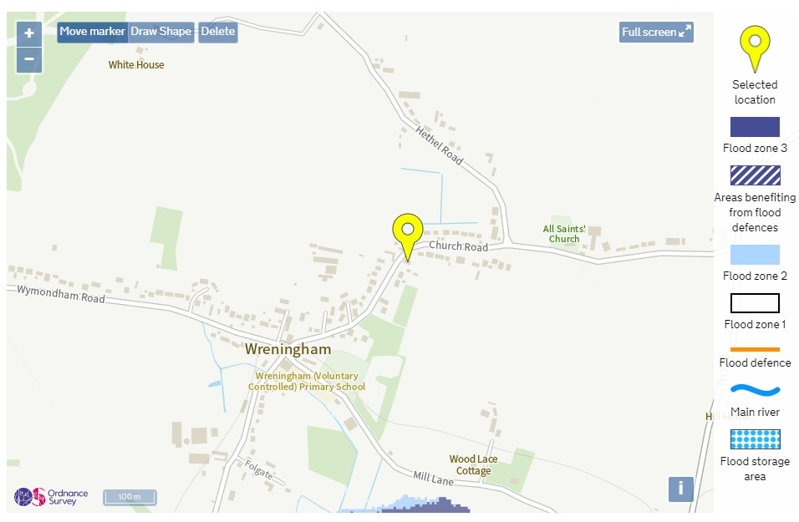

Figure 2: Flood Map extract provided by the Environment Agency

Heritage Statement

The existing building is a designated Grade II Listed Building.

The proposed works externally take into account the positive contribution that the existing Listed Building makes to the local character of the area and it is considered that the proposed works will not have an adverse effect on the building, site and the location as a whole and will, in fact, by removing the modern glazed structure, improve the building within the built environment.

The external material choice will ensure that the appearance of the building is altered and improved in a positive and sympathetic manner and will therefore minimise the visual impact of this application.

The application has considered the neighbouring property and will not present any over-looking issues.

The Historic England extract for the property is included below.

WILLYS CROFT

Overview
Heritage Category:
Listed Building
Grade:
II
List Entry Number:
1389114
Date first listed:
19-Mar-2001
Statutory Address:
WILLYS CROFT, CHURCH ROAD

Map

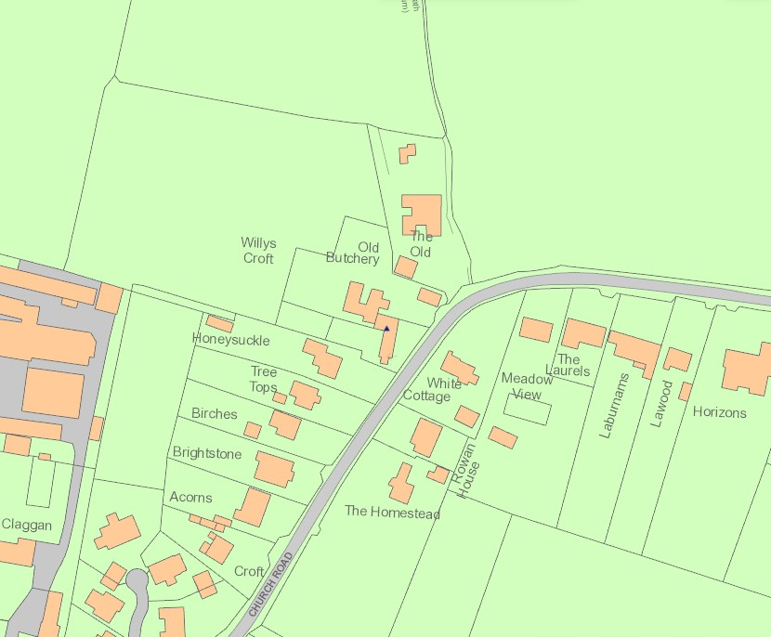

© Crown Copyright and database right 2021. All rights reserved. Ordnance Survey Licence number 100024900.
© British Crown and SeaZone Solutions Limited 2021. All rights reserved. Licence number 102006.006.
Use of this data is subject to Terms and Conditions.
The above map is for quick reference purposes only and may not be to scale. For a copy of the full scale map, please see the attached PDF - 1389114.pdf(opens in a new window)
The PDF will be generated from our live systems and may take a few minutes to download depending on how busy our servers are. We apologise for this delay.
This copy shows the entry on 19-May-2021 at 14:04:38.
Location
Statutory Address:
WILLYS CROFT, CHURCH ROAD
The building or site itself may lie within the boundary of more than one authority.
County:
Norfolk
District:
South Norfolk (District Authority)
Parish:
Wreningham
National Grid Reference:
TM 15963 98787

Details
WRENINGHAM
TM19NE CHURCH ROAD 76/5/10013 Willys Croft 19-MAR-01
II
House. Late C17 with early/mid C19 parlour extension and later additions. Rendered timber-frame with thatch roof to main part, brick with flint plinth and pantile roof to extension. 2-unit plan with cross passage and two service rooms , now one large room, extended to left beyond stack. Main part of single storey and attic; extension of two storeys. Front from left has 10/10 sash with 2-light casement over, 4-panel door, 12-pane window, door with 2-light gabled dormer over , 4-pane window. Door with 12-pane window in single-storey extension on right end where casements and door in side. Triple casement in gable above. Door and casements to rear. INTERIOR. Timber-framed unit now opened up on ground floor but retaining the framed partitions and chamfered bridging beam. Tall panel framing to walls. Open fireplace with bressumer and winder stair behind it. Former service rooms divided by a now open stud partition. First floor has wide floor boards and 4-bay roof roof, only the central and gable-end trusses having tie beams. The central tie beam is cut and dovetailed into a door frame. This may be an original feature as the truss was originally closed and a door way needed to provide access to the far chamber. Two tiers of wedge-tenoned butt purlins, collars and straight braces. A little-altered 2-unit plan cottage with a late parlour extension.
Listing NGR: TM1596398787

Legacy
The contents of this record have been generated from a legacy data system.
Legacy System number:
486632
Legacy System:
LBS

Legal

This building is listed under the Planning (Listed Buildings and Conservation Areas) Act 1990 as amended for its special architectural or historic interest.
End of official listing

Images of England
Images of England was a photographic record of every listed building in England, created as a snap shot of listed buildings at the turn of the millennium. These photographs of the exterior of listed buildings were taken by volunteers between 1999 and 2008. The project was supported by the Heritage Lottery Fund.
Date: 25 Jul 2007
Reference: IOE01/16047/15
Rights: Copyright IoE Mr John Giles. Source Historic England Archive
Archive image, may not represent current condition of site.

The Approach to the Access Element

Vehicular Access

There are no alterations to the existing pedestrian site access directly off Church Road proposed as part of this development.

There are no alterations to the existing vehicular access directly off Church Road proposed as part of this development.

Inclusive Access

The proposed development will be as accessible as possible in accordance with Lifetime Home standards.

All new internal doors will comply with all the relevant Building Regulations Approved Documents including Part M where applicable and practicable.

The nature of the existing historic building makes wheelchair access to all areas impractical.

Provision for the following will be included:

Means of escape: the provision of a safe means of escape from the building is to be provided via compliance with Building Regulations Approved Document Part B.

Door widths and openings: All door widths and openings to meet the minimum requirements of Approved Document M and BS 8300 (for clear openings, type and height of handles, vision panels, door closers etc).

The existing means of escape will be unaffected by the proposed works.

Photographs of Existing Windows to be Replaced

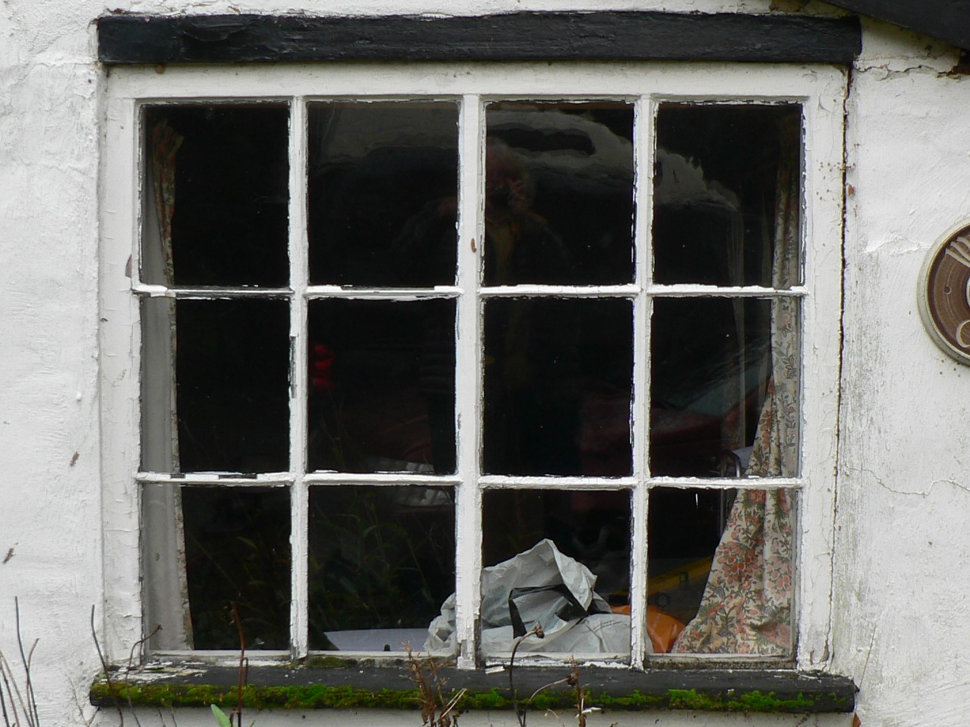

Figure 3 : View of window unit A to be replaced

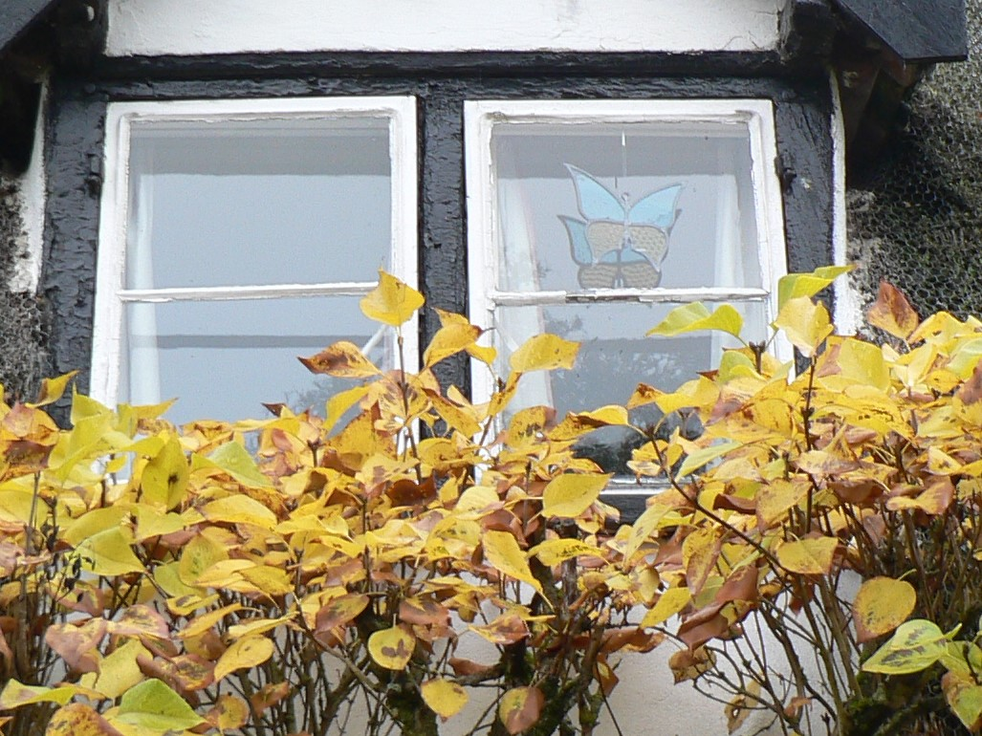

Figure 4 : View of window unit B to be replaced

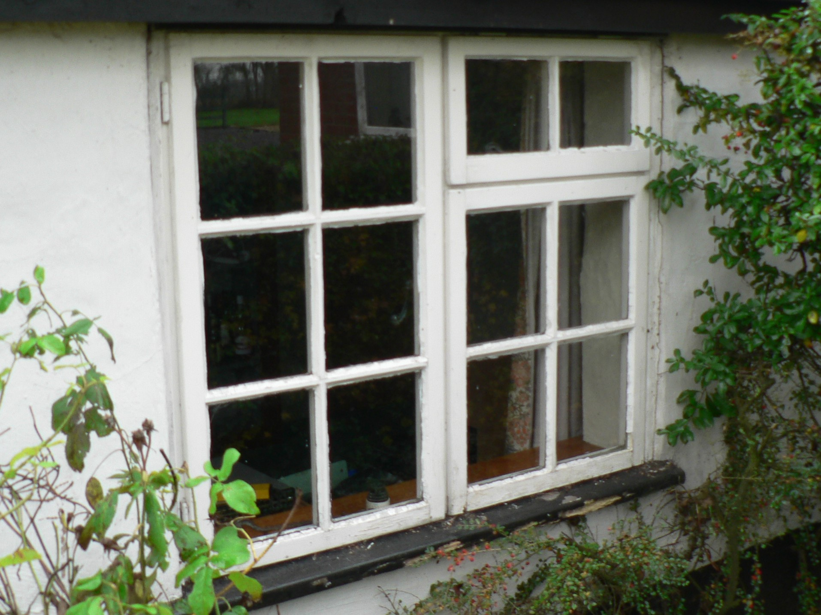

Figure 5 : View of window unit C to be replaced

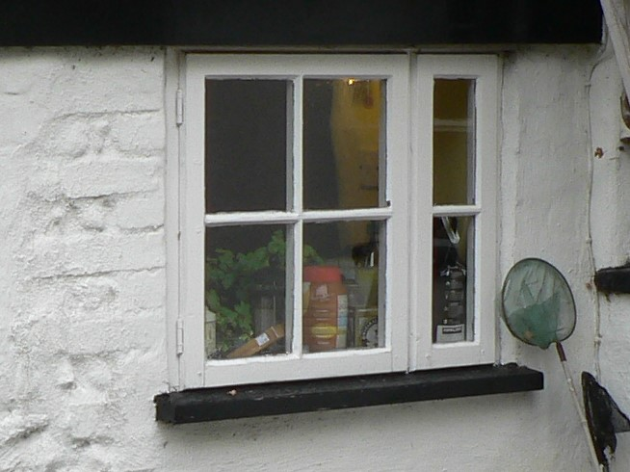

Figure 6 : View of window unit D to be replaced

This Design, Access and Heritage Statement is also to be read in accordance with the following drawings and documents.

- JM/1763 9900 - site location plan
9901 - existing block plan
9902 - existing layout – survey drawing
9903 - existing elevations – survey drawing
SK07A - proposed layout – scheme four
SK08A - proposed elevations – scheme four
SK09A - proposed block plan – scheme four
SK10 - proposed window elevs – scheme four

Design, Access and Heritage Statement

for

Removal of the existing modern glazed entrance lobby structure, extension of the existing kitchen area, and the replacement of 4 no. existing window units. Solar pv panels to detached garage/ storage out-building

at

Willy’s Croft : Church Road : Wreningham : Norfolk : NR16 1BA

for

Mrs Jill Maidment
Willy’s Croft : Church Road : Wreningham : Norfolk : NR16 1BA

Job ref. JM/1763 7th. May 2021
REV A 23/06/2021

