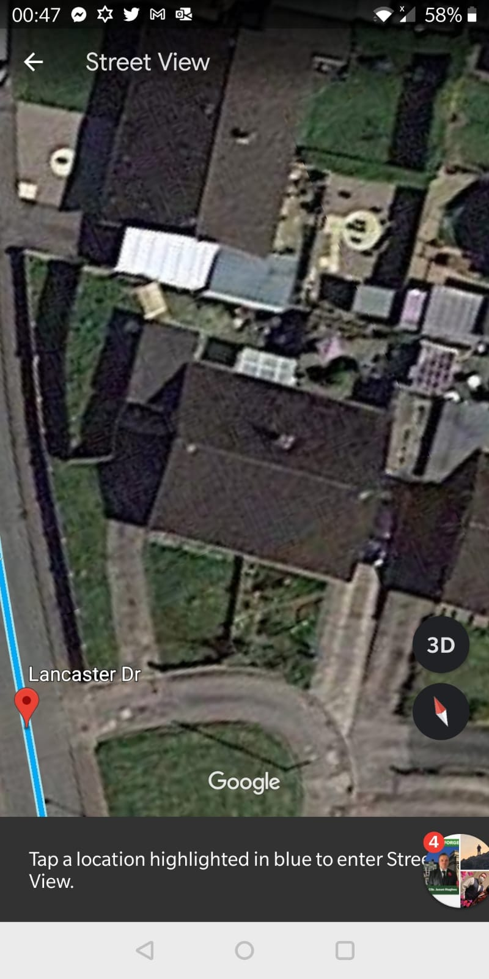

**PICTURE 1**

Existing fence is 7ft high and was done by the previous owner to get around planning permission, the fence is unsightly and since buying the property the neighbours have said they are so glad someone has bought the bungalow to make improvements. All the Neighbours have said the fence is awful and if you were to visit the sight you would understand their frustrations as the pictures do not do it justice.



PICTURE 2

New Fence Boundary

I would like to remove the old fence and apply for planning permission. The existing boundary is showing there is already a wall around the property that is one meter high and i would like to put feather edge around the wall to another meter as shown by the yellow outline.