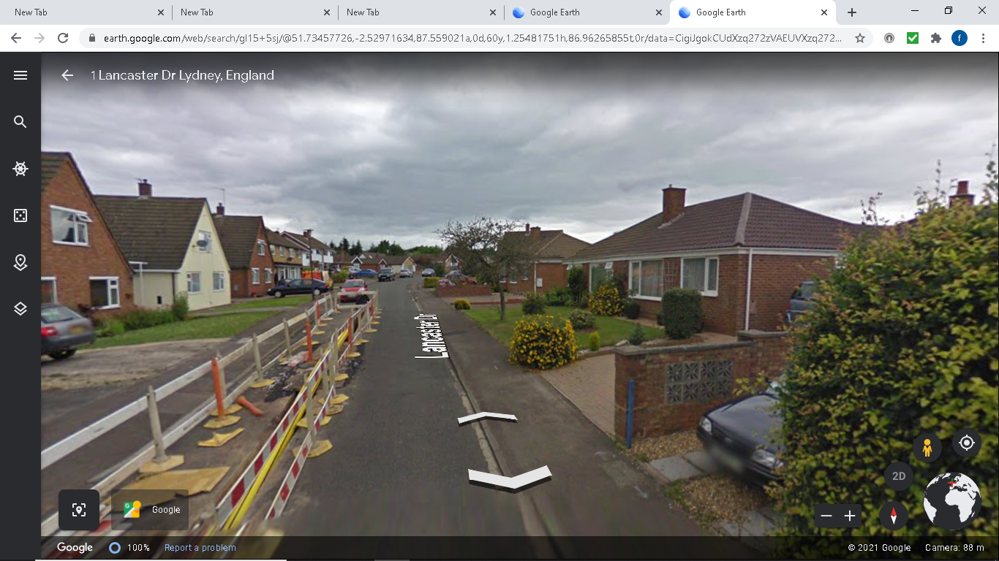
The first picture is taken from google earth, what I am trying to show are the two properties at the beginning of Lancaster drive. Both properties to the left and right have 6ft fencing. The property on the right is currently showing a hedge border this has been changed to fencing.
a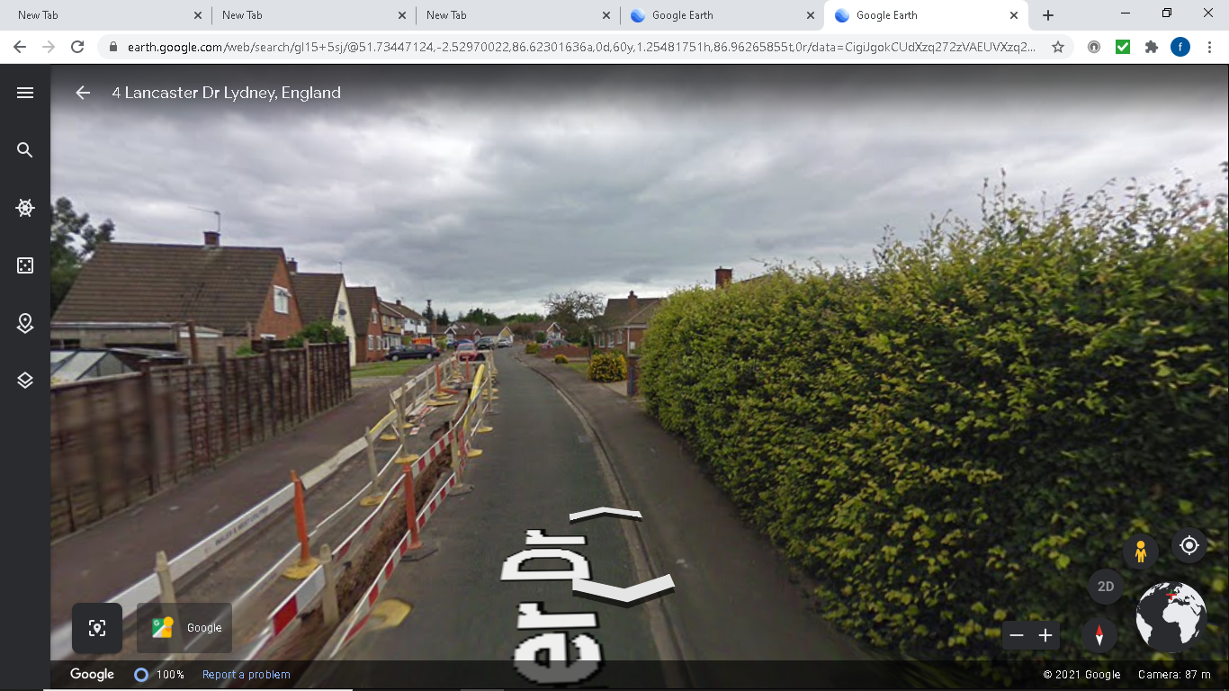
Another picture of both properties The hedge has now been replaced with a six foot fence.
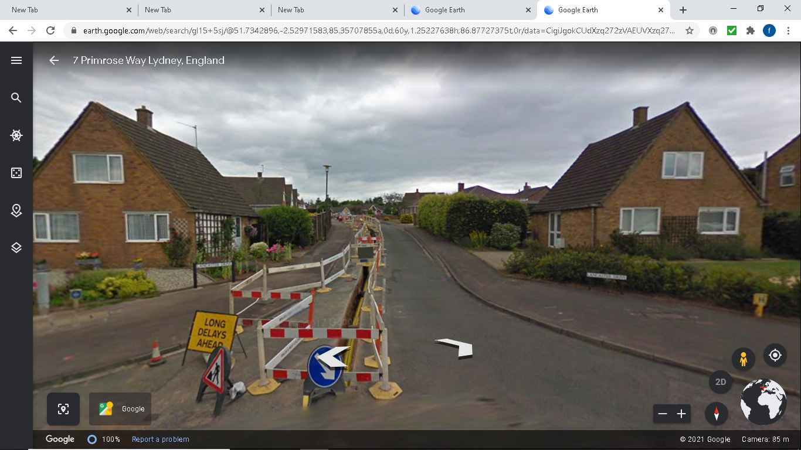
This is currently an old picture and both properties have been changed to 6ft fencing around the garden.

