Design and Access Statement

Conversion of
7 Hayes Road
Clacton On Sea
CO15 1TX
Into
2 no. Two bed Flats
1 no. One bed flat
For Mr Anil Lal

Keith O’Dell
KO Designs May 2021

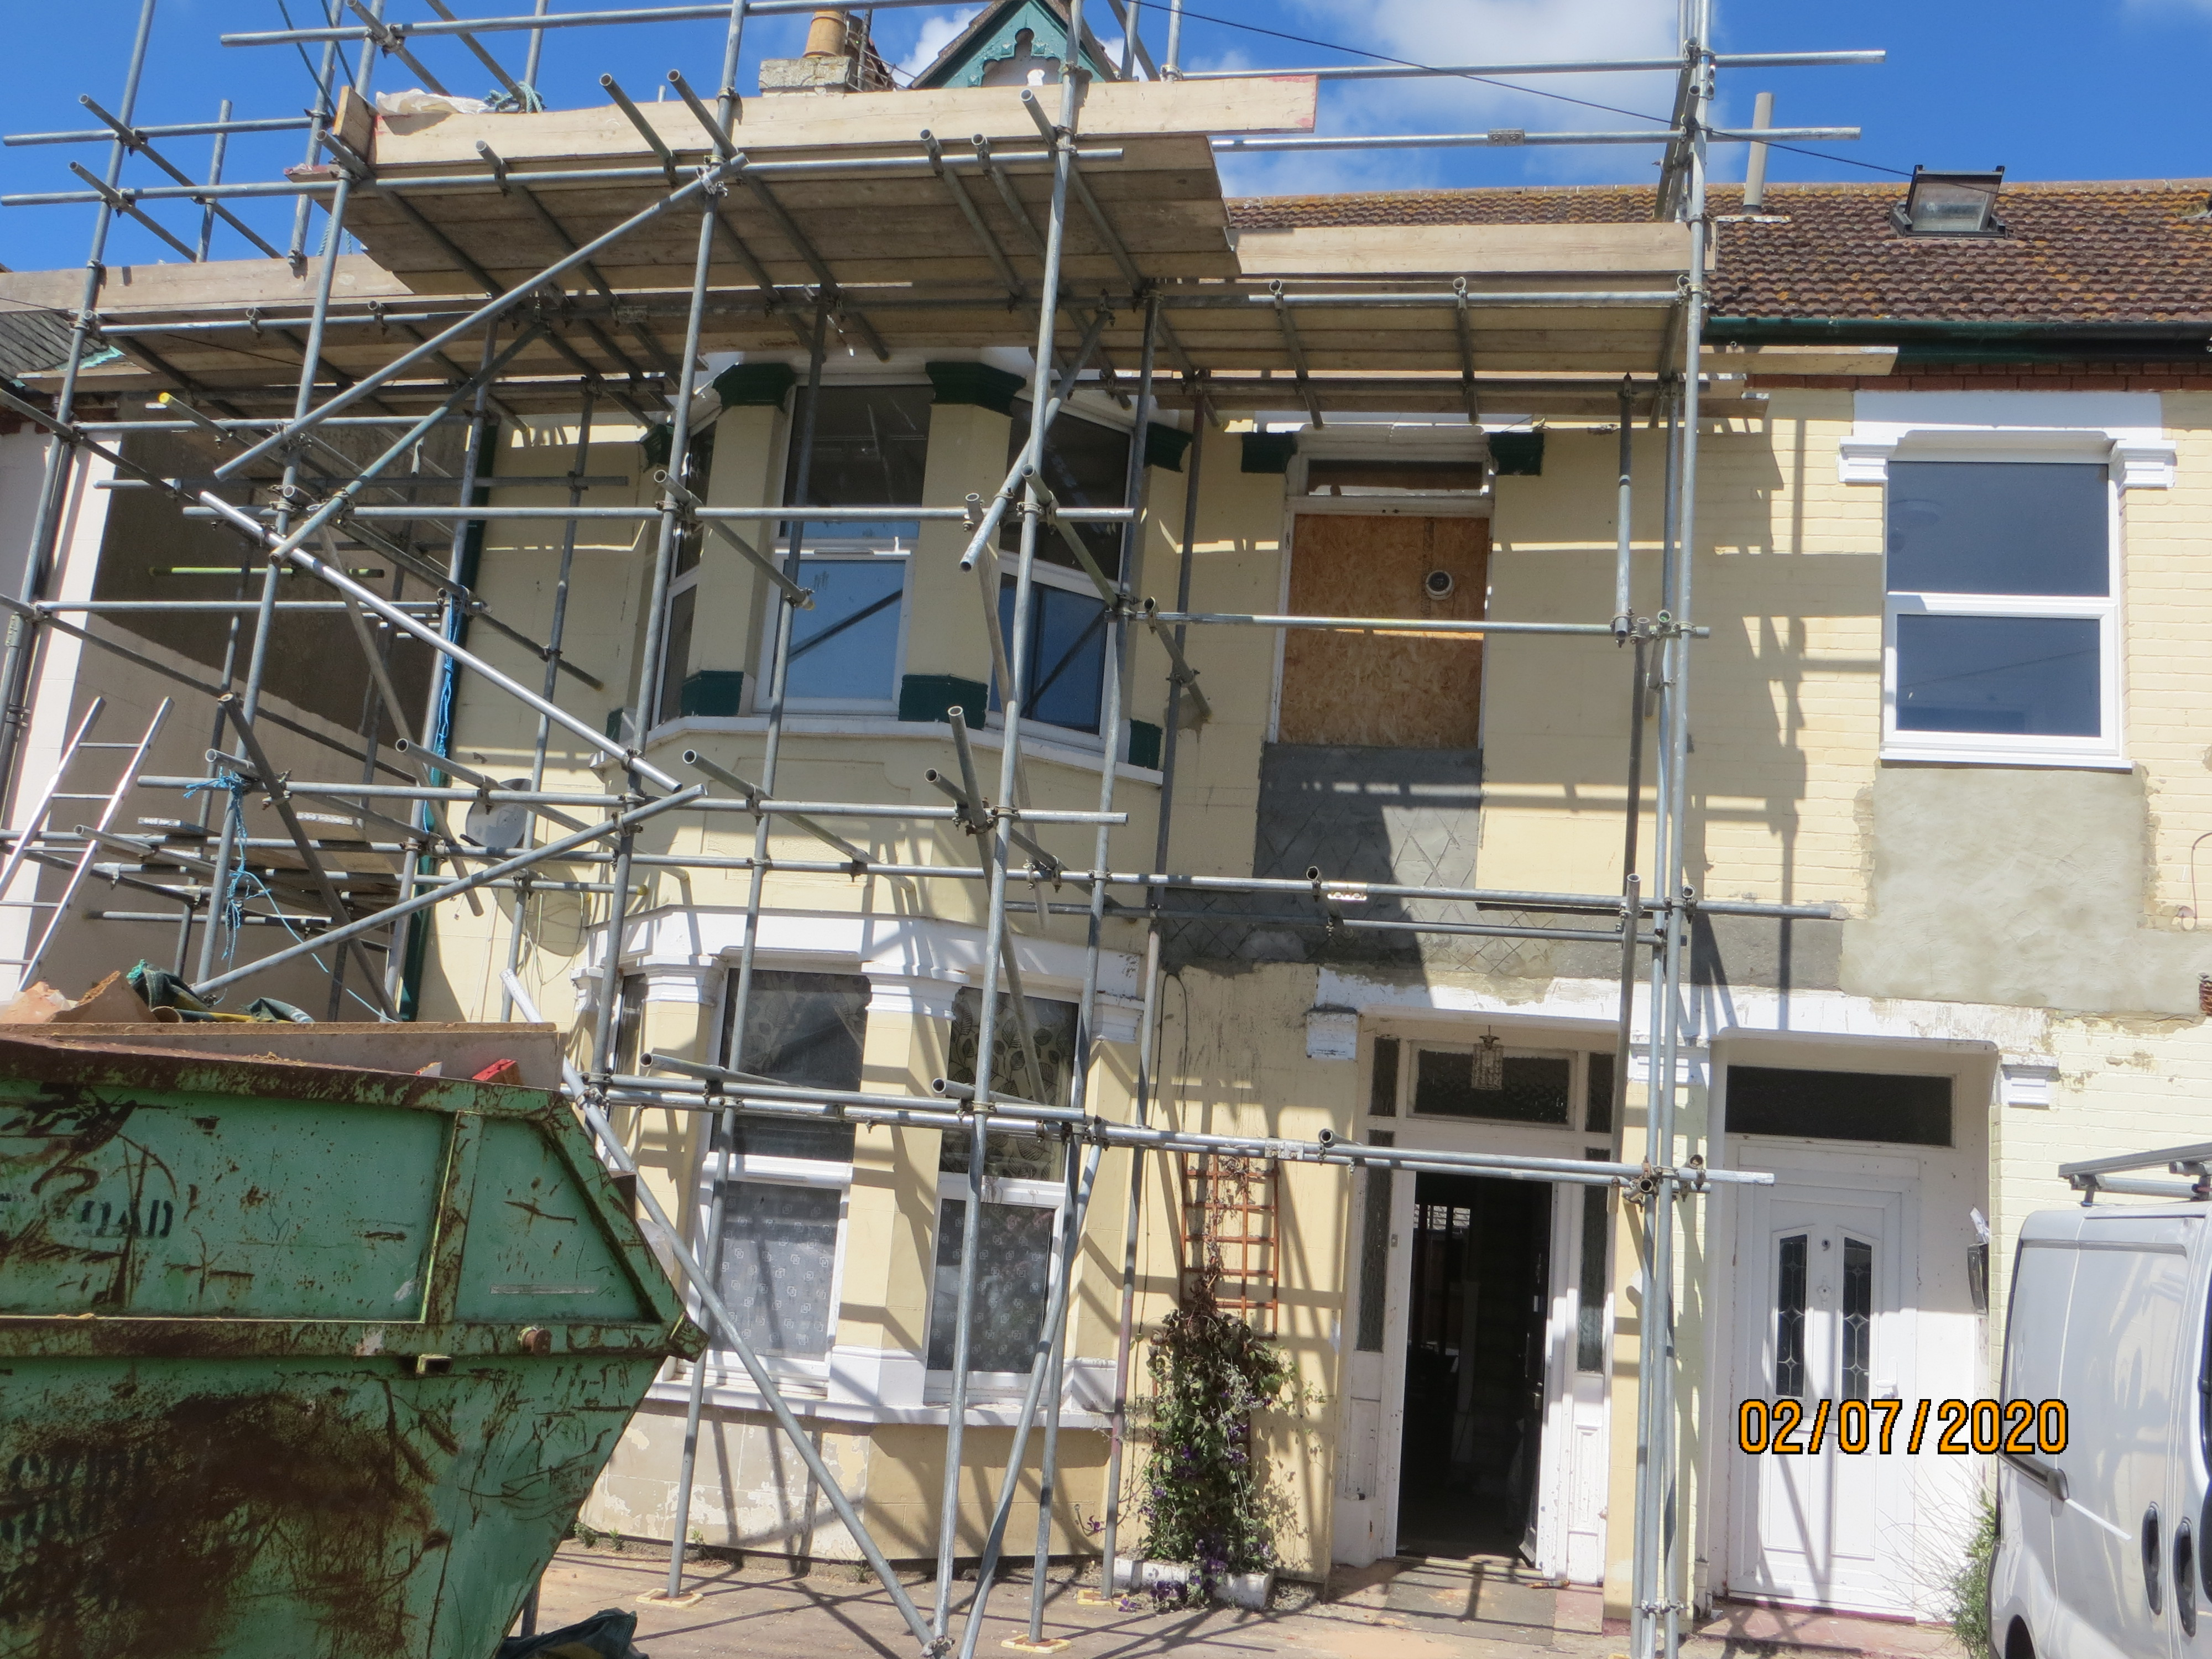

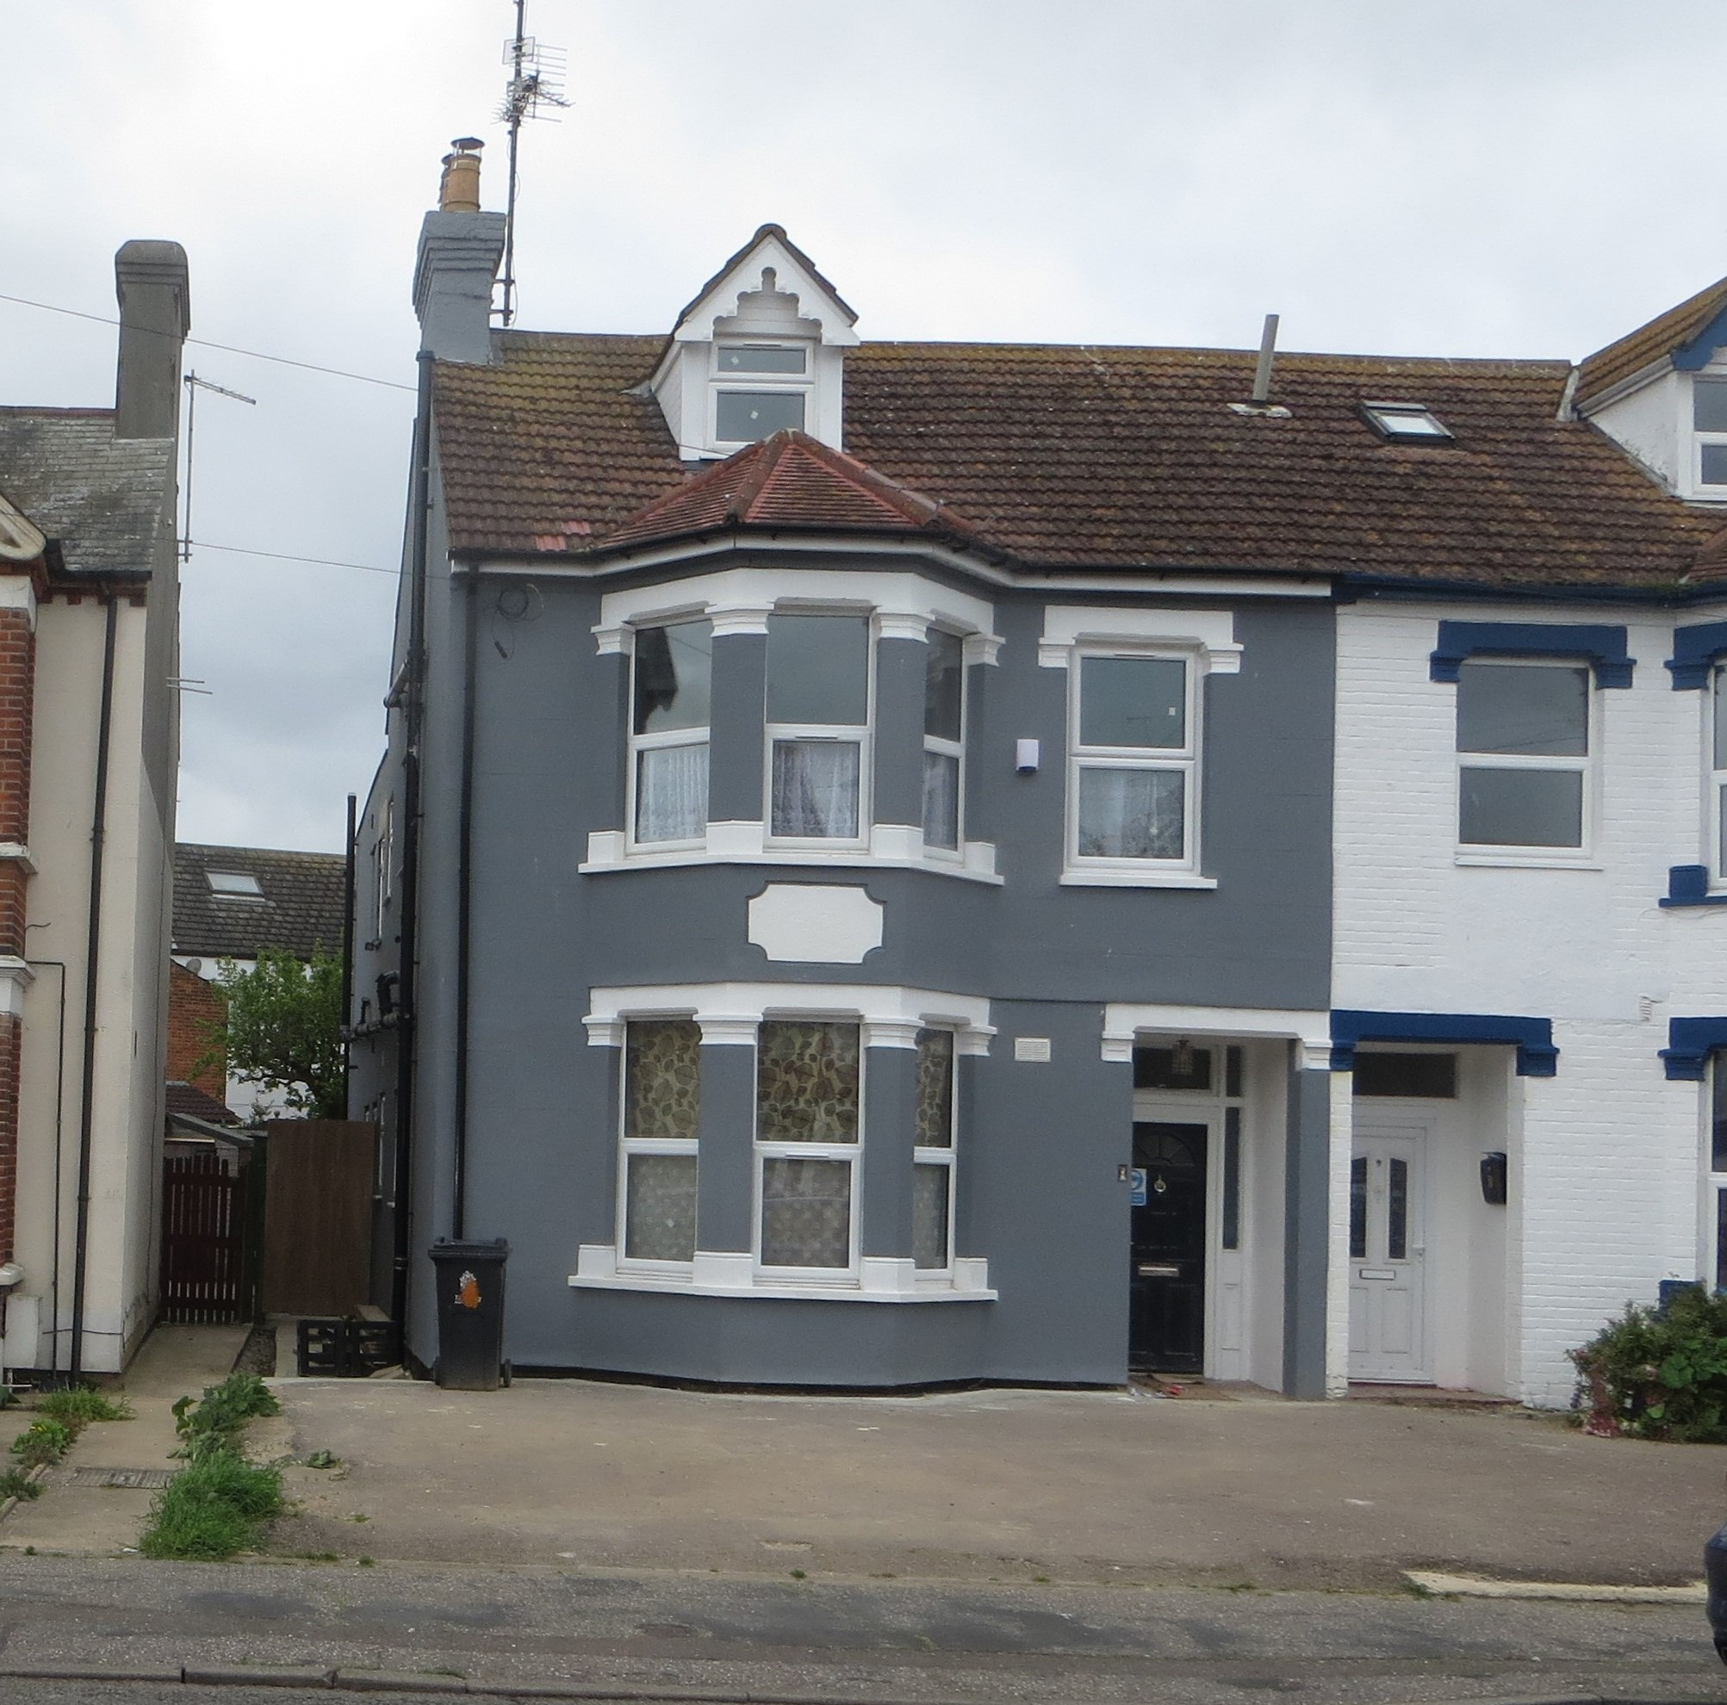

Introduction

This statement is prepared on behalf of Mr Anil Lal and is in support of a full planning application for the conversion of 7 Hayes Road Clacton into 2 x 2 Bedroom flats and 1 x 1 Bedroom flat.
The application is submitted following an application for pre-planning advice Ref No. 20/30135/PREAPP
My client purchased this Semi-Detached property in 2020 which was previously used as a house of multiple occupation. This was originally the subject of an enforcement notice which was quashed and permission given for a 7 room HMO in 2019.
It has been unoccupied since August 2019. Previous to the house of multiple occupation, it had been a residential home with No.9 adjoined which had planning permission 94/01345/FUL for 7-8 Hayes Road for lift shaft and internal works.
When my client purchased the property, it was in need of urgent repairs to the roof and other internal and external maintenance. As you can see from the two photos the repairs have been done and the property has been updated.
It will comply with the National Planning Policy framework and National Planning policy guidance.
There are approximately 67 sq.m. of communal garden space and with the reinstatement of the front balcony and enlargement of the rear balcony although this does not precisely meet the requirements of HG9 with all local amenities nearby it should meet with the needs of the future occupants.
My client proposes to turn this property into 3 self-contained flats which he intends to rent. The property is in the centre of Clacton with all amenities within walking distance including essential shops, general shopping, bus routes a railway station, library and entertainment facilities.

The property is in an area where there are similar flat conversions and as the modifications are mainly internal with the reinstatement of the front balcony and enlargement of the rear balcony this should not have any visual effect or be harmful to the character of the area

Use

My client intends to rent these self-contained flats when completed
The square meterage of the individual flats will be:
Flat A = 72.3m2
Flat B = 71.4m2
Flat C = 36.5m2
This does not include the communal areas.
All will have bathroom and kitchen facilities, Each of the Flats will be fully equipped with white goods and individually registered for energy bills.
The property is not within a conservation or flood risk area.
There will be a rack for the storage of cycles at the rear of the property to encourage eco principles of carbon reduction. There will be a bin store for both refuse and recycled rubbish to the front of the property.
The appearance of the building will not change as there is only 1 new side window proposed to bathroom and to the rear the existing balcony will be slightly extended and have French doors. The lower flat will have a replacement window for the existing door. All the other windows are in good repair so will remain. 2 velux windows one to the front and one to the rear will be added.
There will be a drying area at the rear of the property but each flat will have drying facilities.
Soundproofing and insulation and upgrading all the thermal requirements will be carried out as per building regulations.

Access
The existing access will remain unchanged with a dropped kerb and car parking for two vehicles to the front of the building. Although this does not fully meet the requirements, as the property is in the centre of Clacton there are sufficient public transport links and services, amenities and opportunities for leisure that we hope that this will be enough to satisfy the amenity space. There will also be storage for bicycles.

Discussion with neighbours has taken place and none have any objections and general consensus is that it would be a vast improvement on what was there already.

Building Regulation approval has already been obtained
Keith O’Dell
22 May 2021

