BRITISH CYCLING ADVICE ON ROAD POSITIONING https://www.britishcycling.org.uk/cycletraining/article/ct20110110-cycletraining-Bitesize-Bikeability--Part-4--On-Road-Positioning-0

Bitesize Bikeability: Part 4: On-Road Positioning
Navigation:

Home » Education & Coaching » Cycle Training
Bitesize Bikeability: Part 4: On-Road Positioning
Posted: 12th January 2011 | Source: British Cycling Cycle Training
Bikeability is Cycling Proficiency for the 21st century, teaching the skills to ride confidently and safely on today's roads. In this series of articles we'll look at some of the key concepts introduced on a Bikeability course, and show you some of the resources used on our National Standard Instructor Training Courses. These articles are not intended to replace Bikeability training, but hopefully will give you a taste of what might be covered on a course.
How to Identify Appropriate On-Road Positioning
Cyclists are safest when they can easily see and be seen. Adopting a safe road position can also allow the cyclist a safety zone in which to manoeuvre in the event of a potential accident. By using positioning as a tool to help drivers understand what they are about to do next, the cyclist can also affect driver behaviour, and discourage drivers from performing potentially dangerous manoeuvres.
It is important to remember these key points:
- - know which side of the road to ride on
- - ride so as to see and be seen
- - ride predictably
- - identify what vehicle movements pose potential hazards
- - show how road position can affect driver behaviour
The two road positions to remember are the primary and secondary positions, which are both equally useful and should be applied at the appropriate time.
The primary road position refers to the general flow of traffic and the secondary road position refers to the normal riding position of a cyclist.
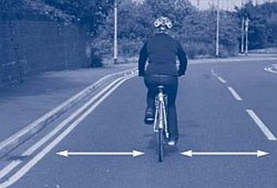
Primary Road Position
Understanding Primary Road Position
The primary road position is that of the general flow of traffic (ie in the centre of the lane). Contrary to what inexperienced cyclists may think, this is where they are often safer, as it is where they can most easily see and be seen. Trainees should be encouraged to think like a driver of a vehicle, and if in doubt position themselves where a vehicle would be.
Riding in the primary position is sometimes called taking the lane as the cyclist takes the position normally taken by the motorist, who is thus prevented from attempting to overtake.
When riding in the primary position, trainees should travel at a reasonable speed, as part of the traffic flow. If, however, traffic is building up behind them and the road ahead is clear, they may wish to move to the secondary position to avoid obstructing other road-users unnecessarily.
It is important to:
- - know which side of the road to ride on
- - recognise the road edge/kerb and centre lines
- - continue to monitor other road users in front and over their right shoulder
- - identify situations where the primary position is appropriate
- - move into the primary position in a controlled manner
- - demonstrate that the primary position is the centre of the lane
- - monitor the road for vehicles stopping, the road narrowing or other potential hazards
- - cover the brake levers at all times.
Understanding Secondary Road Position
The secondary road position (roughly 1 metre to the left of the traffic flow and not less than 0.5 metres to the edge of the road) may be appropriate if the road is wide enough to allow safe overtaking, and the rider’s safety is not reduced by riding in this position.
The correct choice of road position can be used to help riders affect driver behaviour, in order to help avoid collisions with other road users, or to avoid them having to brake suddenly. The secondary position is a useful position on most minor roads where there are few parked vehicles on the carriageway, and is particularly appealing to beginners as it leaves them closer to the perceived safety of the pavement.
It is important to:
- - know which side of the road to ride on
- - recognise the road edge/kerb and centre lines
- - use the see and be seen principle and show how this relates to road position
- - identify situations where the secondary position is appropriate
- - establish the minimum distance to be maintained from the kerb for safety reasons
- - ride a consistent path in a controlled manner
- - continue to monitor other road users in front and over their right shoulder
- - monitor the road surface for potential hazards
- - look ahead along the road for vehicles stopping, the road narrowing or other potential hazards
- - cover the brake levers at all times.
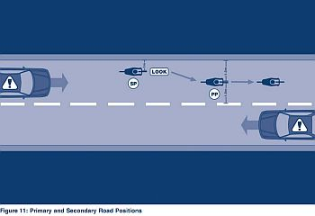

CYCLING UK

How far from the edge?
Normally you’ll be a metre out or more.
The key factor is not so much the edge of the road as the location of the traffic stream on that road; that is, where cars are actually driving in that traffic lane.
Unless you’re turning right, for example, there are two cycling positions to choose from, relative to the traffic stream.
One is the centre of the traffic stream – that is, the centre of the lane, rather than the centre of the road.
You’ll sometimes hear this called ‘the primary position’, but it’s easier to think of it as ‘taking the lane’. The other position is about a metre to the left of the traffic stream, so long as that doesn’t bring you too close to the kerb.
Sometimes called ‘the secondary position’, you can think of it simply as ‘not taking the lane’.
For more on this topic, visit cyclecraft.co.uk
