GGL 2570H / centre-pivot / conservation
When planning dictates that a window of traditional external appearance is required, conservation roof windows should be considered. All of our conservation roof windows have the same technical features of a VELUX roof window but in a traditional black conservation style.
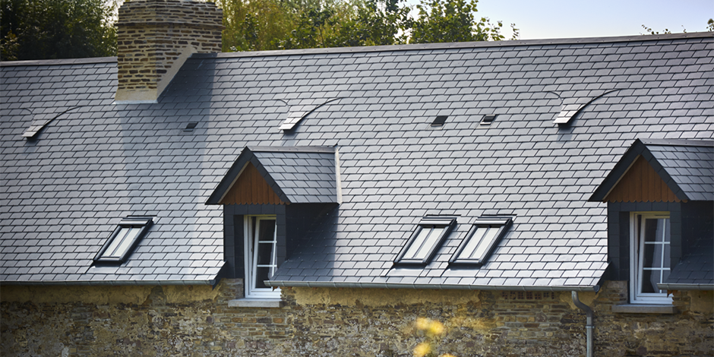
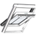
Price from inc. VAT £402
Control : | Manual
Glazing : | 70H
Operation : | Centre Pivot
Internal Finish : | Pine Finish
This is my product id
GGL FK06 2570H
This is my product price
£468

