Creative Doors
https://www.creativedoorsdirect.co.uk/bifold-doors/deluxe/openvu-deluxe-2690mm

OpenVu Deluxe 2690mm
Oak Bi-fold Doors (approx 9ft)
10-YEAR GUARANTEE
£1999INCLUDING VAT

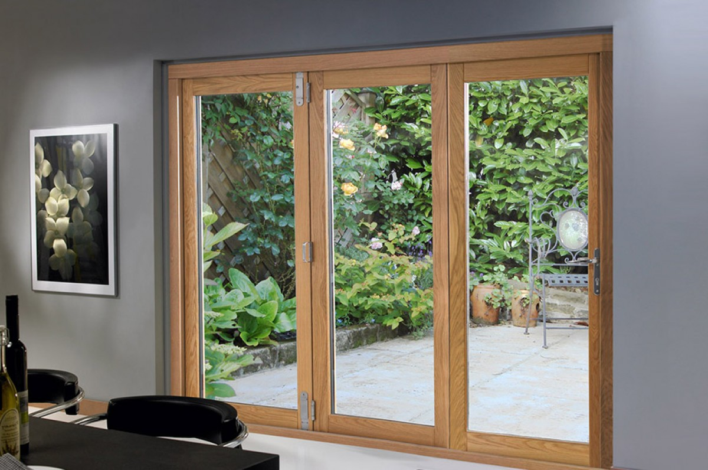
- 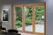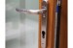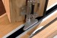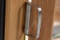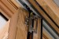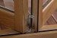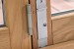
- 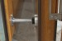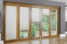

t

OpenVu Deluxe 2690mm
Made from a slowly grown hardwood core and thick real oak veneer (unfinished) with 54mm thick doors, these Deluxe 3 doors, 2690mm wide ( approx 9ft) bi-fold doors are built to last. Due to the thickness of the doors and thinner stiles, you gain a bigger glass area with more light penetration - ideal for that new extension.
The Deluxe range is by far our best seller due to the classy stainless steel hardware, stylish aluminium and oak external cill and being the perfect choice to stain, varnish or paint to your own colour choice to match your internal décor. A three-point locking system coupled with other internal bolts and excellent thermal efficiency means you can be safe and snug in your home.
Designed and manufactured by us, you can be assured there is no better unfinished oak 2690mm wide, 3 door bi-fold doors on the market with the same quality at such affordability. And what’s more, they are designed for easy installation (instructions included) by you or your builder. We also have an internal cill option if you are fitting between a conservatory and the original external wall of the house. Now with slimmer stiles and rails to give you a bigger glass area.
Additional extras:
• Brushed graphite handle
• Door catch kit

- Our OpenVu Deluxe 2690mm have been rated 4.96/5 stars from 276 individual customer reviews
- Starting at: £1999 - In Stock

