Continued…

**T6**

**T6**

Continued …..

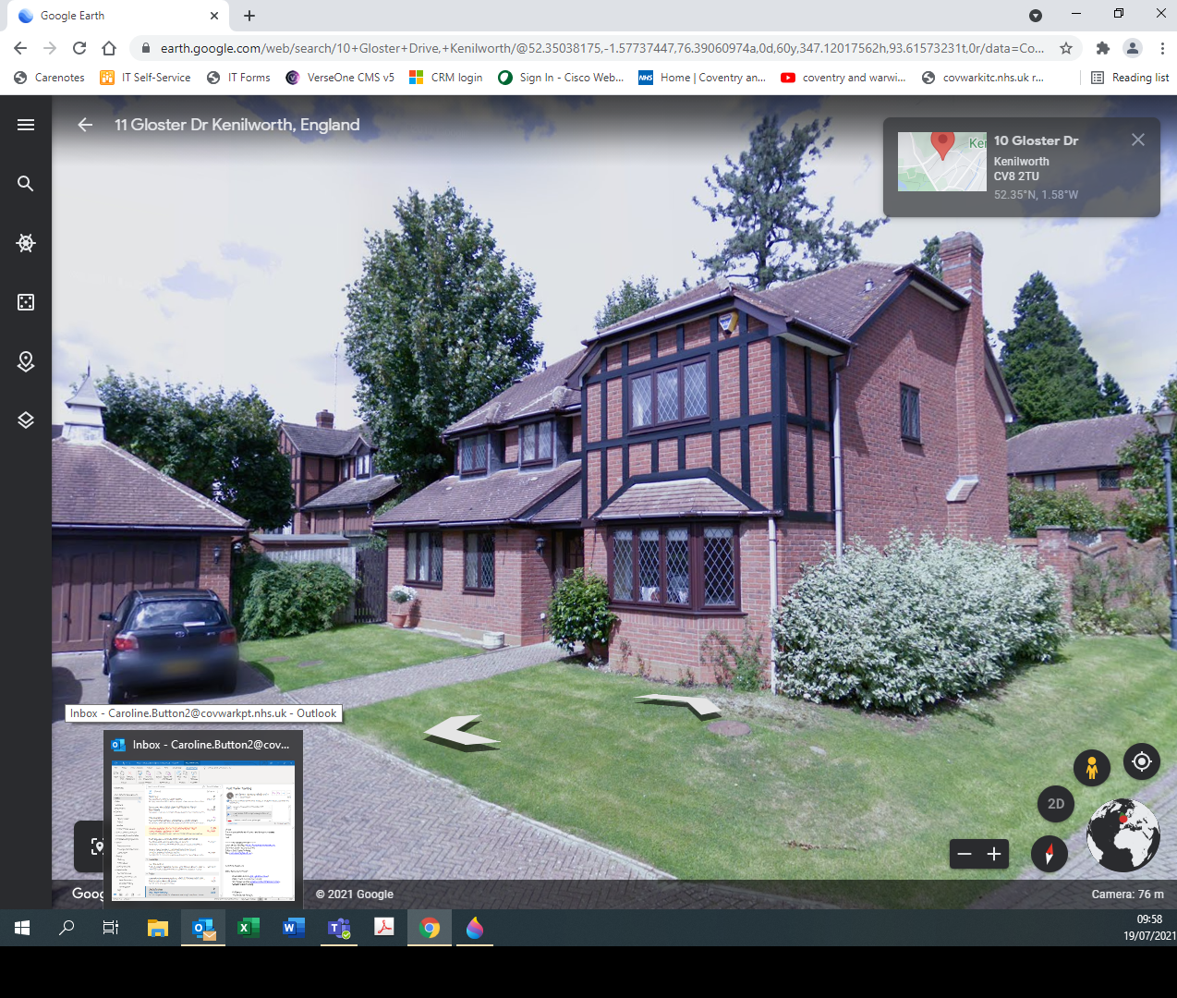 Continued …..

**T6**