Jeune, Brittains Farm, Sevenoaks

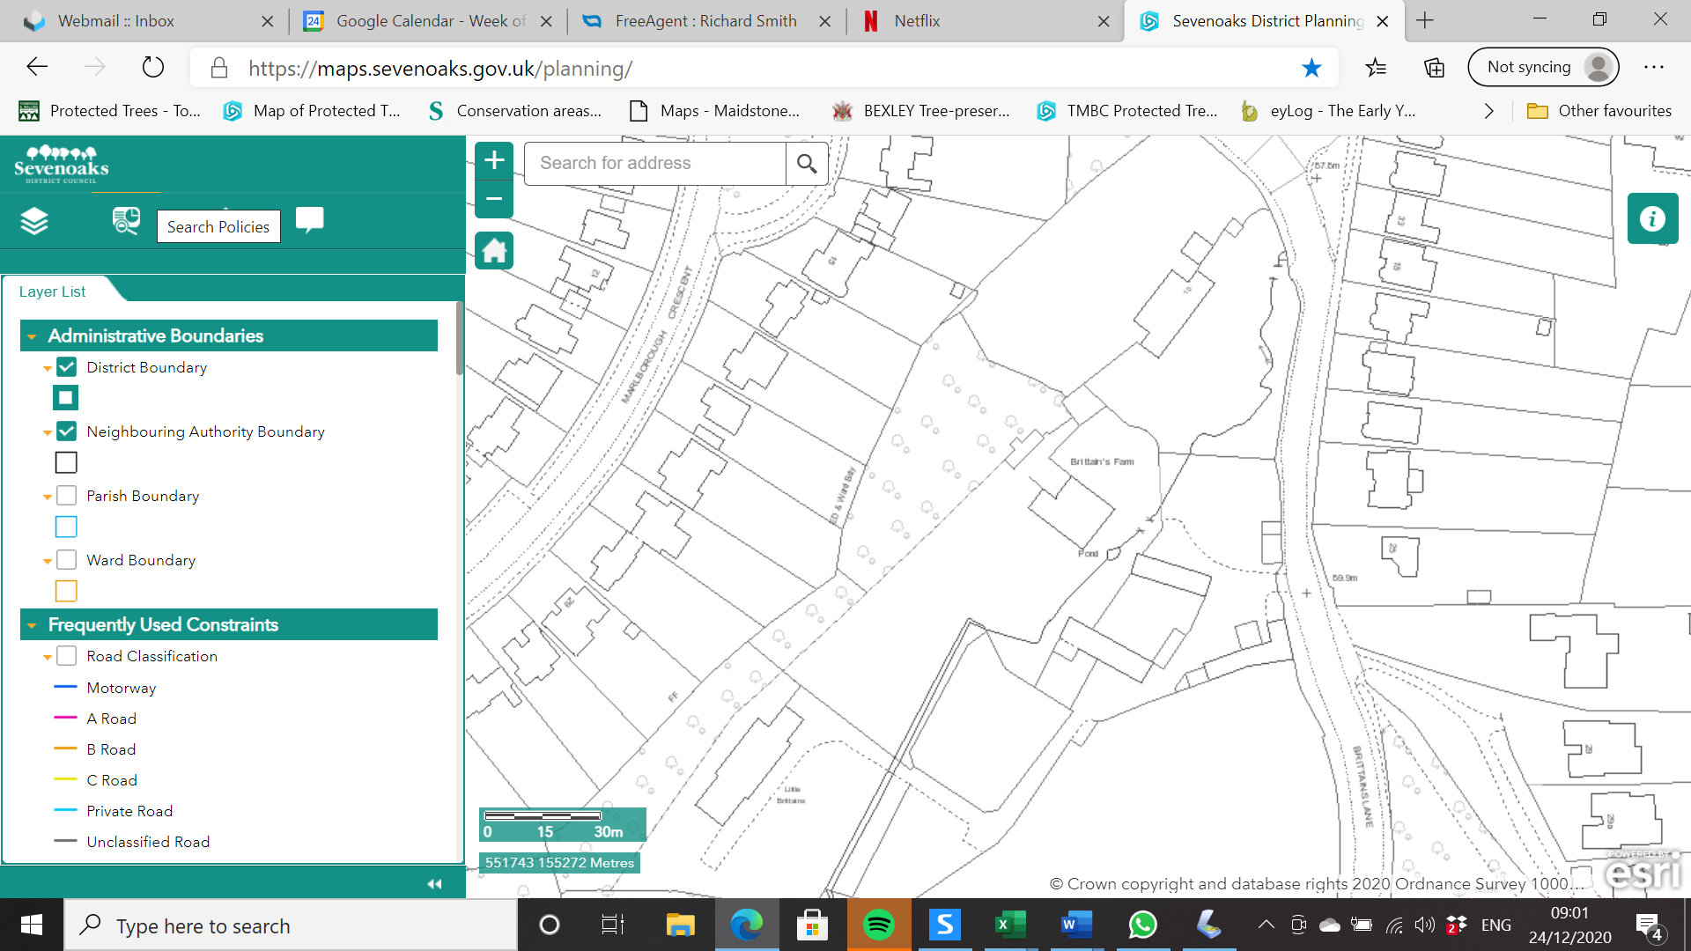

T2 Ash

T3 Ash

T1 Ash

T4 Poplar

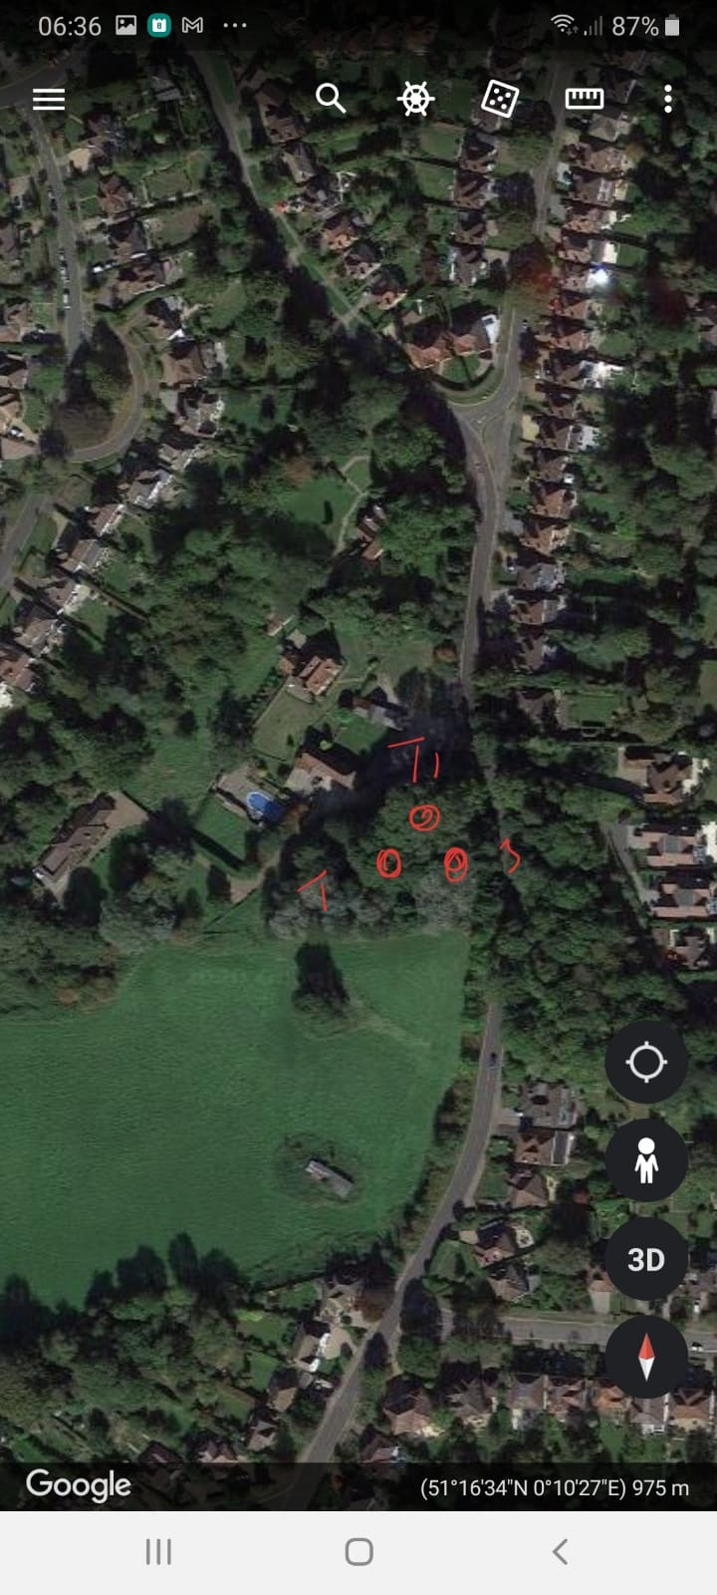

Reduce Large Limb

Fell