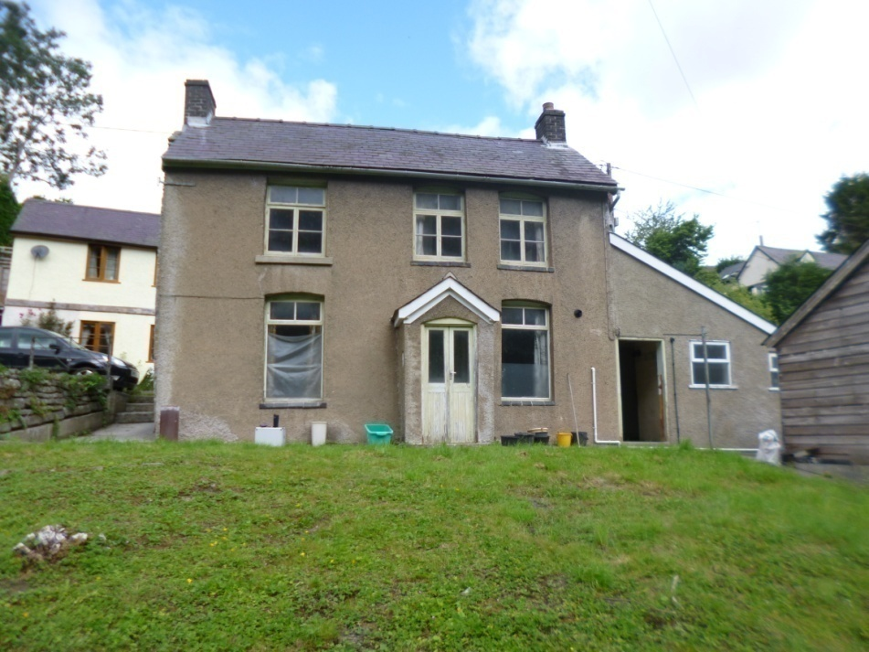
58 MILL RD
KNIGHTON LD71RT

JUSTIFICATION, DESIGN & ACCESS STATEMENT

APPLICATION:
Demolition of garage and outbuildings to create new joint/combined access, alterations and extension to existing house, with adjoining parking and amenity space.

SITE ADDRESS | 58 MILL ROAD  KNIGHTON  LD7 1RT | Date: | 24.07.2021

Contact Details
 | Applicant’s details |  | Agent’s details
Name: | MR. R.THOMAS | Name: | RICHARD HURLOCK
Address: | BRON HEULWEN  BLEDDFA  KNIGHTON  LD71PA | Address: | 37 FORGE HOUSE  HIGH ST  PRESTEIGNE
Email: |  | Post code: | LD8 2BE
Tel: |  | Tel: | 01544 267622

JUSTIFICATION

The proposal is for the renovation and alteration of the existing house to provide a three bedroom house with modern standards of insulation and services. The overall footprint of demolition (including garage and outbuildings) is 72.5 sqm and the new one will be 69sqm.
There is no Planning requirement in a conservation area to demolish a building which does not exceed 115 cubic metres or to take down any wall, gate or fence which is less than 1 metre high where abutting a highway, or less than 2 metres high elsewhere.

(1) The application site is historically a domestic one and adjoins a larger area owned by the applicant currently classed either as B8 or sui generis (used for storage or distribution and retail) that abuts the public road. Currently parking and access for both sites is unrestricted over a total length of approx 24 metres parallel to the public road. The line between public and private has no delineating kerb or gutter, whilst the public road is less than 5.5 wide.
The driveway will be constructed to ensure that access to the development is sustainable for all users, promoting active travel in line with the Active Travel (Wales) Act. Ensuring that the driveway is permeable, connected and complements the surrounding environment
The applicant would consider gifting enough space to provide a width of 5.5 metres where the access meets Mill Road and the design takes into account the measures necessary in order
(a) Not to have a detrimental impact upon highway safety; it is considered that both sites would benefit from a shared access with defined boundaries
(b) Retain the boundary structure to continue making a positive contribution to the character or appearance of the conservation area and create a layout which has a distinctive character within the built environment and landscaping;
(c) Create a vertical visibility envelope at the public Highway interface where the driver’s vision will remain clear, enabling a driver to see a potential hazard and react appropriately. A height of 600mm should be taken as the point above which unobstructed visibility should be provided.

In addition the overall design:
(a) Will employ holistic solutions, improving the site’s environmental credentials for the purposes of sustainable land drainage (and the water cycle) and will provide multiple benefits such as improving visual amenity with compensatory planting, whilst creating space to park off road thereby supporting sustainable travel and connectivity."
(b) Surface water drainage will be designed, to mitigate the potential adverse impact of any new development on flood risk and incorporate the existing system. Given that the public Highway is higher than the proposed access, there is no prospect of the discharge of private water into the highway drainage systems.
(C) The design and materials are sympathetic to the existing and surrounding dwellings and locality of the development, whilst the design and scale are appropriate in relation the building; and the height is subordinate to the original structure.
The Northern extension is being reduced to keep the retaining wall and the new extension being built some 1500 inside this line.
There is no adverse effect on the amenity which neighbouring residents could reasonably expect to enjoy.
Policies considered:

National Planning Policy:

Planning Policy Wales (Edition 10, Dec 2018)
Technical Advice Note (TAN) 5: Nature, Conservation and Planning (2009)
Technical Advice Note (TAN) 12: Design (2014)
Technical Advice Note (TAN) 18: Transport (2007)
Technical Advice Note (TAN) 24: The Historic Environment (2017)

Local Planning Policy:

Local Development Plan (2018)

DM2 – The Natural Environment
DM4 - Landscape
DM13 – Design and Resources
H7 – Householder Development
SP7 – Safeguarding of Strategic Resources and Assets
T1 – Travel, Traffic and Transport Infrastructure

Principal Planning Constraints

Knighton Conservation Area
Public Right of Way 124/1160/1

Principle of Development

Polices TAN18, DM13 (Part 10) and H7 setting out the principle of development for the creation of a pull in space of for vehicles.

ACCESSABILITY
Currently the site accesses Mill Road over an approx 24.500 metre frontage comprising direct access, garage frontage and parking with mixed use of Classes C3 and B8 traffic. The public road is of varied width at this point and a pinch point for two way traffic.
The proposal would involve the demolition of the garage, removal of the parking bay immediately adjacent to no 58 and begin the new driveway access at the point indicated on the plan thus releasing a public road width of 5.5 metres over the aforementioned approx 25.5 frontage.
The re-designed access will follow Highways guidelines as drawn and service both sites with adequate visibility onto Mill Road and parking and turning created within the site. The surface would be in porous laid paviors with adequate run off surface drainage. Surface water run-off will be more than offset by the removal of a total area of approx 250 sq m of assorted hard surfaces (tarmac, concrete, etc)
The property will have level access to the door and throughout. There is plenty of room for bike storage, refuse storage etc. A carriageway gradient of 1 in 20 (5%) to 1 in 12 can be maintained.

CHARACTER
The Site falls away from the road with an average gradient of 1 in 12 and comprises of mostly lawn. The existing house is unusually narrow reflecting the rather pinched site that it occupies. The proposed development is mostly away from the road to the SE of the building that is historically the front, again owing to the unusual siting of the house.
The proposed design follows traditional vernacular styles of render and lapboard under slate with fenestration sympathetic to other houses. This will follow criteria that supports quality and locally distinct design which complements and protects the built heritage. It will also enhance and value the historic environment and context of the site

COMMUNITY SAFETY
The new access will remove Highway concerns and the shared access is controllable from the house. The existing kitchen wall fronts a public road, this will be reduced in height and rebuilt to give greater stability whilst maintaining the same appearance and outer material The proposal will address this issue.
Currently it is possible to park outside the property though this causes a restriction to the road width and creates an element of personal risk. The proposal will address this issue.
The presence of the owners living on site will enable prompt response to any vandalism or break in. The proposed car parking and turning area with reactive lighting will be adequate for medical or criminal situations.

ENVIRONMENTAL SUSTAINABILITY

The hard standing will be of paviers or a similar porous system allowing a soakaway style drainage process
No trees are affected by the development and whilst bearing in mind that this is an existing domestic garden, a scheme of additional “random hedge type” planting will be carried out along the North edge of the garden,(currently a wire stock fence)creating privacy and a wildlife corridor. Consideration has been given to incorporating biodiversity enhancements to ensure net biodiversity benefits. The “random hedge” will create a wildlife buffer strip with a scheme of appropriate management of these areas,
These alterations help to Protect, enhance and demonstrate a value for biodiversity and the historic area. Existing boundaries are retained and maintained.

MOVEMENT

The site already has hard standing pedestrian access from the public road, straight into the centre of town with a full range of amenities. The location is easy walking distance to local schools, shops, town centre & bus stop, whilst popular leisure walks begin literally at the front door..
This would seem to satisfy local authority proposals for sustainable movement.

CONCLUSION

The alterations will improve applicants lifestyle, safety and energy consumption, whilst creating a viable contemporary household with parking and unloading area that will be unobtrusive in impact. The removal of any impediment to the Highway is a community gain and the retention of the original house maintains the historic context of the site.

