Tendring District Local Plan Publication Draft Final
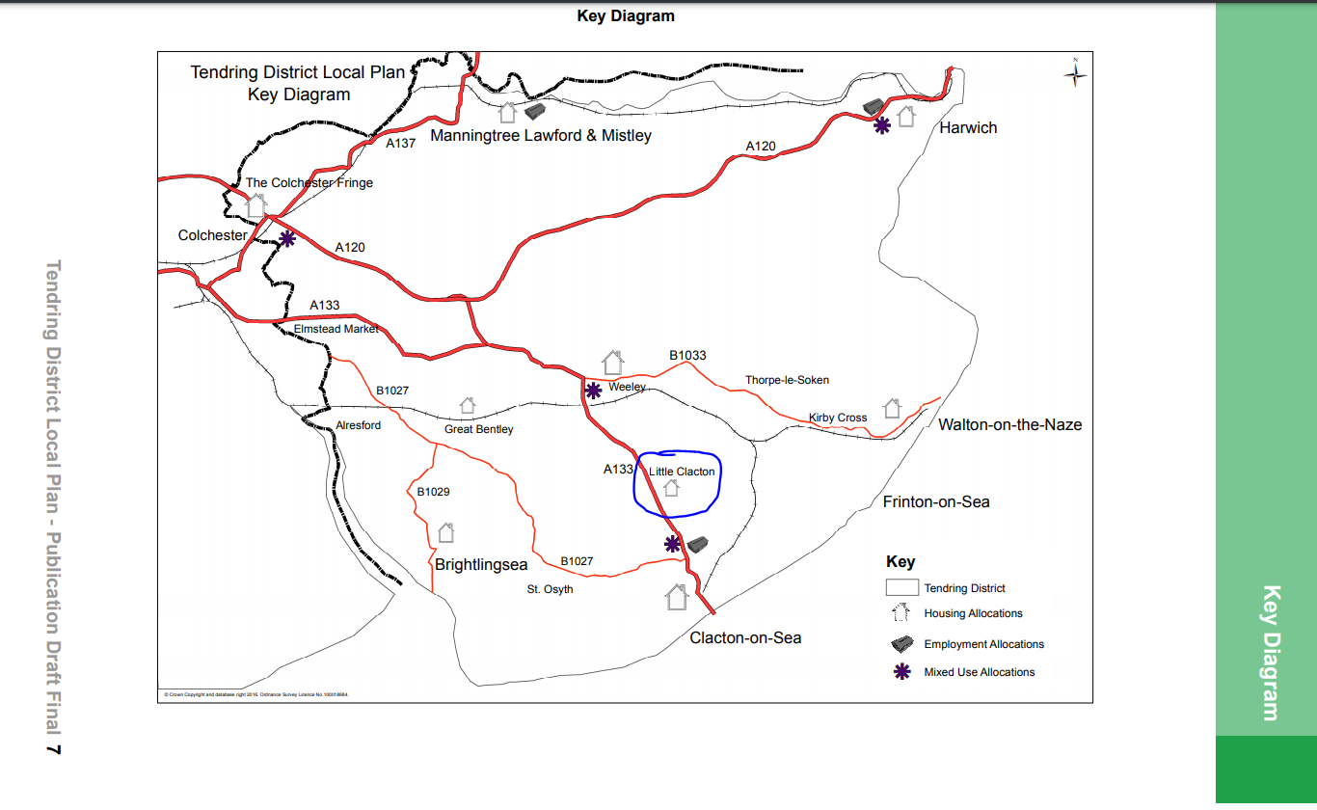

Proposals Map B.19 Little Clacton Enlarged. Site marked with blue cross.

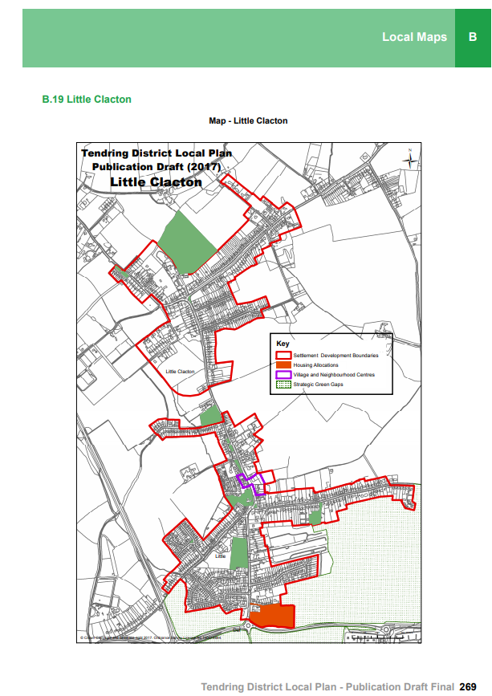
Enlarged Proposals Map B.19 Little Clacton Enlarged. Site marked with blue cross.

