Google Earth Images Site is marked with a blue cross.

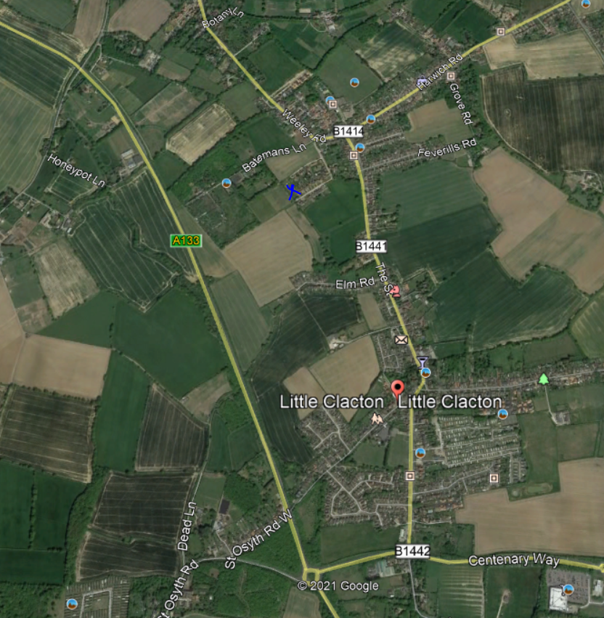
Map data ©2020Google

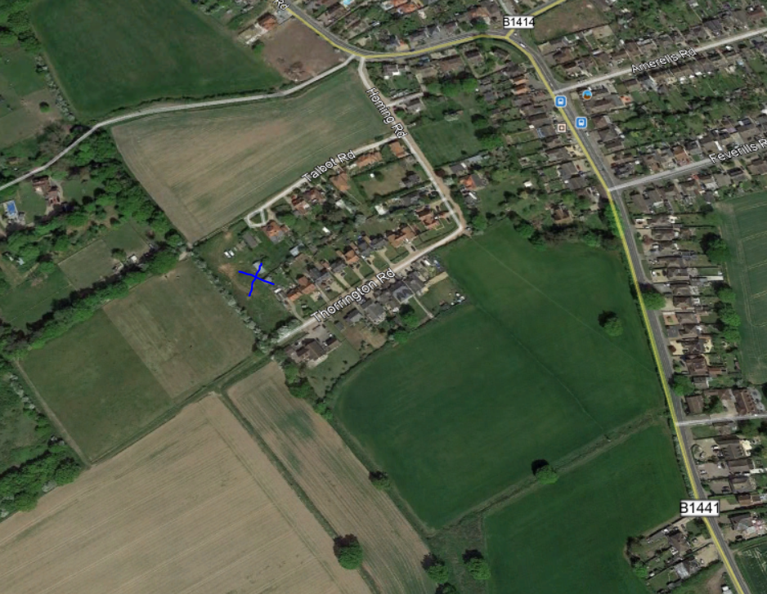
Map data ©2020Google

