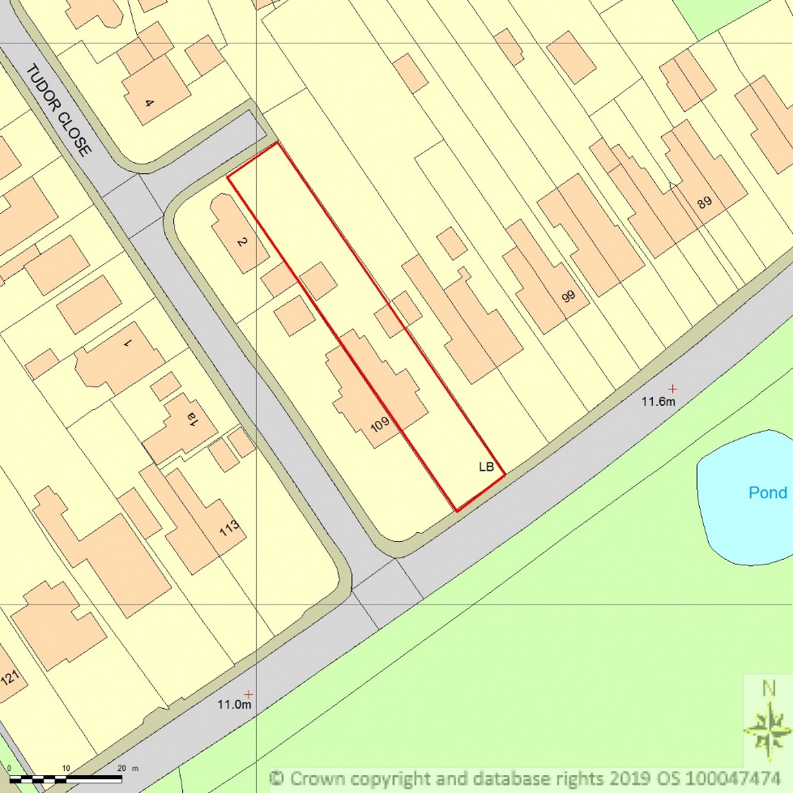
SITE LOCATION PLAN
AREA 2 HA
SCALE 1:1250 on A4
CENTRE COORDINATES: 333525, 439837

Supplied by Streetwise Maps Ltd
www.streetwise.net
Licence No: 100047474
11/03/2019 13:04

