STEPHEN KNIGHTLEY PARTNERSHIP
Chartered Award Winning Architectural Designers

DESIGN & ACCESS STATEMENT

26 Beech Road, St Austell, PL25 4TS, Cornwall

Cornish Building Group Awards.

DESIGN STATEMENT

LOCATION: 26 BEECH ROAD
ST. AUSTELL
CORNWALL
PL25 4TS

PROPOSAL: ALTERATIONS TO EXISTING GARAGE WORKSHOP/SHOWROOM

CLIENT: MR GEACH

DESIGNER: STEPHEN KNIGHTLEY PARTNERSHIP
SPRING GARDENS
BRADFORD’ S QUAY
WADEBRIDGE
CORNWALL
PL27 6DB

PLANNING AUTHORITY: CORNWALL COUNCIL

PLANNING CONSULTANTS:

26 BEECH ROAD, ST. AUSTELL, CORNWALL

INTRODUCTION

The present garage/workshop is in extremely poor condition with the existing roofs leaking and failing structurally.

The showrooms are no longer in use and indeed much of the building is redundant.

The proprietor who formerly rented the property but now owns it and wishes to remove part the building and create a new ‘fit for purpose’ industrial building.

Where buildings have been removed there will be parking areas where at present there are none.

LOCATION

The site is found adjoining a park in an area of mixed housing and light commercial buildings.

The location plan clearly shows that the proposals are within the extent of the existing business.

This application site is within walking distance of the local amenities such as transport, schools, shops, doctors and other commercial outlets.

The speed limit along Beech Road is 30mph.

Vehicular access to the site is via an existing entrance/driveway

Disabled access is provided via a level approach to the proposals

KEY FEATURES

The existing buildings are in poor condition and beyond economic repair being no longer fit for purpose.

The footprint of the new unit is less than the existing footprint.

The boundaries of the site are well defined and heavily planted with bushes/trees on the south elevation (park), all of which remain.

The land belongs to the applicant.

The applicant is willing to have all permitted development rights removed from the site upon approval of the application.

The design proposals are intended to provide a modern version of a working garage/work shop with good parking facilities and amenities for employees such as washing and WC’s.

Having discussed these proposals locally it is considered that the design would enhance this rather untidy space.

26 BEECH ROAD, ST. AUSTELL, CORNWALL

SITE LAYOUT
It is intended to place this proposals on the site in a position that makes maximum use of the existing levels and entrances thus the new property will be a more user friendly premise which will tidy up this rather scruffy site.

The entrance to proposed site is via the existing public adopted highway and footpath. The existing accesses will be retained.

The site layout provides level parking for customers and employees.

ROOF FORM

The roof design provides a simple gable roof. The roof will be clad with industrial cladding.

ELEVATIONS

The elevations are designed to provide a street scene that fits with the existing.

LANDSCAPING

The proposals make good use of the existing topography and will maintain the existing levels, boundaries etc.

CONCLUSIONS

This application allows for the existing outdated buildings to be removed and a new purpose built building be created with better facilities, parking and of a more suitable appearance.
We would respectfully suggest this application meets the requirements of planning consideration and therefore request this application to be approved.

Stephen Knightley
July 2021

LAND AT CLAPPER, WADEBRIDGE, CORNWALL.

PHOTOGRAPHS

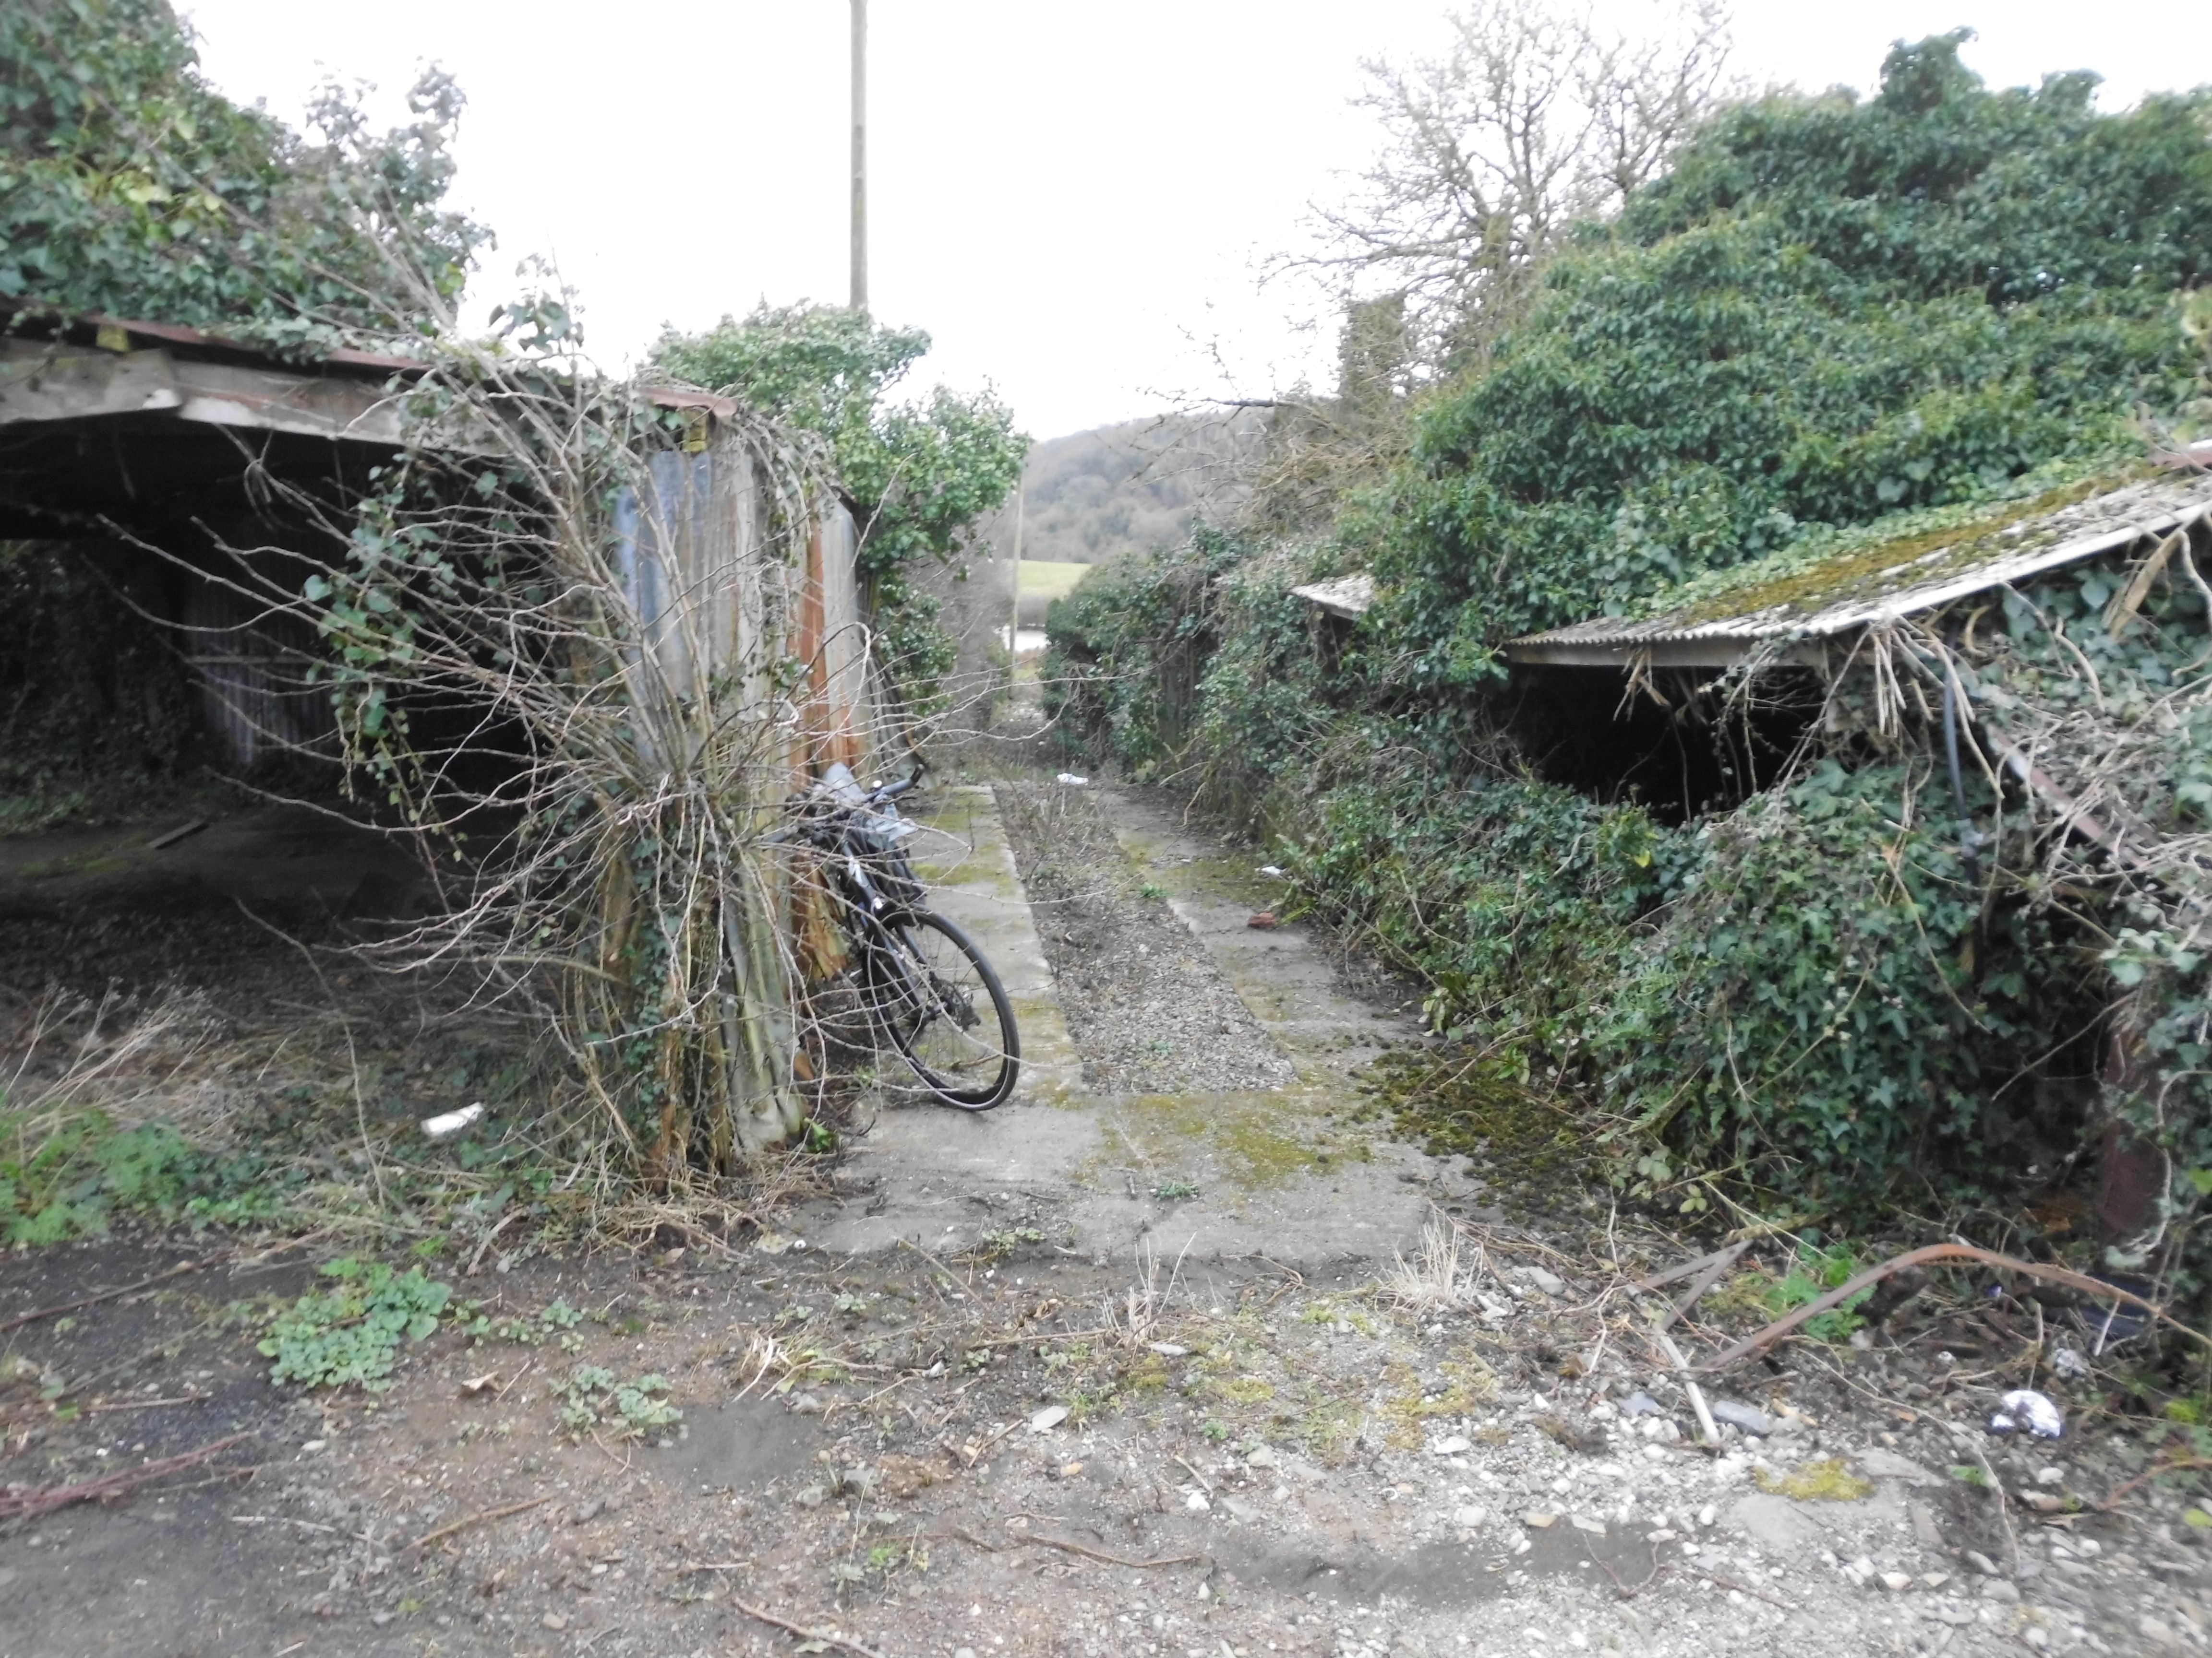

Existing vehicular access to the site and redundant buildings to be renovated.

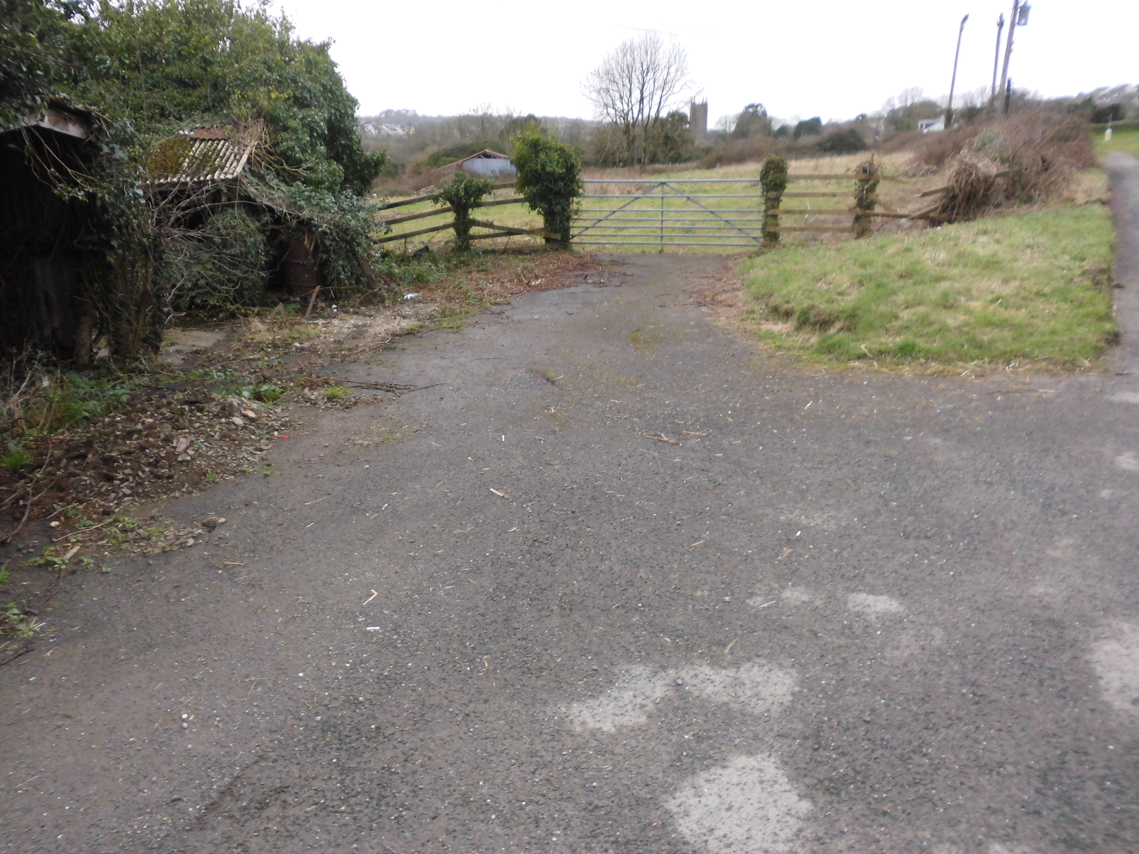

Existing access from road

LAND AT CLAPPER, WADEBRIDGE, CORNWALL.

PHOTOGRAPHS
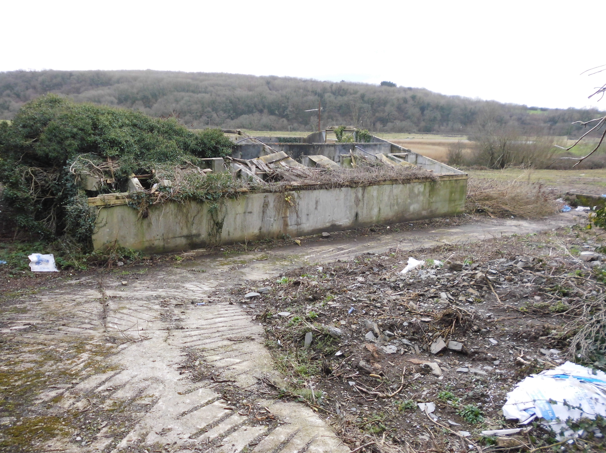

Existing access and redundant building on site of proposed dwelling.

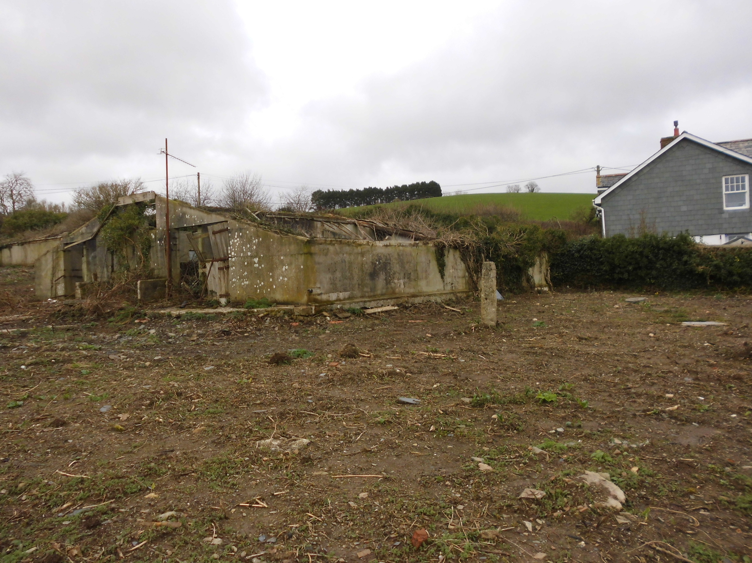

Redundant building on site of proposed dwelling and existing adjoining dwelling/workshop

LAND AT CLAPPER, WADEBRIDGE, CORNWALL.

PHOTOGRAPHS

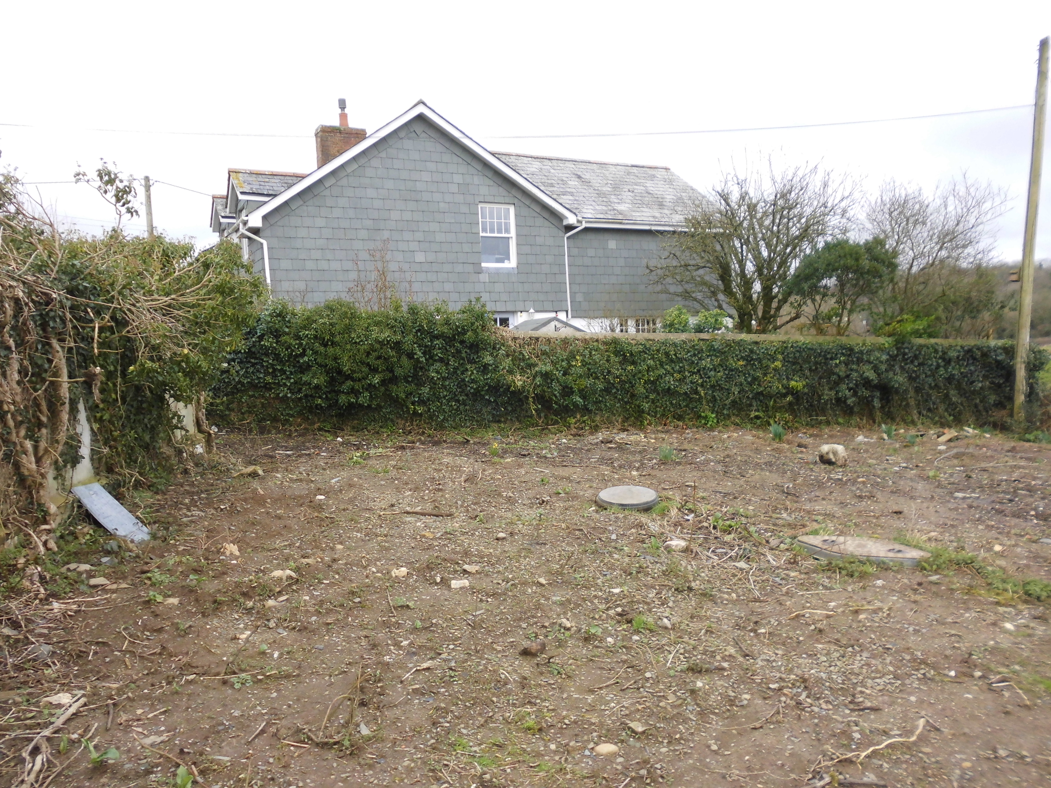

Adjoining dwelling/workshop

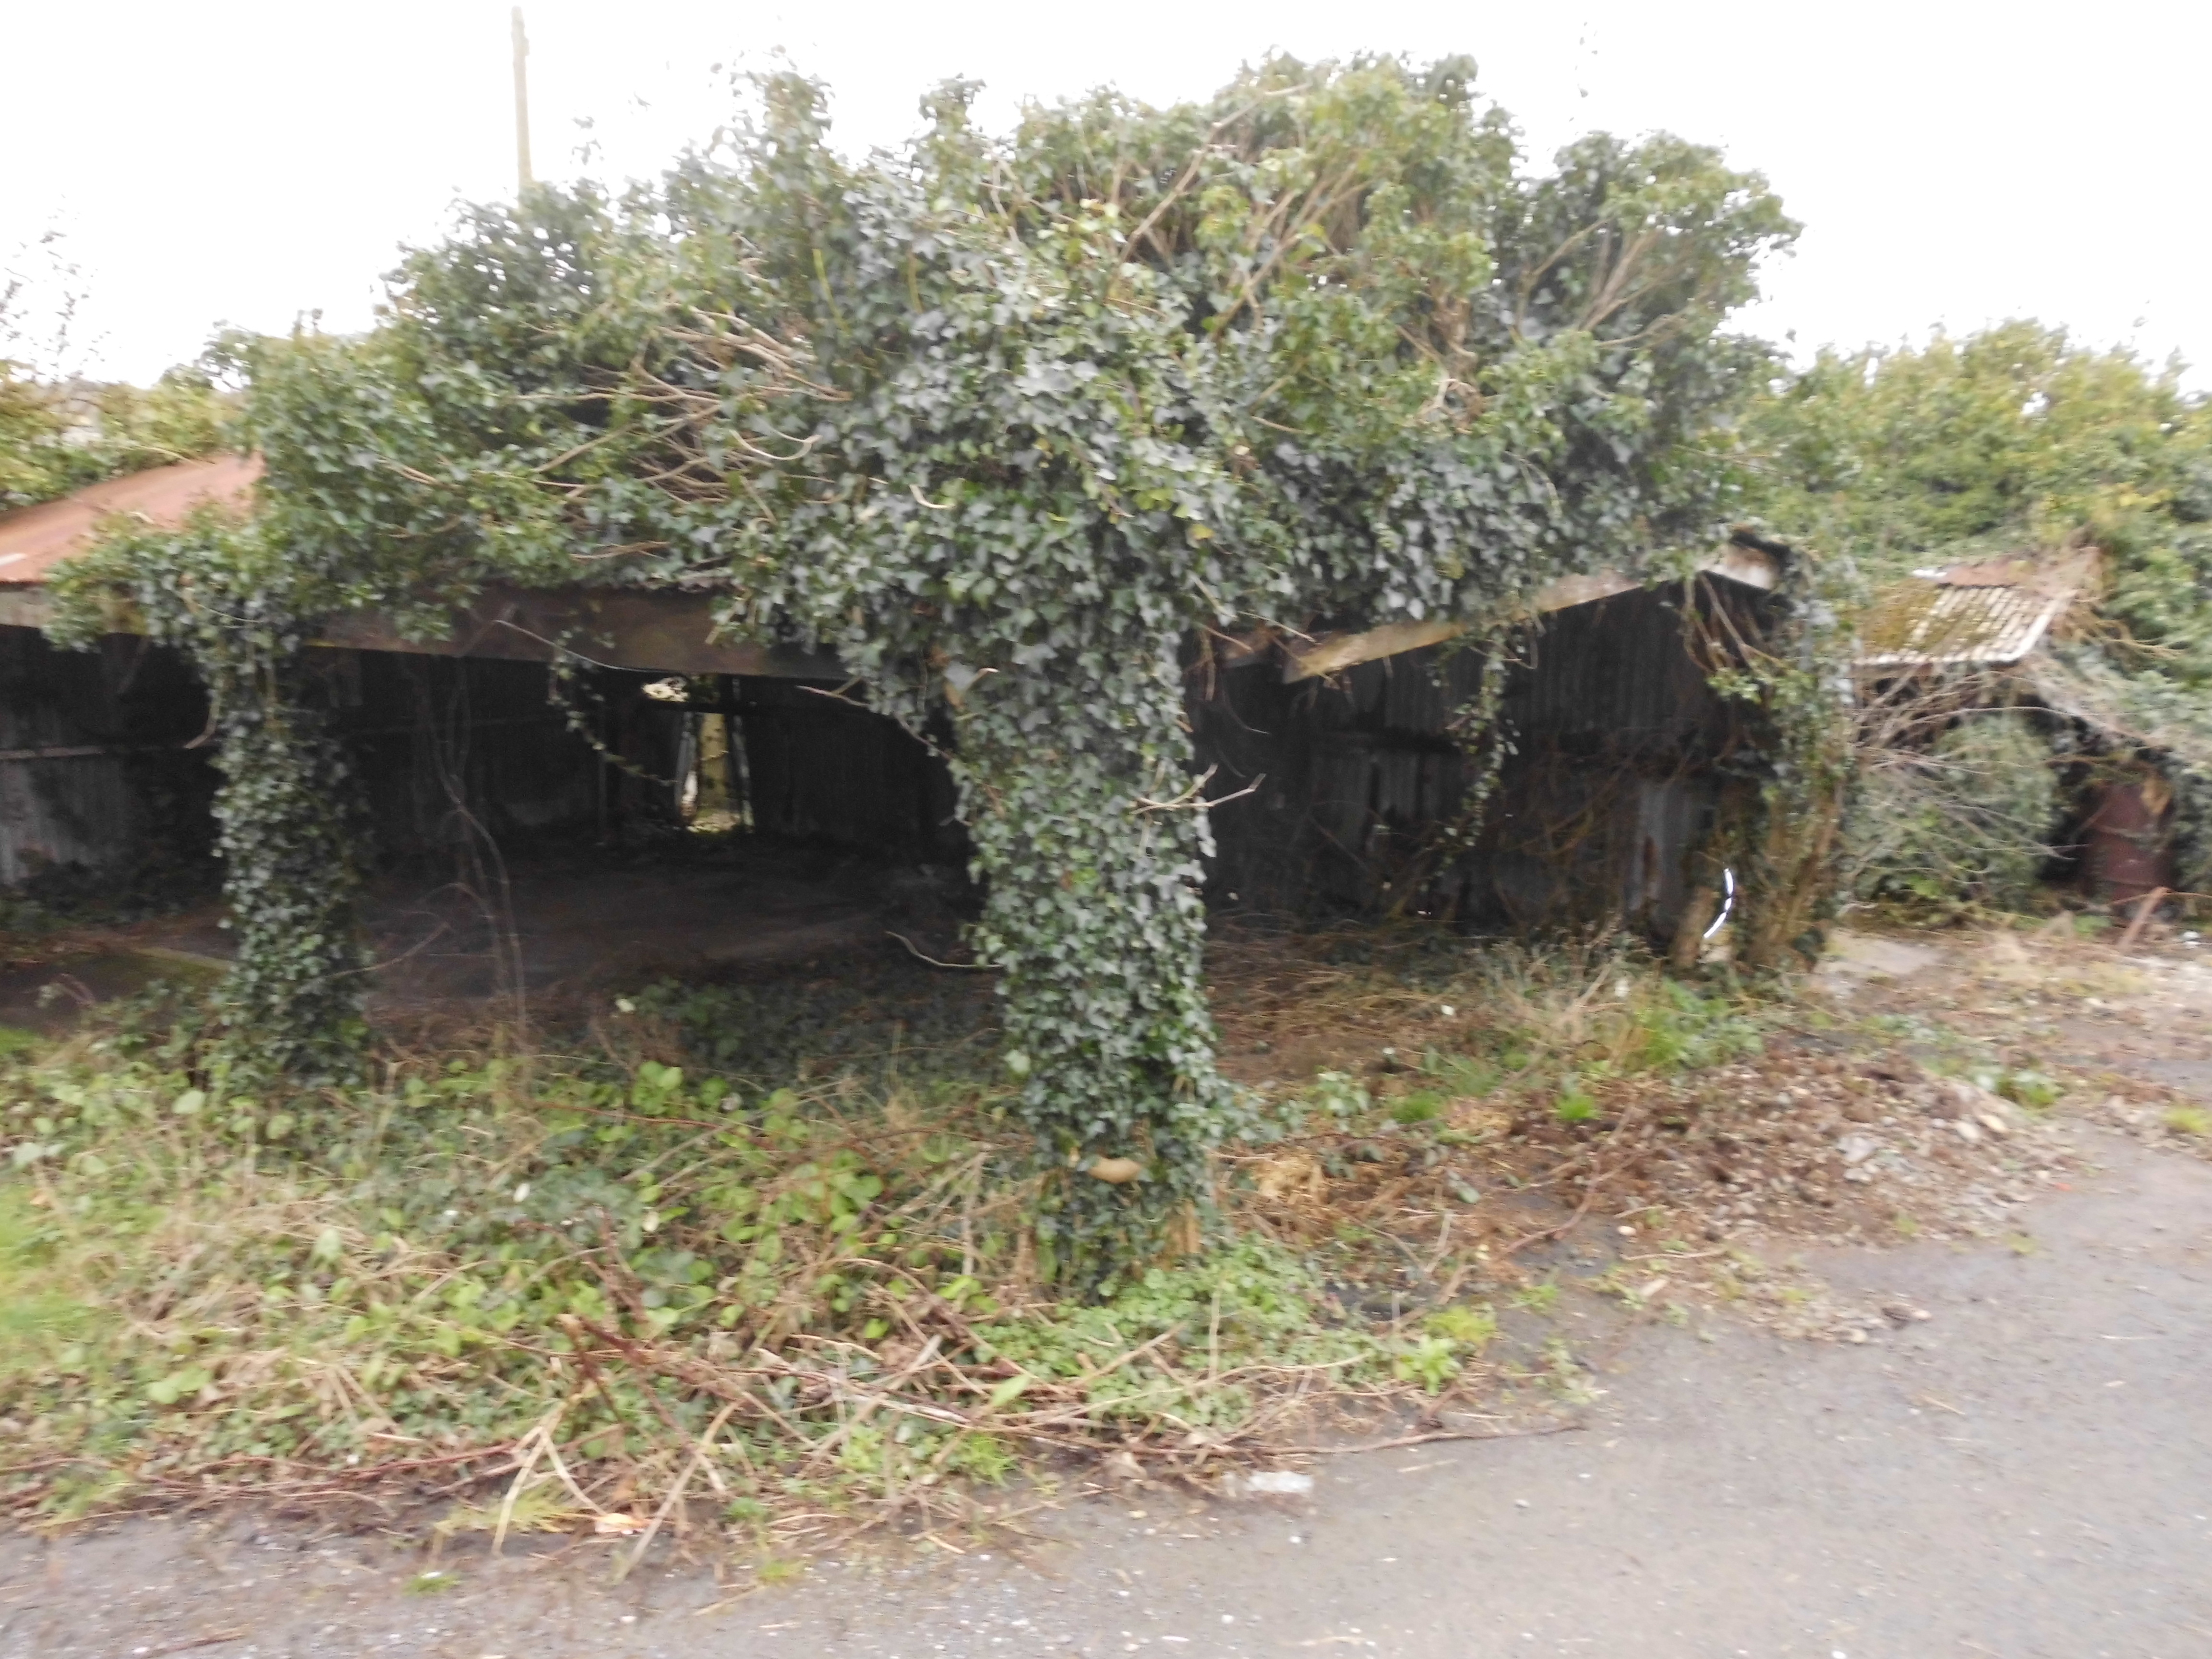

Redundant building at entrance to site, this is the unsafe view of this site from the road.

LAND AT CLAPPER, WADEBRIDGE, CORNWALL.

PHOTOGRAPHS

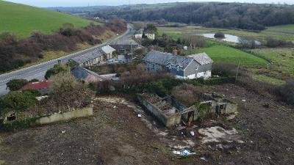

Ariel view

