The Grove
8 Blakebrook
Kidderminster, Worcs. DY11 6AP

Heritage Statement

This document is to accompany a Retrospective Listed Building Application for the retention of an external flue to the front elevation of the building.

This document is a Heritage S tatement in compliance with the NPPF paragraph 189. 7 Blakebrook is a Grade II listed building set within the Blakebrook Conservation Area.

Kidderminster is a large market and historic minster town and civil parish in Worcestershire, England, 17 miles south-west of Birmingham and 15 miles north of Worcester. Located north of the River Stour and east of the River Severn.

The property lies on Blakebrook, on the east side of the road on the West Side of Kidderminster Town Centre.

The Property is a Grade II Listed Building.

List Entry Number:
1100074
Date first listed:
17-Jan-1980
Statutory Address:
FLATS, 1-6, BLAKEBROOK
Statutory Address:
THE LIMES, 8, BLAKEBROOK
County:
Worcestershire
District:
Wyre Forest (District Authority)
Parish:
Kidderminster
National Grid Reference:
SO 82082 76647

Details
BLAKEBROOK 1. 5250 (west side) Flats 1 to 6 (consec), No 8 (The Limes) SO 8276 1/65 II GV
2. Early-mid C19. Two storeys, rough rendered with hipped slate roof. Four windows of irregular size above 3 to ground floor, stepped rusticated lintels with keystones. Porch with narrow columns, modern door. Window to gable end has 4 plain pilasters. Included for group value.

Planning Applications (9)
Planning (Listed Buildings and Conservation Areas) Act 1990 Planning (Listed Buildings and Conservation Areas) Regulations 1990 Listed Building/Conservation Area Consent WF326/05 dated 16 May 2005. Erection of a conservatory at The Grove, 8 Blake B
Ref. No: WF326/05 | Status: Pending Consideration
Town and Country Planning Act 1990 Town and Country Planning (General Development Procedure) Order 1995. WF327/05 dated 16 May 2005. Erection of a conservatory at The Grove, 8 Blake Brook, Kidderminster.
Ref. No: WF327/05 | Status: Pending Consideration
Town and Country Planning Act 1990 Town and Country Planning General Development Procedure Order 1995 WF355/01 dated 19 June 2001. Modification of Condition No.2 to planning permission WF45/84 to enable the property to be used by people with learning
Ref. No: WF355/01 | Status: Pending Consideration
Town and Country Planning Act 1971 WF957/88 dated 11 October 1988. Extensions at The Limes Rest Home, Blakebrook, Kidderminster.
Ref. No: WF957/88 | Status: Pending Consideration
Town and Country Planning Act 1971 Town and Country Planning (Control of Advertisements) Regulations Advertisement Consent WF297/86 dated 22 July 1986. Sign at The Limes, 8 Blakebrook, Kidderminster.
Ref. No: WF297/86 | Status: Pending Consideration
Town and Country Planning Act 1971 Listed Building Consent WF740/85 dated 15 October 1985. Extension to lounge at The Limes, 8 Blakebrook, Kidderminster.
Ref. No: WF740/85 | Status: Pending Consideration
Town and Country Planning Act 1971 WF314/85 dated 21 May 1985. Extension to communal living room at 8 Blakebrook, Kidderminster.
Ref. No: WF314/85 | Status: Pending Consideration
Town and Country Planning Act 1971 WF45/84 dated 21 February 1984. Change of use from flats to rest home at Blakebrook, Kidderminster.
Ref. No: WF45/84 | Status: Pending Consideration
Town and Country Planning Act 1971 WF75/75 dated 18 March 1975. Alteration to form six flats at The Limes, Blakebrook, Kidderminster.
Ref. No: WF75/75 | Status: Pending Consideration

Impact upon Building:
The inclusion of the flue does have a slight impact on the front elevation of the building. It’s been suggested that the flue should be painted a colour to match the main building render to soften the impact.
Choice of Materials:
The flue material choice is UPVC to avoid any future maintenance issues.

Feature:
The existing heritage features of the building will remain unaffected.

Justification/Mitigation:The proposed works will cause no long-term harm to the building.

Site Photos;

Photo prior to fitting of flue;

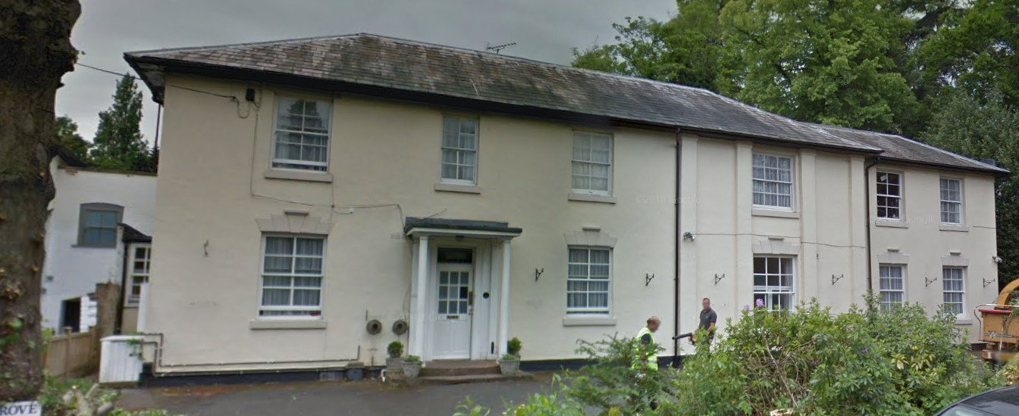

Current Photo;
