DESIGN, ACCESS and STATEMENT (DAS)

Proposal: Demolition of existing modern agricultural buildings and the erection of three detached dwelling houses.

Address: Poplars Farm. Lower Road, Hardwick, Bucks. HP22 4DZ

Application: Full planning and demolition in a conservation area.
Minor development

Full application pp-10050703
ALB pp-10143625

Local Planning Authority:
Formerly Aylesbury Vale District Council amalgamated with Buckinghamshire County Council, Chiltern, South Bucks and Wycombe District Councils in April 2020 to form the single unitary of Buckinghamshire Council.

Applicant: Mr K. Skinner

Site area: 2291 sq.m

Agent: ACH Planning Ltd Email: office@achplanning.co.uk
Tel: 01297 728274 Mobile: 07774 200026

Presenting the information:

Please refer to the ‘Validation Statement’.
The information excludes the traditional Outhouse building at the southern end, which is addressed in accompanying statements, thus focussing on the modern agricultural buildings and their replacement with two detached dwellings.

Pre-application discussion:

Please refer to the ‘Planning Statement’.

The design component:

Amount and scale

Existing structures:
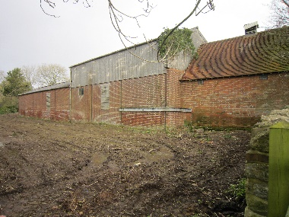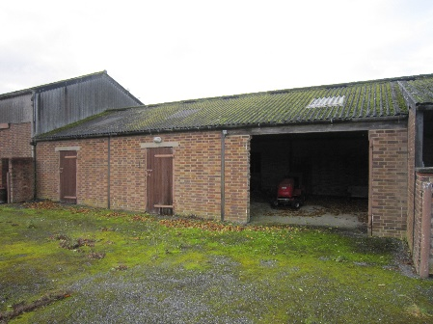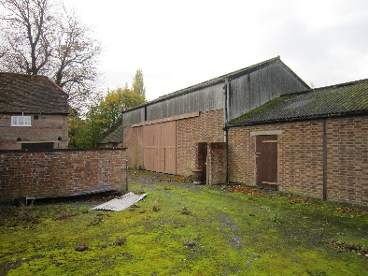

The existing buildings comprise three elements all joined together as one and identified as Barn 1, Barn 2 and Barn 3. Barns 2 and 3 relate to a single storey sections and Barn 1, a higher building that could accommodate two storeys.

Length 37m
Depth 9m reducing to 7.5m at the southern end
Ridge 6.8m and 8.1m reducing to 4.5m and 5.8m
Ground footprint area 291m² or 10,277 ft²

Proposed houses:

The main body of both houses is
Length 10m
Depth 6m
Eaves 3.8m
Ridge 7.1m

Ground footprint Plot 2 and 3 88.65m²
Plot 4 97.65m²
Total 274.95m² (net reduction of 16m² or 5.5%)

Additional detail can be found on the accompanying drawings.
Layout

Existing layout compared with the proposed layout

Please refer to the drawing number PFH.PLAN 5

The houses are located in the same position as the existing buildings and yard.

The design philosophy is based upon reducing the bulk and massing of the existing structures
to create the perception of greater space and reduced scale. This has been achieved by the introduction of variable roof levels and subservient appendages made up of contrasting timber framework with glass panels and timber weatherboarding commonly seen in rural areas. The main body of the houses are generously separated by a distance of 5m.

The modern farm buildings were served by a stock yard made up of granite chips set in tarmac and enclosed by a 1.6m high brick wall and tubular gates extending to the rear of the Range section of the Farmhouse.

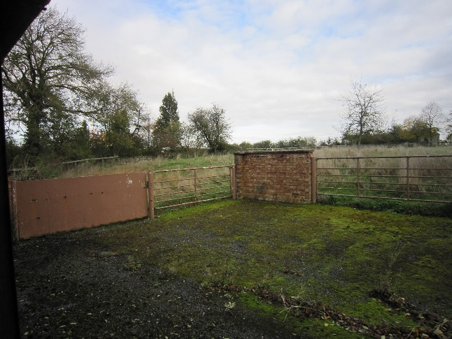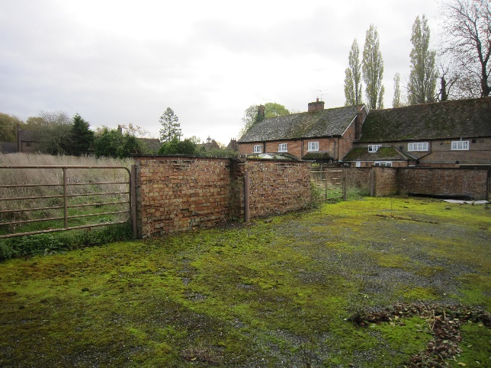

Existing walled stock yard

Planning permission has already been granted for the extended latter area to be used as part of the domestic garden serving the newly approved subdivision of the Range dwelling house. The enclosure is of no architectural or historic value and the common bricks show signs of serious deterioration and spalling.

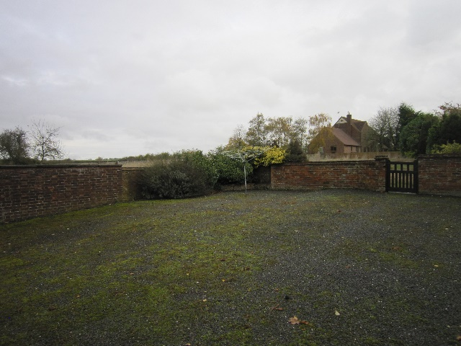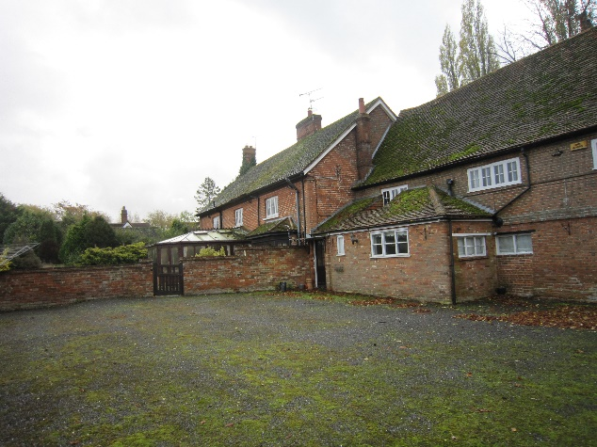
Stockyard extending to the north of The Range

It is proposed to utilise the existing walled stock area for access and car parking that will extend approximately 6m beyond the existing walled boundary to enable ease of parking and turning. It is proposed to replace the brick walls with a softer treatment with a 1.2m close boarded fence and native country hedging.

Landscaping

Please refer to drawing number PFH.PLAN 5.

The livestock retaining walls and gates will be removed and replaced by a 1.2m post and rail fence on the western boundary with native hedging planted on its eastern side. The existing yard will be re-laid with tarmac and the car parking spaces laid with brick pavers.

It is proposed to retain the Leylandii row of trees lining the western boundary with the A413.
The stone wall and gated entrance on the southern boundary with the Conservation Area will be repaired as necessary and maintained as existing. In other respects, the private gardens will be divided with 1.8m c/b timber fencing and laid to grass.

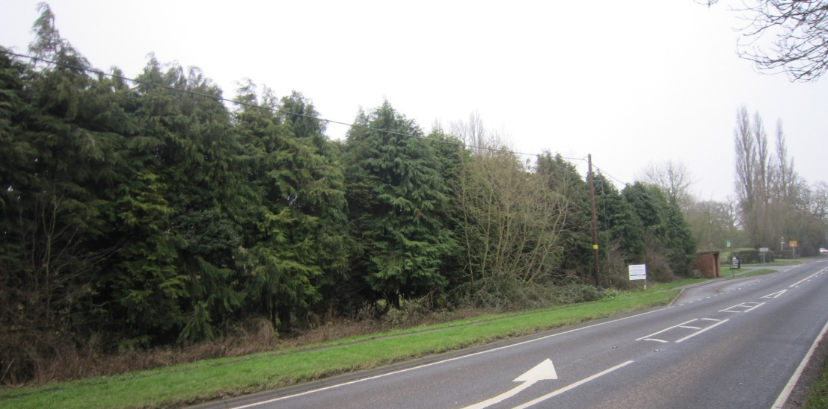
View from the A 413 showing the boundary trees to remain as existing and the nearby bus stop in the distance.

Appearance

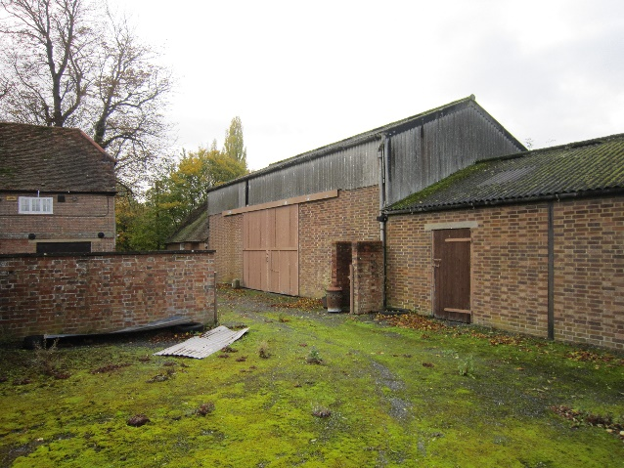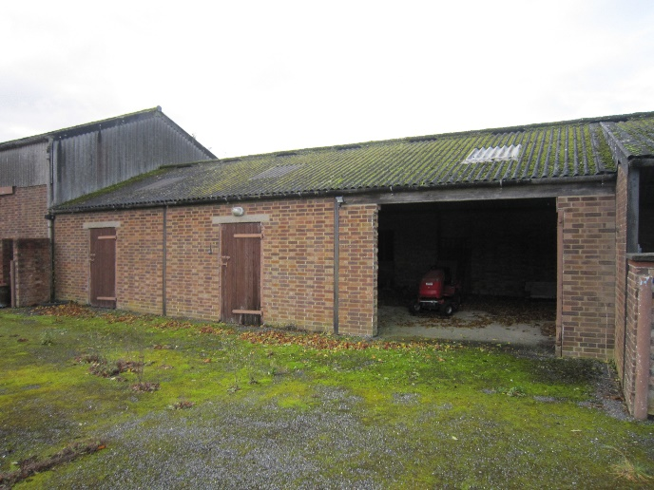

Inner/east elevations of existing barns

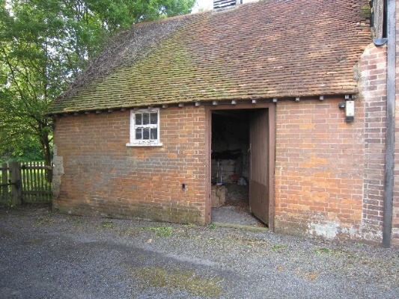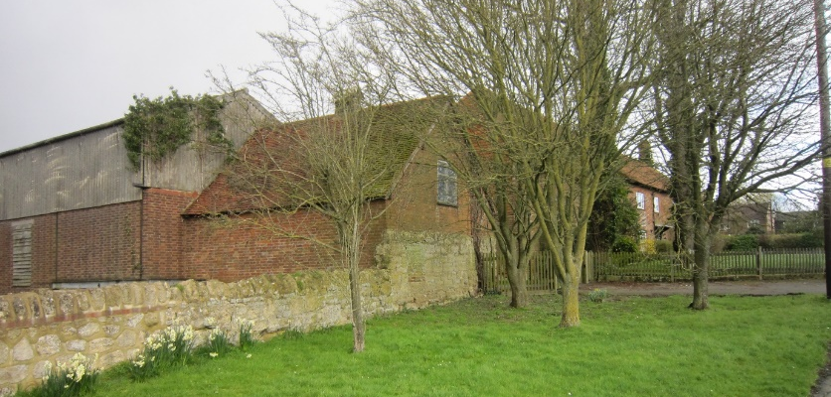
Inner/east elevation of outhouse View looking from the road NE

Materials: (Brick walls and roof tiles to be subject to above ground or dpc conditions)

Walls Roof Windows/doors

Plot 1 brick clay plain tiles powder coated timber
weatherboarding
Plot 2 brick clay plain tiles powder coated timber
weatherboarding

Storage sheds:

Modern motoring technology means that garages as such are rarely ever used for the purpose of protecting private cars as used to be the case and more to do with storing bicycles and other domestic paraphernalia. With this in mind, it is proposed to provide storage sheds located in the garden areas for garden equipment, children’s toys, garden furniture, bicycles and other paraphernalia can be conveniently accessed. Locating the sheds close to the retaining walls means that they are generally out of site from public areas.

Appraising the context including the use

The farming use and activities ceased many years ago and the buildings and yard have evolved into other more utility uses and storage in recent times. The present owners have used the buildings for general storage of building materials and workshop during the ongoing restoration of the Farmhouse. The modern agricultural building are not suitable for any alternative commercial use due to the character of the surrounding conservation area which is now predominantly residential, accordingly, the proposed change of use to residential would be in keeping with the predominant surrounding use.

ACCESS:

The only public transport available in Hardwick relates to the regular bus services to the nearby town of Aylesbury to the south and Winslow and Buckingham to the north. Aylesbury has a wider railway network service to London and the south.

It is proposed to utilise the existing access that once served the farmstead as shown in the plan below. The access is sufficiently wide at the junction with the public highway to allow refuse bins to be located for collection and private vehicles to enter and leave the site at the same time, thus avoid any obstruction of the highway. The access road narrows to a pinch point 3.6m wide, but sufficient for all emergency vehicles access to the site.

Disabled access and emergency evacuation is available to the building in accordance with Building Regulations.

Access plan

Car parking spaces are designed to meet the Council’s standards, namely:
Space area 5m x 2.5m
Plots Bedrooms Spaces Visitors
Range 3 2 1
1 3 2 1
2 4 3 1
3 4 3 1
4 4 3 1

ACH PLANNING LIMITED
Directors: Adrian C Hoy & Victoria Hoy
Registered Office: 3 Carrera House, Merlin Centre, Gatehouse Close, Aylesbury, Buckinghamshire HP19 8DP
VAT Registration Number: 203 8732 24 Company Number: 9563249
Bank Details: Metro Bank Sort Code: 23-05-80 Account Number: 18220385

