STRUCTURAL STATEMENT

ACH Planning Ltd Email: office@achplanning.co.uk
Tel: 01297 728274 Mobile: 07774 200026

Date: August 2021

Site address: The Outhouse, Poplars Farm. Lower Road, Hardwick, Aylesbury, Bucks. HP22 4DZ

Introduction

ACH Planning Ltd are engaged by the owner to prepare a report on the state and condition of the building identified as the ‘outhouse’ at Poplars Farm in Hardwick. The definitive age of the building is unknown, but it is likely to have been constructed in its present form in the mid 1800’s which is likely to have superseded an earlier building.

Location and topography

The building is located on the northern side and at the western end of Lower Road at the northern end of the village of Hardwick. It is separated from The Range by a tarmacked access road that falls gently toward Lower Road, serving the former built farmstead. The land falls in an east to west direction with a drop of approximately 1.5m from side to side. Relatively newly planted trees are located on its south side. Modern agricultural buildings are attached to the north wall of the building and extend in a northerly direction with a tarmac yard to their west.
The grounds of Hardwick Place lie to the south on the opposite side of Lower Road.

LOCATION PLAN
Planning status

The traditional outhouse and modern agricultural buildings appear to be purposely omitted from the Conservation Area however, it is in close proximity to the western end of the Grade II listed ‘Range’ section of Poplars Farmhouse and as such it would be reasonable to assume that it would be considered to lie within the curtilage of the listed building, thus be considered to represent a ‘curtilage listed building’. In other respects, when viewed from the Lower Road to the south, it would appear to form part of the traditional street scene within the Conservation Area, as such, it could be considered to represent a non-designated heritage asset, although it has not been properly tested as such.

Either way, the building is considered to represent an asset that contributes a significant part of the gateway to the northern end of the village within the street scene of the Conservation Area and in the context of the adjacent Listed building and worthy of preservation.

Description and scale

The east and west walls are constructed of 225mm brickwork essentially in a Flemish bond. A window and single personnel door are located in the east elevation with upper vent openings in the west elevation. The separating wall with the modern barn comprises weatherboarding on the inner side supported by timber framework. The south wall comprises a lower clunch stone wall plinth returning at the corners with the east and west brickwork. The upper gable section comprises 225mm brickwork with a central upper window. A bricked in window in the stonework would indicate a lower floor at some time in the past.

The roof is covered by hand made clay plain tiles supported by rafters, purlins and a central truss. The floor has been made up from the original level and covered by Staffordshire blue stable bricks.

State and Condition

Early maps of the area indicate that the outhouse is all that remains of the original buildings that once stretched toward the north and has since been replaced by modern agricultural structures. Unfortunately, what remains provides evidence that no structural tie was provided between the outhouse and the newly introduced buildings, the result of which has caused serious structural failures to the roof construction and the supporting walls. The plans shown below illustrate how the roof structure has tilted outwards away from the modern buildings, buckling the central supporting truss and pushing the southern gable wall pivotally from two fault lines at the wall plate and the purlin levels. It is evident that the progress of this movement is steadily increasing to such an extent that the entire southern gable end brickwork is in imminent danger of totally falling outwards by the pressure of the roof structure.
Early 2020 Mid 2021
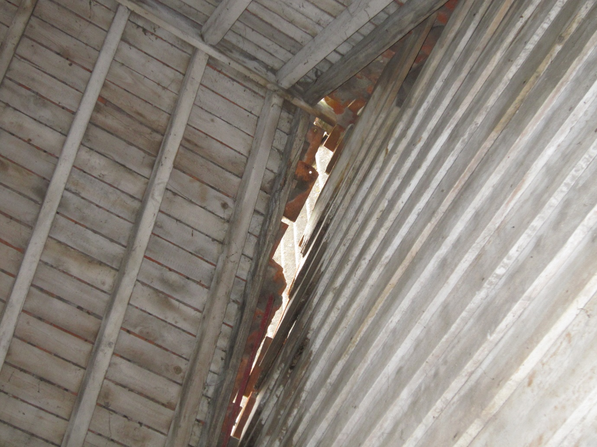
Internal view of the roof at the intersection with the adjacent building

The photographs shown above illustrate the degree of movement over a period between 2020 and 2021, demonstrating how the structural integrity of the building has been compromised to such an extent that it now represents a dangerous structure that must be made safe immediately. Accordingly, the following mitigation measures must be implemented, namely:
- Disconnect all electricity and water supplies.
- Provide temporary Harris security site fencing (minimum height 2m) a safe distance from the building to provide a safe barrier around the entire structure.
- Reduce the pressure load of the roof by removing the tiles.
- Provide props to shore up the gable end or remove the top gable of the brickwork.
- Make safe the central truss from collapse.
- Reassess the structure throughout the course of remedial safety measures being implemented.

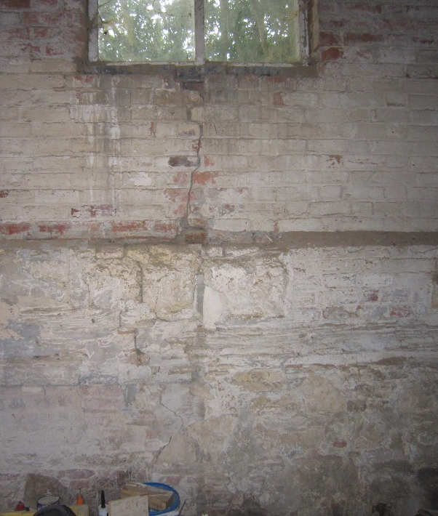
Internal view of the south gable wall
Indicative drawings showing how the roof movement has caused damage to the south wall.

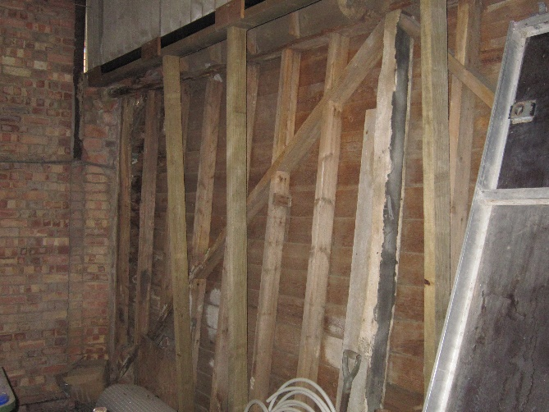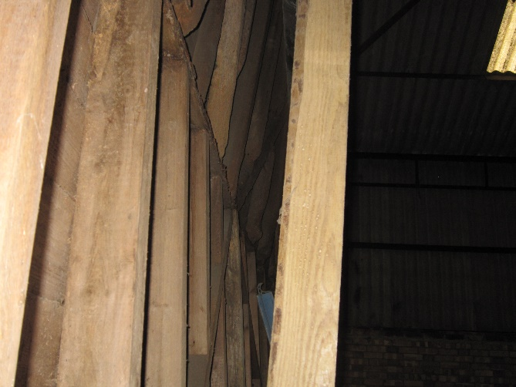

North wall taken from the north side showing the distorted timber frame.

The timber frame of the internal north wall separating the outhouse with the modern agricultural buildings has bowed inwards possibly as a result of the roof movement. In other respects, the base plate shows signs of serious rot as a result of rising damp. Large sections of the weatherboarding and timber framework show signs of serious rot and degradation as a result of the ingress of water.

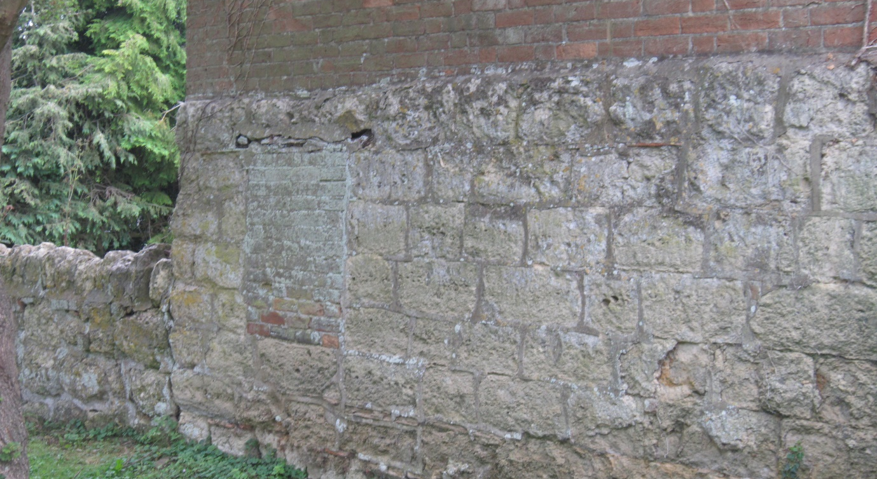
Bricked in window in the south elevation.

The bricked in window opening in the south elevation provides clear evidence to demonstrate that the original floor level floor level was significantly lower than presently exists, having been filled in at some stage in the past. The floor surface is uneven and shows signs of subsidence on the western (lower) side.

Summary

As a result of neglect possibly caused by the absence of a viable use the building has fallen into dilapidation with almost every element of the building structure failing to serve its purpose. This is exacerbated by one structural failure causing a ripple affect and the failure of other elements as a result, none of which is unusual. The structural integrity of the entire building is so badly compromised that the building is now potentially unsafe. Accordingly, it is strongly recommended that remedial works are undertaken to make the building safe without delay.

Before any works are undertaken electricity and water supplies must be disconnected.

ACH PLANNING LIMITED
Directors: Adrian C Hoy & Victoria Hoy
Registered Office: 3 Carrera House, Merlin Centre, Gatehouse Close, Aylesbury, Buckinghamshire HP19 8DP
VAT Registration Number: 203 8732 24 Company Number: 9563249
Bank Details: Metro Bank Sort Code: 23-05-80 Account Number: 18220385

