CHRISTOPHER JONES: architect

Cherry Tree: Grenville Road: LOSTWITHIEL: Cornwall: PL22 0EP
Telephone: 01208 873234
E-mail: cojarchitect1@yahoo.co.uk

May 2021

DESIGN AND ACCESS STATEMENT

INSERTION OF NEW WINDOW IN SIDE ELEVATION
2 FIELD CLOSE LOSTWITHIEL PL22 0HJ

Mr J and Mrs A Hurst

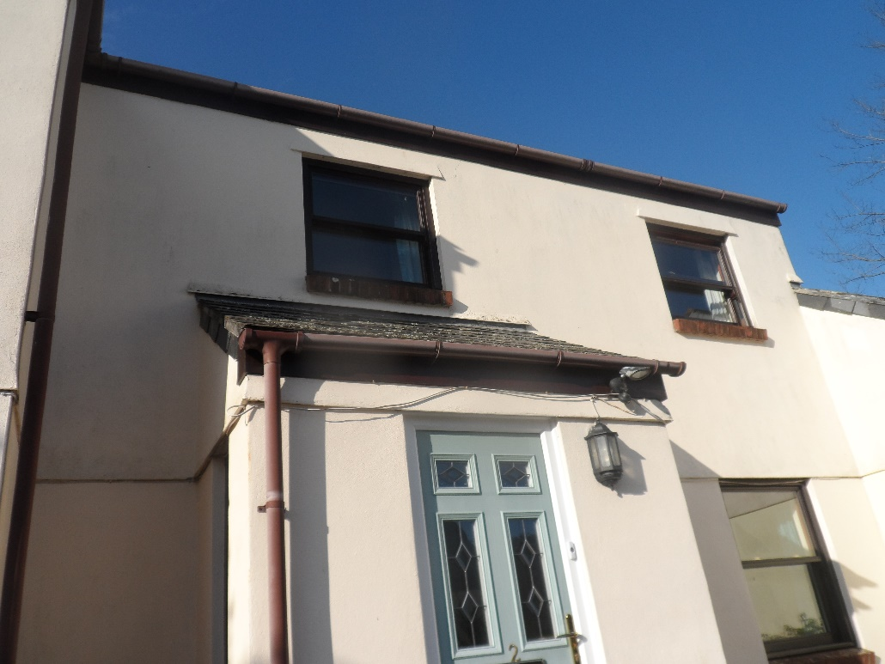

Mr and Mrs Hurst have lived in Lostwithiel for several years.
They currently live in the property known as 2 Field Close which is in a relatively modern complex of three houses built behind terraced and much older houses in North Street.

The property was subject to a planning application in late 2017 the work for which has now substantially been completed. However the dormer window in one of the rear bedrooms does not let in a lot of light and this proposal (the insertion of a small window) seeks to redress that issue.

The window is in a side elevation but is far enough away from the party boundary wall to avoid overlooking. There is the garage of the property between the house and the boundary wall.

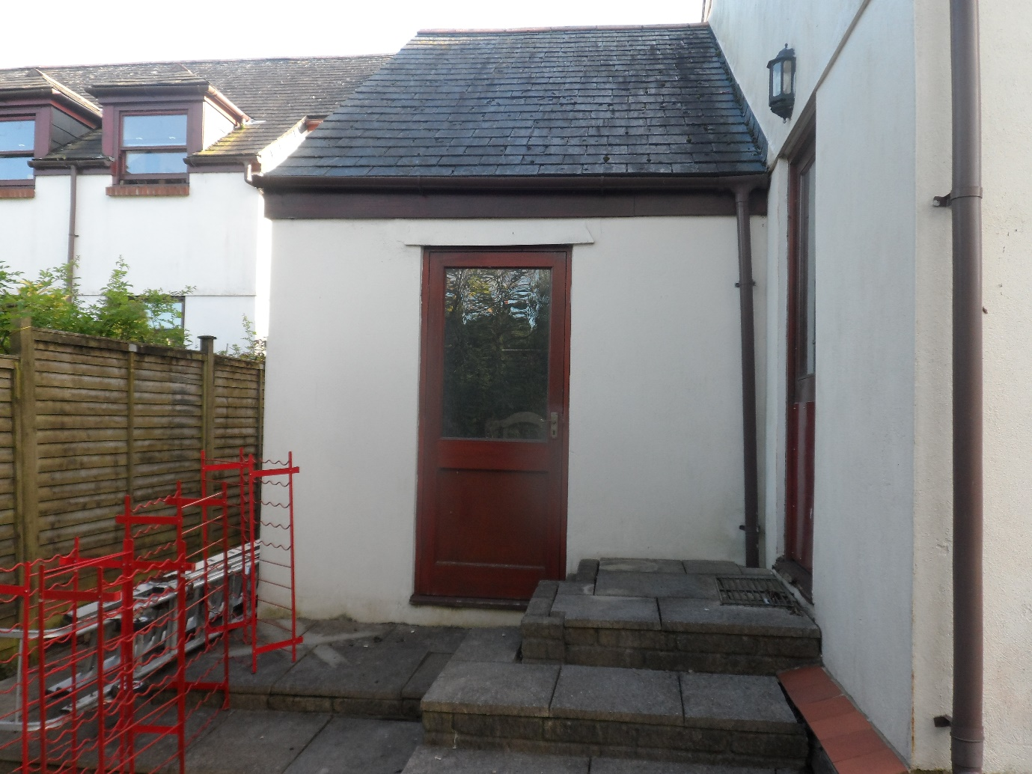

The site is located in the conservation area for Lostwithiel but the improvements generally will not impact on the character and heritage of the historic town centre.

The site is within walking distance of the town’s shops, restaurants and public houses and the railway station which serves the rest of the country.
Bus services along the A390 are, again, a short walking distance away.

