SUPPLEMENTARY INFORMATION
- Site Details

Site Name: | Kirkton Road North S/W | Site Address: | Kirkton Road North  Livingston  EH54 6GU
National Grid Reference: | E: 304340 N: 667256
Site Ref Number: | 137615 | Site Type: | SW Monopole Upgrade

- Pre-Application Check List

Site Selection

Was an LPA mast register used to check for suitable sites by the operator or the LPA? |  | No
If no explain why:

After a phone call to the LPA, it was established that the LPA do no hold this information.

Was the industry site database checked for suitable sites by the operator: | Yes
If no explain why:

N/A

Annual rollout consultation with LPA

Date of last annual rollout information/submission: | This information can be emailed to the LPA on request
Name of Contact: | This information can be emailed to the LPA on request
Summary of outcome/main issues raised: | Strategic level pre-rollout meetings are held with the LPA to discuss the necessities of the project, benefits and best practice going forward.

Pre-application consultation with LPA

Date of written offer of pre-application consultation: | 31st July 2021
Was there pre-application contact: | Yes
Date of pre-application contact: | N/A
Name of contact: | The Director of Planning
Summary of outcome/main issues raised:

Prior to the submission of this application the applicant-initiated pre-consultation discussions with the local planning authority. This provides an opportunity for the LPA to discuss development proposals and identify site specific issues, however, due to the minimal nature of the proposal it was not considered necessary to pay the fee requested, therefore, no comments were received in respect to the consultation submitted at the time of submission.

Strategic level pre-rollout meetings are held with the LPA to discuss the necessities of the project, benefits and best practice going forward.

S.P.P. recognises the importance of operators and their agents establishing an informed working relationship with planning authorities and encourages pre-application discussion. PAN 62 provides further information at paragraph 114 and Annex E on the Mobile Operators Association (formerly FEI) Ten Commitments to Best Siting Practice. Commitments 1 and 2 relate to pre-application consultation with the community and the planning authority. Such consultation is undertaken in accordance with MOA’s Traffic Light Rating & Site Selection & Planning Model.

The operators fully comply with the Guidance on pre application consultation with schools and colleges. They provide evidence to the local planning authority that they have consulted the relevant body of the school or college.

A recent report stated there is no scientific basis for siting base stations away from schools (NRPB report, January 2005)

Ten Commitments Consultation

Rating of Site under Traffic Light Model: |  | Amber
Outline of consultation carried out:

Prior to the submission of this application the applicant initiates pre-consultation discussions with the local planning authority. This provides an opportunity for the LPA to discuss development proposals and identify site specific issues.

No comments were received in respect to the consultation submitted at the time of submission.

Further consultation with the local Ward Councillors for Livingston South Ward (Councillor Moira Shemilt, Councillor Peter Heggie, Councillor Lawrence Fitzpatrick, Councillor Maria MacAulay) and MP Hannah Bardell and MSP Angela Constance.

Summary of outcome/main issues raised:

No responses had been received from any of the Ward Councillors at the time of submission.

School/College

Location of site in relation to school/college:

Fun Little Education Is in relatively close proximity to the site

Outline of consultation carried out with school/college:

Fun Little Education Has been notified prior to submission

Summary of outcome/main issues raised:

There has been no response from the School at the time of submission.

Civil Aviation Authority/Secretary of State for Defence/Aerodrome Operator consultation

Will the structure be within 3km of an aerodrome or airfield? |  | No
Has the Civil Aviation Authority/Secretary of State for Defence/Aerodrome Operator been notified? |  | No
Details of response:

N/A

Developer’s Notice

Copy of Site Provider Letter / Developer’s Notice enclosed? |  | Yes
Date served: | 19th August 2021

- Proposed Development

The proposed site:
The current monopole installation is being replaced however, only with a larger 5G monopole installation of similar monopole design to facilitate significantly improved connectivity. The existing site can be seen below in Figures 1 -3, the site is located off Kirkton North Road surrounded by tall existing street furniture (streetlights) opposite Geddes House Business Centre. It is important to note that this is an existing site, thus meaning the LPA have already determine an acceptable location to house telecommunications equipment.

Figure 1:
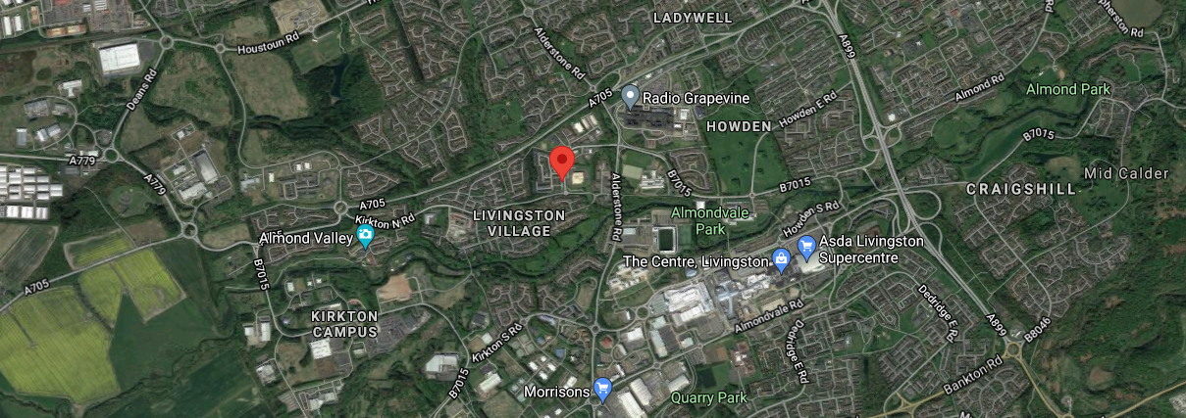

Figure 2:
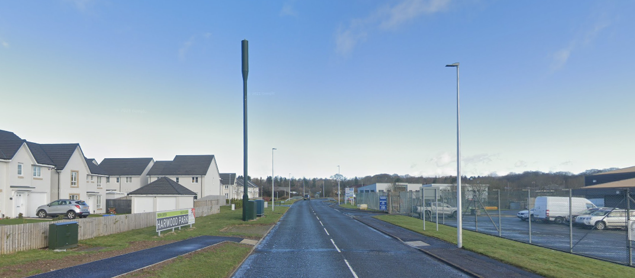

Figure 3:
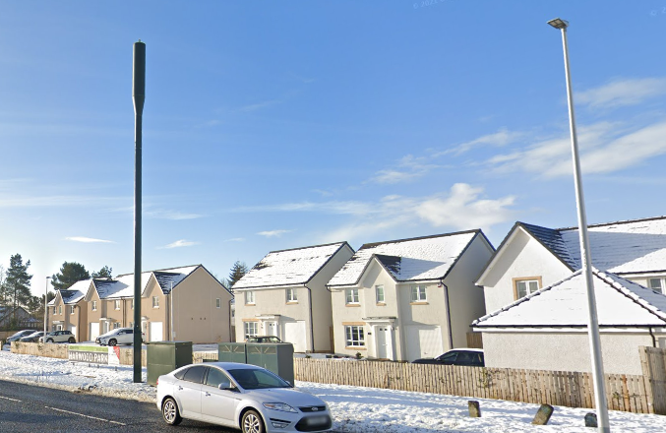

There are no other viable alternative options other than to upgrade the existing installation. Discounted options were put forward and assessed at the original planning application stage and this was deemed to be the most appropriate location. Given the height that is required for this site sharing 5G upgrade there is a lack of available rooftops.

Please note any Highways issues with the number of cabinets and maintaining visibility splays at the junction and maintaining footpath widths has been robustly assessed. The presence of the existing column sets a clear precedent for telecommunications development in this location and indicates that the principle of this proposal is acceptable in terms of siting. Although it is accepted that the height and width will be increased, it is felt that such an increase in the overall bulk of the installation would not detract from the character of the area in which the proposal sits.

Any other proposal to satisfy the identified requirement would result in the addition of a separate ground based column elsewhere in close proximity to the existing structure. In our opinion, such a proposal would, in this instance, unnecessarily add to the clutter in this location and result in a greater visual impact. As previously stated the proposed site is an established telecommunication installation. This submission is purely to upgrade this existing telecoms installation with new equipment to facilitate 5G coverage.

Local Planning Authority: West Lothian Council
Development Plan: West Lothian Local Development Plan (2018)

The site is designated as being within the settlement boundary, with urban uses to the north, east, south and west. The site designation is not a material consideration.

West Lothian Council does not have a specific telecoms SPD, however Policy INF 2 relates directly to telecommunications. Therefore PAN62 is of relevance. The National Planning Policy section of this supporting statement goes into detailed analysis of why this site is in compliance with PAN62.

Policy Analysis:

Policy INF 2 Telecommunications:

Proposals for telecommunications developments will be supported in principle and provided they are sited and designed to minimise visual and environmental impact.

New homes, business properties and re-development proposals should be designed in such a way as to incorporate high speed broadband connections and other digital technologies that could optimise energy efficiency and contribute to reducing the carbon footprint of the building.

Considerations to be taken into account are:

- technical and operational considerations;
- the possibility of sharing existing telecommunication facilities, subject to consideration of any additional visual impact;
- the possibility of erecting/installing equipment on existing structures or buildings;
- the possibility of concealing or disguising masts, antennas, equipment housings, etc., where appropriate;
- impact on residential amenity and other sensitive sites and areas;
- the availability of alternative sites;
- safety of vehicular access;
- disturbance to agricultural management, trees and woodland, wildlife habitats and land of community value;
- landscape impact;
- use of the smallest suitable equipment, commensurate with technology requirements; and
- any other relevant policies in the Local Development Plan.

This proposed development at the proposed site seeks to consolidate all existing elements into one location on site, minimised to ensure the scale and mass of the design is sympathetic to its surrounds, limiting visual impact on the wider character of the area and retaining the existing distance from sensitive receptors, yet retaining structural capacity to ensure that it would deliver the level of service needed in this location. As such it is considered the proposed development would accord with the principles of the Development Plan policy. The proposal fully accords with the requirements of PAN62.

The design of the proposed equipment is considered to be the least visually intrusive option available. Although it is accepted that there will be an intensification in the amount of equipment it is felt that such a minor increase would not detract from the character of the area in which the proposal sits.
The proposed site is an established telecommunication installation. This submission is purely to upgrade this existing installation with new equipment to facilitate 5G coverage.

Enclosed map showing the cell centre and adjoining cells:
This can be emailed to the LPA on request.

Type of Structure:
Description:

Proposed Upgrade to existing 15.0m Hutchinson Engineering Elara Streetpole. Proposed GPS module mounted to top of pole. Proposed 6No. antennas mounted SW pole. Proposed 3No. RRU’S mounted to SW pole. Proposed 2No. 300Ø Dishes. Proposed 20.0m High Orion V2 pole with on a few D9 root foundation. Existing Ericsson RBS6102 Cabinet (1) to be refreshed internally, Cabinet (2) to be removed. Proposed York Cabinet on a new root foundation. For Full details please refer to enclosed drawings, numbered: 100 - 301 (Revision A, Pack Issue A) at Kirkton Road North, Livingston, EH54 6GU, E: 304340 N: 667256.

Overall Height: 20.0m AGL
Height of existing building: |  | N/A
Equipment Housing:
Length: |  | See Drawings
Width: |  | See Drawings
Height: |  | See Drawings
Materials:
Tower/mast etc – type of material and external colour: | RAL6009
Equipment housing – type of material and external colour: | Grey

Reasons for choice of design:
The proposed equipment has been selected to minimise visual impact whilst enhancing coverage. 5G is short for ‘fifth generation mobile networks’. It has been designed to be far faster than previous generations and to allow new uses for mobile data.

In the UK, rollout is now commencing. The main benefits of 5G are that it will be
much faster and have higher capacity than 4G, with download speeds in excess of 1Gbps. To place this in context, customers will be able to download - not merely stream - a full HD movie in less than 10 seconds on a 5G network. The same task would take closer to 10 minutes on 4G

- Technical Information

ICNIRP Declaration attached  ICNIRP public compliance is determined by mathematical calculation and implemented by careful location of antennas, access restrictions and/or barriers and signage as necessary. Members of the public cannot unknowingly enter areas close to the antennas where exposure may exceed the relevant guidelines.  When determining compliance, the emissions from all mobile phone network operators on the site are taken into account. | Yes

Frequency: | 4G 800 MHz Cellular band  2G/3G 900 MHz Cellular Band  2G 1800 MHz Cellular Band  3G 2100 MHz Cellular Band  4G 2600 MHz Cellular Band
Modulation characteristics | 2G (900 or 1800) – GMSK  3G (900 or 2100) – QPSK  4G (800 or 2600) – 64 QAM
Power output (expressed in EIRP in dBW per carrier) | 800 MHz Cellular band – 31 dBW  900 MHz Cellular Band – 32 dBW  1800 MHz Cellular Band – 32 dBW  2100 MHz Cellular Band – 35 dBW  2600 MHz Cellular band – 31 dBW
In order to minimise interference within its own network and with other radio networks, Telefónica UK Ltd operates its network in such a way the radio frequency power outputs are kept to the lowest levels commensurate with effective service provision

As part of Telefónica UK Ltd.’s network, the radio base station that is the subject of this application will be configured to operate in this way.

All operators of radio transmitters are under a legal obligation to operate those transmitters in accordance with the conditions of their licence. Operation of the transmitter in accordance with the conditions of the licence fulfils the legal obligations in respect of interference to other radio systems, other electrical equipment, instrumentation, or air traffic systems. The conditions of the licence are mandated by Ofcom, an agency of national government, who are responsible for the regulation of the civilian radio spectrum. The remit of Ofcom also includes investigation and remedy of any reported significant interference.

The telecommunications infrastructure the subject of this application accords with all relevant legislation and as such will not cause significant and irremediable interference with other electrical equipment, air traffic services or instrumentation operated in the national interest.

Height of antenna (m above ground level) | 20.0m AGL

- Technical Justification

Reason(s) why site required:
5G is short for ‘fifth generation mobile networks’. It has been designed to be far faster than previous generations and to allow new uses for mobile data.

In the UK, rollout is now commencing. The main benefits of 5G are that it will be
much faster and have higher capacity than 4G, with download speeds in excess of 1Gbps. To place this in context, customers will be able to download - not merely stream - a full HD movie in less than 10 seconds on a 5G network. The same task would take closer to 10 minutes on 4G

- Site Selection Process – alternative sites considered and not chosen:

If no alternative site options have been investigated, please explain why:

This is an upgrade to an existing site thus no other standalone new facilities have been investigated. A new additional mast to facilitate the upgrade would not be in line with NPPF. By upgrading the current facility the most sequentially preferable option has been progressed.

Environmental information (refer to Section 2 of Site Finder Report):

See above (Section 3 Proposed Development box)

Land use planning designations:

The site is designated as being within the settlement boundary, with urban uses to the north, east, south and west. The site designation is not a material consideration.

Additional relevant information:

Practical Applications of 5G Connectivity as Example of Material Socio-Economic Benefit: -

Education:
The relationship between 5G and education is evolving at a massive rate with educators exploring the relevance of Virtual Reality (VR) technologies for education and training. Crucially, VR can support remote learning, allowing students a presence in the classroom even when working elsewhere.
5G’s ability to deliver real-time information (low latency), ultra-fast speeds (critical for high definition images and video), increased capacity and heightened security will also allow learning on the job, thanks to technologies such as Augmented Reality (AR) goggles, which can give engineers real-time instructions on how to fix a machine on a production line, for example.

Health:
Patients across the country are now becoming accustomed to relying on remote healthcare services such as NHS 111, virtual GP appointments, and ordering online deliveries of essential medical supplies.
5G will prove critical in providing the infrastructure required to deliver remote health services over the next decade. By design, 5G’s ability to deliver real-time information (low latency), ultra-fast speeds (critical for high definition images and video), increased capacity and heightened security are going to be fundamental in scaling the patient benefits of remote healthcare and keeping medical records secure and private. For instance, trials have shown that connecting ambulance crews to expert resources using 5G allows paramedics to work with doctors and conduct specialist procedures in real time whilst on the road.

Confirmation that submitted drawings have been checked for accuracy

Contact Details

Name: (Agent) | Ryan Marshall | Telephone: | Can be requested via email
Operator: | Cornerstone and Telefónica UK Ltd | Fax no: | Can be requested via email
Address: | WHP  Helena House  Troy Mills  Troy Road  Leeds  LS18 5GN | Email Address: | r.marshall@whptelecoms.com
Signed: | Ryan Marshall | Date: | 20th August 2021
Position: | Planning Manager | Company:  (on behalf of Cornerstone and above operator)

Macro or Micro
The modulation method employed in 2G (GSM) is GMSK (Gaussian Minimum Shift Keying) which is a form of Phase modulation The modulation method employed in 3G (UMTS) is QPSK (Quad Phase Shift Keying) which is another form of Phase Modulation The modulation method employed in 4G (LTE) is 64 QAM (Quadrature Amplitude Modulation) which is another form of Phase Modulation The modulation method employed in 5G is 256 QAM (Quadrature Amplitude Modulation) which is another form of Phase Modulation

