Matthew Hollands Associates Limited.

Architectural and Development Consultancy.

**BAT STATEMENT FOR PROPOSED EXTENSION AND ALTERATIONS AT**

**43a EDWARD ROAD, CLEVEDON.**

**Introduction**

The existing house lies in a residential area surrounded by houses

.

The existing property consists of a two-storey house with pitched roof, which was originally constructed in c.1980 and since construction no works have been undertaken on the roof, which is in good condition.

The proposed extensions is to the front and rear of the existing house will have minimal impact on the existing roof structure as part of the works.

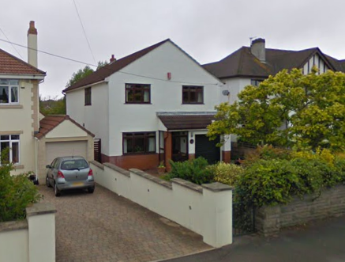

**Conclusion**

Due to the date of construction and the fact that no works have been undertaken to the existing roof, there is no opportunity for bats to be roosting in the building.

Therefore, it is not considered necessary to undertake any further investigation works.

-------------------------------------------------------------------------------------------------------

Matthew Hollands Associates Limited

Yew Tree Farm, 48 Venus Street, Congresbury, Bristol. BS49 5EZ.

Tel. 07808 249410 Email. mha.architecture@btinternet.com.