Heritage Statement in Support of Application P1452/21/FUL

Oakle Farm, Oakle Street, Churcham Glos GL2 8AG

This is a Heritage Statement to consider the effect on historic properties in the vicinity of Oakle Farm (on the West side of Oakle Street) namely the adjoining property Bleak House, and Oakle Barn being located on the East Side of Oakle Street opposite the entrance to Oakle Farm
.
Both Oakle Farm and Oakle Barn are situated substantial distances back from the main road and cannot be seen together, the separation distance is 70 metres.

Oakle Barn is Grade II listed and was converted circa 1992 to residential. Appendix 1 details the characteristics for which it is listed.

Bleak House was constructed circa 1860 and is not a listed property. It has been extended twice in the last 20 years incorporating similar features as the original house.

Oakle Farm was constructed circa 1800 together with outhouses as a working farm. The outhouse which is the subject of this application is built in red brick in various brickwork bonds including English Bond, Header Bond, Garden Wall Bond and a mixture of them all presumably adapted to utilise materials and indicating a possible phased construction of the outhouse.

There is evidence that the building originally had a higher roof by virtue of the level of the original first floor loft which remains, the height of the remaining side wall and a gable end which remains.
Any features such as gable vents slots are therefore not known but are likely to have existed being standard construction of the time and these have been reintroduced in the proposal.

Removal of the original roof tiles, rafters, struts and king post and replacement with corrugated asbestos (presumably for cost reasons) indicates a relatively recent change but one which must be dealt with besides the unacceptable visual appearance brought about through past neglect.

At some time the outhouse was extended to a seemingly irrational or specific intended purpose footprint and this extension is separating from the main building as there are no tying elements within the structure.

The proposed scheme aims to address all these issues in a manner relating to the original property.

The comparison of existing or proposed features of the outhouse of Oakle Farm to Bleak House is not meaningful being of different styles and periods.

The comparison to Oakle Barn is also not meaningful with the properties being from different periods however the materials proposed for roof reinstatement are characteristic to the Oakle Barn and the other outhouses on the property.

In reality because of the separation and natural screening the original Bleak House or Oakle Farm outhouse cannot be seen together from the road and similarly Oakle Barn cannot be seen by Oakle Farmhouse or visa versa.

When viewed alone all properties have a general conformity created by the dominance of the red brick construction but the features from the various periods do not themselves have a meaningful place on the others. Where there are features of the original which needs to be created to reflect the period then this has been incorporated.

Photos associated with this statement are attached in appendix 2

Appendix 1

SO 71 NE CHURCHAM OAKLE STREET
11/34 Barn, between Oakle House and Oakle Cottage
Grade II - Listing NGR: SO7587317272
Barn and stable: early c18, early C19 extension.
Barn brownish brick, English bond on stone plinth: brick bond to extension irregular on ground floor: tiled roof.
Central threshing floor: lofted extension.
Road side, double boarded doors to eaves hung on timber door frame: wall projects 110 mm each side as a buttress.
Each side 2 rows of slit air vents, 4 above, 3 below, since bricked up: small, 4 pane window inserted low down on right.
Pitching-hole in right gable bricked up: owl-hole over.
Rear elevation, wide doors only half-way to eaves, with original brick-nogged timber- framed panel over.
On left air vents as front, but open: on right boarded door with cambered brick arch on ground floor, boarded door above, with 3 light timber window closed by shutter on right.
Extension a boarded door on each floor: roof line slightly lower than barn.
Internally stone paved threshing floor, 5-bay, tie-beam trusses with angle struts, central one sitting on door posts.
Collars probably added: one pair purlins, square ridge; wind-braces rise from wall plates.
On left early inserted wall leaving short bay: probably originally stable with granary over.
Ceiling to latter at eaves level, 3 walls plastered.
Loft inserted on right mid C19: air-vents wider internally.
Good example of early C18 barn.
Derelict, single-storey extension on right and lean-to to rear not of special interest.

Appendix 2

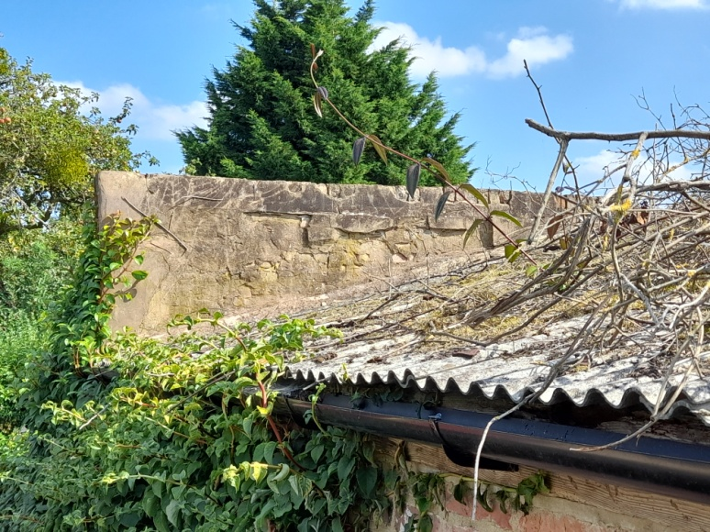

Current Asbestos Roof and original gable end.

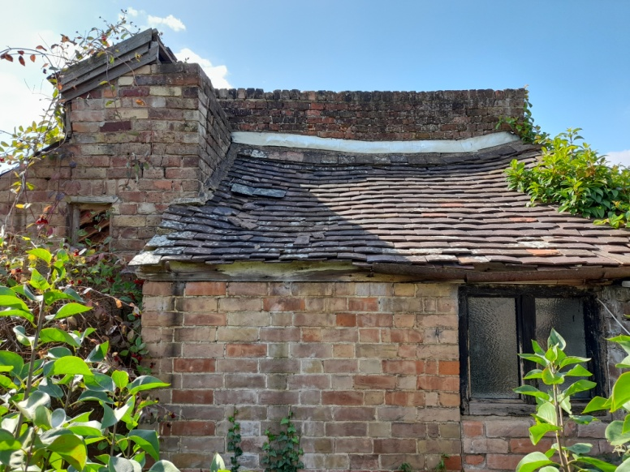

Existing extension separating from main structure

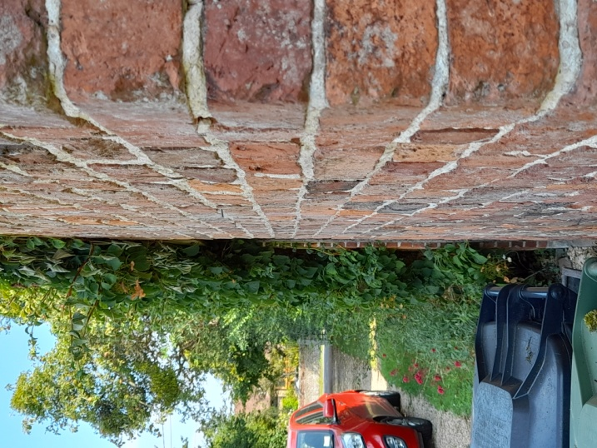

View from sidewall towards Oakle Barn

