Red Furlong Farm,
Poundon

Access Appraisal

INTRODUCTION
  - David Tucker Associates have been commissioned by Mr P Flannery, to provide highways and transport advice and to prepare this access appraisal to support a temporary planning application for the creation of heavy plant operative training centre at land on Red Furlong Farm, Poundon, Buckinghamshire.
  - The site and location plan are included in Appendix A.
  - This appraisal has been prepared in accordance with the National Planning Policy Framework (NPPF) and national Planning Practice Guidance (PPG), and is structured as follows:
Chapter 2: National Policy Context;
Chapter 3: Existing Conditions;
Chapter 4: Development Proposals;
Chapter 5: Traffic Generation; and
Chapter 6: Conclusions.

NATIONAL POLICY CONTEXT

National Guidance - National Planning Policy Framework
    - In February 2019, the Government published a revised National Planning Policy Framework (NPPF). This report should therefore be read in the context of the new NPPF.
    - Paragraph 108 of the NPPF sets out considerations that should be applied when looking at allocation and site specific developments. It states:
In assessing sites that may be allocated for development in plans, or specific applications for development, it should be ensured that:
- appropriate opportunities to promote sustainable transport modes can be – or have been – taken up, given the type of development and its location;
- safe and suitable access to the site can be achieved for all users; and
- any significant impacts from the development on the transport network (in terms of capacity and congestion), or on highway safety, can be cost effectively mitigated to an acceptable degree.
    - Within this context, the NPPF identifies in Paragraph 109 that applications for development should:
Development should only be prevented or refused on highways grounds if there would be an unacceptable impact on highway safety, or the residual cumulative impacts on the road network would be severe

National Planning Practice Guidance (March 2014)
    - The Department for Communities and Local Government (CLG) published the Planning Practice Guidance (PPG), which reinforces the guidance contained in the NPPF.
    - In particular in para 32 the PPG states:
“Local planning authorities must make a judgement as to whether a development proposal would generate significant amounts of movement on a case by case basis (i.e. significance may be a lower threshold where road capacity is already stretched or a higher threshold for a development in an area of high public transport accessibility).
In determining whether a Transport Assessment or Statement will be needed for a proposed development local planning authority should take into account the following considerations:
- The Transport Assessment and Statement policies (if any) of the Local Plan;
- The scale of the proposed development and its potential for additional trip generation (smaller applications with limited impacts may not need a Transport Assessment or Statement);
- Existing intensity of transport use and the availability of public transport;
- Proximity to nearby environmental designations or sensitive areas;
- Impact on other priorities/ strategies (such as promoting walking and cycling);
- The cumulative impacts of multiple developments within a particular area; and
- Whether there are particular types of impacts around which to focus the Transport Assessment or Statement (e.g. assessing traffic generated at peak times).
    - The document advocates early consultation with key decision makers at an early stage through pre-application discussions to determine the scope of the technical work required to underpin the associated assessments and travel plans. The key issues it suggests that should be considered are:
- The planning context of the development proposal;
- Appropriate study parameters (i.e. area, scope and duration of study);
- Assessment of public transport capacity, walking/ cycling capacity and road network capacity;
- Road trip generation and trip distribution methodologies and/ or assumptions about the development proposal;
- Measures to promote sustainable travel;
- Safety implications of development; and
- Mitigation measures – including scope and implementation strategy.
    - It acknowledges that the scope and level of detail in reports will vary from site to site, but suggests the following should be considered when settling the scope of the proposed assessment.

EXISTING CONDITIONS

Site Location
    - The site is located to the north of Poundon, a small village to the east of Bicester. Figure 1 below presents the location of the site.
Figure 1 – Site Location (Google Maps)
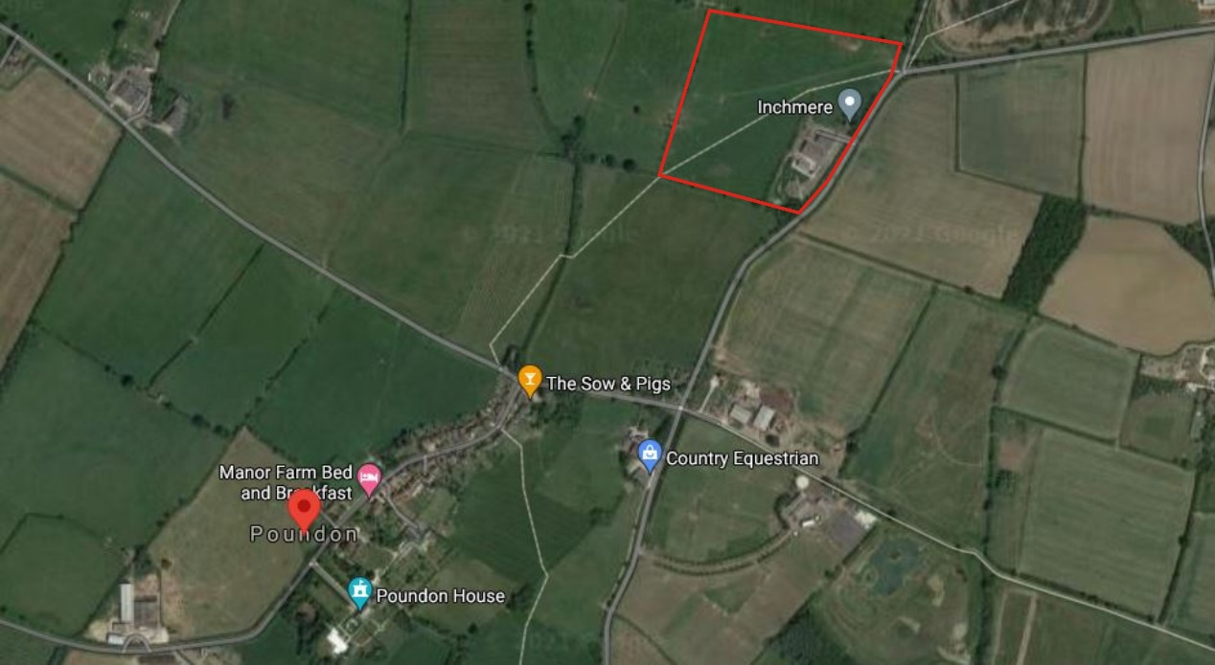
    - The site is served from Bicester Road which runs from north to south along the eastern frontage, connecting Poundon and Twyford.
    - The road is subject to a 60mph speed limit and approximately 6.0m in width wit no street lightning.
    - To the south of the site is the A41 which provides links to the M40 and Bicester (9km). To the north is the A421 and Milton Keynes (24km)

Existing traffic flows
    - An automatic traffic counts (ATC) was undertaken between 18/05/2021 and 24/05/2021 in the vicinity of the site access. The results are attached as Appendix B and summarised in Table 1 below.

Table 1 – ATC Results – Bicester Road
 | Average Speed 85% | Average Mean Speed
Northbound | 43.9 mph | 37.5 mph
Southbound | 40.6 mph | 35.0mph

    - As can be seen the recorded speeds are significantly below the signed 60mph speed limit.
    - To determine the necessary stopping sight distance it is appropriate to use the above 85th percentile speeds as starting point. These would then be used in the visibility calculations set out in Manual for Streets using the DMRB deceleration rates and reaction times due to the speeds being in excess of 60kph. This results in visibility splays of 109.2m to the south and 95.8m to the north from a ‘x’ distance setback of 2.4m from the access.
    - In excess of these distances are available from the existing site access.

Collision Data
    - To understand the existing highway safety record for Bicester Road near to the site, crashmap.co.uk has been interrogated for the last 5 years. Figure 2 below demonstrates there have been no recorded collisions in the last 5 years, meaning the access has operated safely.
Figure 2 – Personal Collision Records (www.crashmap.co.uk)

DEVELOPMENT PROPOSALS

Proposed Development
    - The development proposes to use the existing Red Furlong Farm access as shown below.
Figure 3 – Site Access (Google Maps)
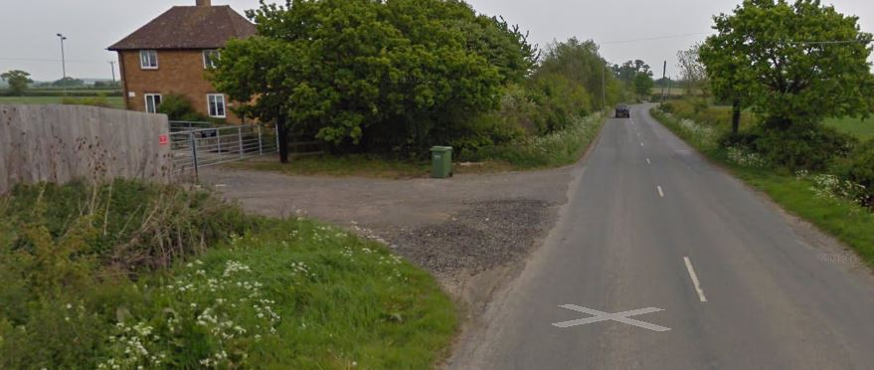

    - The proposals will include a training centre on simulators and a practical training plant aera on the adjacent land. The site will have capacity for up to 40 people via ‘bunk house’ style accommodation. There will also be space for 10 touring caravans with car parking provisions.
    - The course last for 4 weeks and it is envisioned that most will stay on stie during this time. Large plant vehicles will remain on the site during the training time.

TRAFFIC GENERATION
  - Traffic generation numbers aren’t readily available however, it is envisioned that up to 40 vehicles would arrive at the start of the training process with most staying on site for the duration of the 4 weeks of training. Some daily trips may occur if the trainers live locally, or for leisure and recreational activities.
  - 7-day average daily flows on Bicester Road have been extracted from the ATC information and are roughly 1300 movements per day. Given the site will generate a maximum of 40 movements at the beginning of the course, the impact on the Bicester Road will be negligible.

SUMMARY & CONCLUSIONS

This appraisal has reviewed the potential impact of a proposed new large plant training centre at land off Red Furlong Farm, Poundon, Buckinghamshire.

Accident records for the area have been reviewed and it is determined there is no highway related safety issue within the vicinity of the proposed site.

Vehicle speeds along Bicester Road are within the signed speed limit and visibility from the existing access are achievable within highway controlled land.

The development will generate very few vehicle movements once the initial 4 week training begins.

Overall, it has been demonstrated that the residual cumulative impact of the proposed development cannot be considered severe in accordance with relevant policies of the Framework.

Appendix A
Site Layout and Location

Appendix B
ATC Data

