DESIGN ACCESS AND HERITAGE STATEMENT
WORKS TO THE COTTAGE AND CARTSHED
TITLINGTON HALL
ALNWICK, NE66 2EB

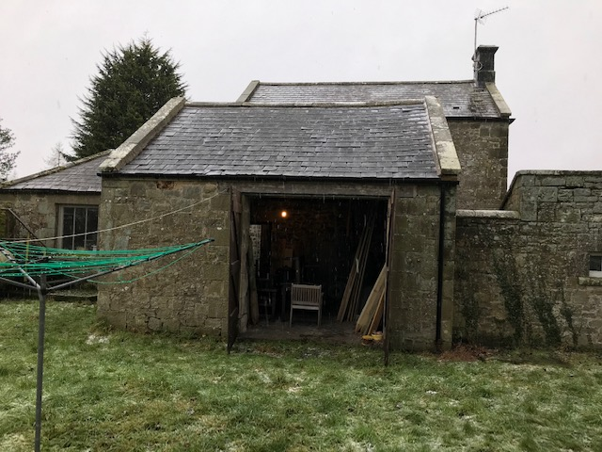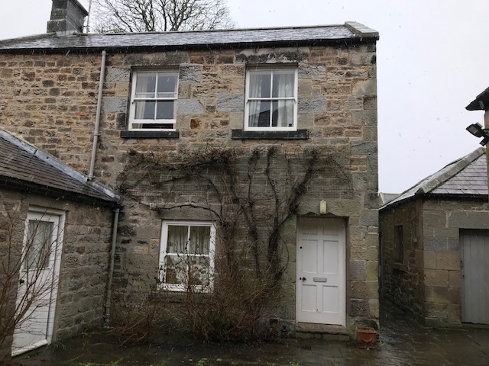

1 Background

Titlington Hall is a large detached late Georgian house, built in the early 19th century on the site of a previous house. The symmetrical South East and South West elevations are in ashlar stonework with raised window surrounds and projecting dressed quoins, while the rear elevations are in roughly squared coursed stone with flush quoins and window dressings.

There is an attached cottage which is used as separate accommodation along with a number of outbuildings which include a Cartshed and separate Stable Block.
The main Hall is used as the private residence of the owner and the applicant.

The house is Grade II Listed. See separate Listing text, it mostly describes the external stonework and window detailing with limited notes on the interior.

The following is an application which was made for retrospective permission by the previous owner and was approved on 12th August 2016

16/01775/LBC | Listed building consent for the following minor works completed in the 1990s:- New internal door opening, removal of walls to butler's pantry to enlarge kitchen, removal of maid's cupboard to give light to back stair and blocking of 20th Century window on main facade | Titlington Hall Titlington Hall Drive Alnwick Northumberland NE66 2EB

2 Proposal

The proposal deals with the cottage accommodation and is to incorporate the Cartshed for conversion and alteration to increase the ground floor accommodation

The small kitchen that serves the cottage is currently located in a mono pitched single storey block which links the cottage to the main hall. It is proposed to revert this section back to the Hall and block up the linked opening as indicated on the proposed floor plans

The ground floor will be reconfigured and also linked to the Cartshed by infilling the narrow exposed passageway between the two buildings with a flat roof extension
This also allows for the current store to be incorporated and to provide a ground floor w.c. and shower room.
The current living room will now be used as the kitchen/dining room and a section of external wall removed to the cottage and the Cartshed so that these become linked by the new infill extension.
The Cartshed will then be used as the main living space and provide an improved outlook from the cottage. Outlook is currently limited due to the arrangement of the existing outbuildings and small courtyard between the Hall. The existing double door opening will be glazed and fitted with French Doors to open out onto its own garden space.

As part of the works it is also proposed to provide 2 additional windows to the first floor to provide natural daylight to the landing and to the bathroom.

Roof windows will be provided to the linked extension to provide natural daylight into this section

Photo below shows the existing exposed passage which is to be enclosed and also shows the small store building in the background which is now to be used as the ground floor w.c.

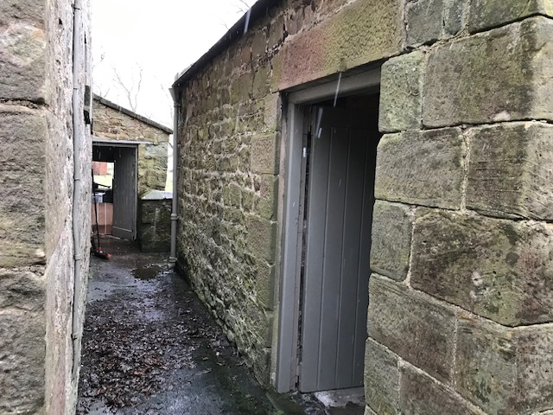
3 Design

The design of the proposal is minimal and unobtrusive and utilises a space which collects debris and retains moisture. The surface water from the rear of the Cartshed disperses into this area.
The linked section between the gable of the cottage and the Cartshed will be built up in natural stone to the south east elevation, the remaining new walls to the extension will be timber frame with a horizontal board cladding.
The external walls being removed between the Cottage and the Cartshed will be used to build up the new external wall. The openings will also be hidden from view due to the new extension making this an internal space.

The existing double door opening to the Cartshed will be fitted with doors and glazed screens

The new first floor window openings will be fitted with windows to match the style and size of those in the bedrooms on the south west elevation.

Photo below showing the existing opening to the Cartshed

Photo below showing the existing first floor windows which are to be replicated

Photo below of the store building which will be used for the new ground floor w.c.

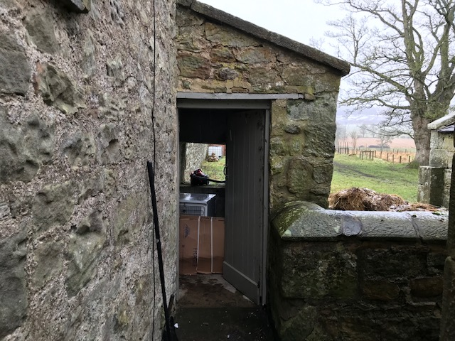

4 Listing

TITLINGTON HALL LISTING HEDGELEY TITLINGTON NU 01 NE 4/254
Titlington Hall 31.12.69 GV II House, rebuilt 1824 for W.M. Pawson (inscription on north-west corner quoin). Tooled-and-margined stone; right return and rear roughly-squared stone with tooled-and-margined dressings; blue slate roof.
Main house 2 storeys, 2+1+2 bays. Chamfered plinth, rusticated quoins, moulded eaves cornice, blocking course.
Slightly-projecting centre has altered flush-panelled door with 2-pane overlight, between plain pilasters carrying frieze and cornice; two 4-pane sash windows above; antefixae on blocking course.
Flanking bays have early C20 6-pane casementswith 4-pane sashes above. All windows in architraves, those on ground floor with plain aprons, dropping to plinth. Small inserted window with rusticated lintel near right end.
To far right, single-storey part with renewed 12-pane sash. 2-bay left return shows similar fenestration; rear elevation shows large arched stair window with renewed glazing, and slightly-projecting wing to left. Interior: not fully seen. 2-bay screen with tall fluted columns at foot of geometrical stair.
Drawing room fireplace and some other features said to have been brought from Lemington Hall.
Another north-west corner quoin dated 1745 probably relates to the previous house on the site, replacing a tower thought to have stood on what is now the front lawn, where parch marks sometimes show a rectangular structure. Listing NGR: NU0988215170

Michael Rathbone ACABE
Architectural & Surveying
5 Church Hill
Chatton
NE66 5PY
Tel; 01668 215227
Mob: 07796 071743
Email: michael.rathbone05@gmail.com

