**Flat 1 81 Heathfield Road Keston BR2 6BB**

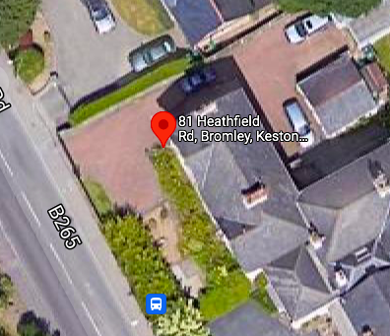

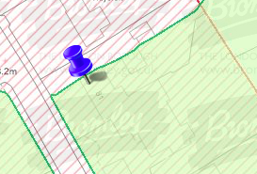

Conifer Hedge: Hedge Reduction – to reduce the height and width of the hedge by up to 4 metres, to create a tight and compact hedge.