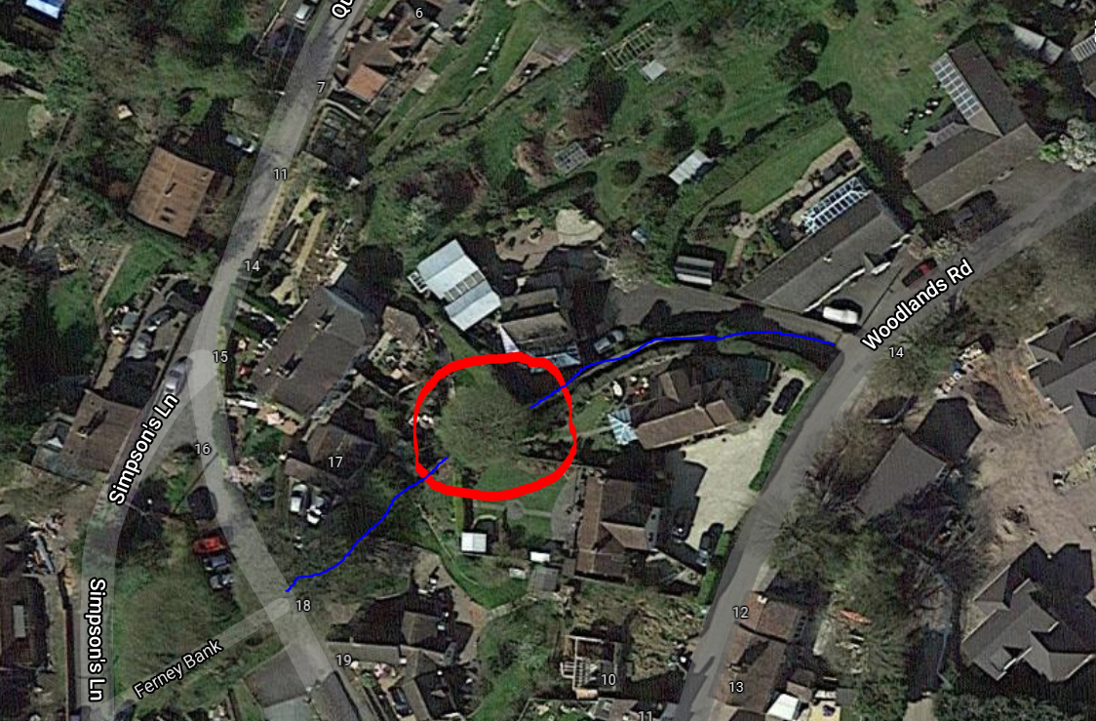

Blue line= Balls Jitty

Red circle= Sycamore tree in question

