Cypress at 60 & beech at 58 Watergate Road, Newport PO30 1XP

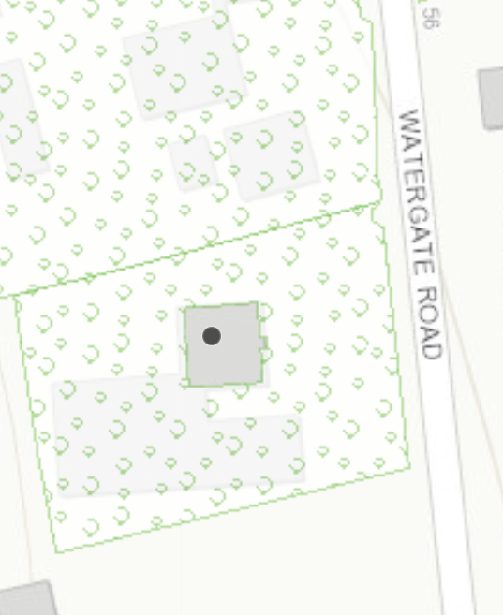
Cypress
Beech

